Interview with Ephemerist Artist
Aarishi
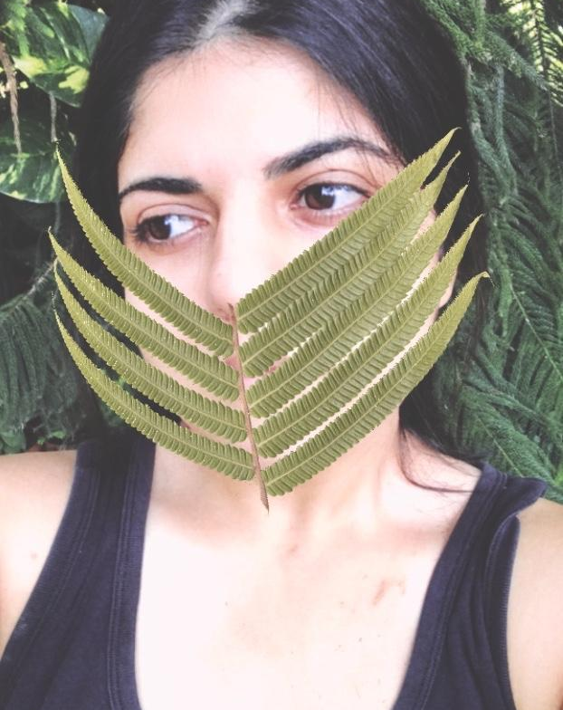
Location Singapore
Website aarushigurnani.com
Instagram aarushigurnani_

Ingredients
- Visual Artist
- Maker
- Ephemerist

Preparation
- Artistic Weapon of Choice:
I almost always know that the first few attempts at attacking the media will fail. So, I sketch it out, and that fails too. I like to mess around and really just get my hands dirty. That's when an idea comes through. That's when it starts to work. ‘Time’ is my weapon of choice. Literally. I work with time, and I work on the idea of time. I have absolutely no control over it, it always flies away.

- How did you get your start in the art world?
All I wanted as a small child was to paint…and when I grew up, all I wanted was to paint and make money off it. I knew from a very young age the kind of life I wanted; away from the corporates, away from the concrete jungles of the world, and somehow realistically still a part of the world where I’d find my tribe. So I went to art school, and art school is a luxury. As much as I like my freedom, I do know that an arts education gave me perspective. That’s where it really started. My ‘norm’ was painting, and I suppose I broke out of it. I’m still just about getting started in the art world.

- Do you experiment with other art forms and media?
I experiment with new media a lot. It is fun to take something new, and tear it apart; become familiar with it so much that it changes complete form. The possibilities really become endless, over and over again. That's exciting to me.

- Who/what are your influences? (This does not need to be limited to other artists, if licking lead paint inspires you then by all means...)
Never tried to lick lead paint. Am I missing out? Musicians and dancers(or movers) inspire me. Famous ones, and my ‘’struggling’’musician friends. They really make magic. Janis Joplin, Olafur Eliasson, Yoko Ono are incredibly inspiring names for me... and Absurdist philosophy. I read a lot of Camus.
- Do you have a day job or are you able to live off your work?
I work at a travel agency. It's nice because that’s my other big passion. When I have a studio, I dream of wandering out on a train.. and when I hit the road, it's a studio dreaming. Haven’t figured out the living off my artworks yet… I wonder how the others do it.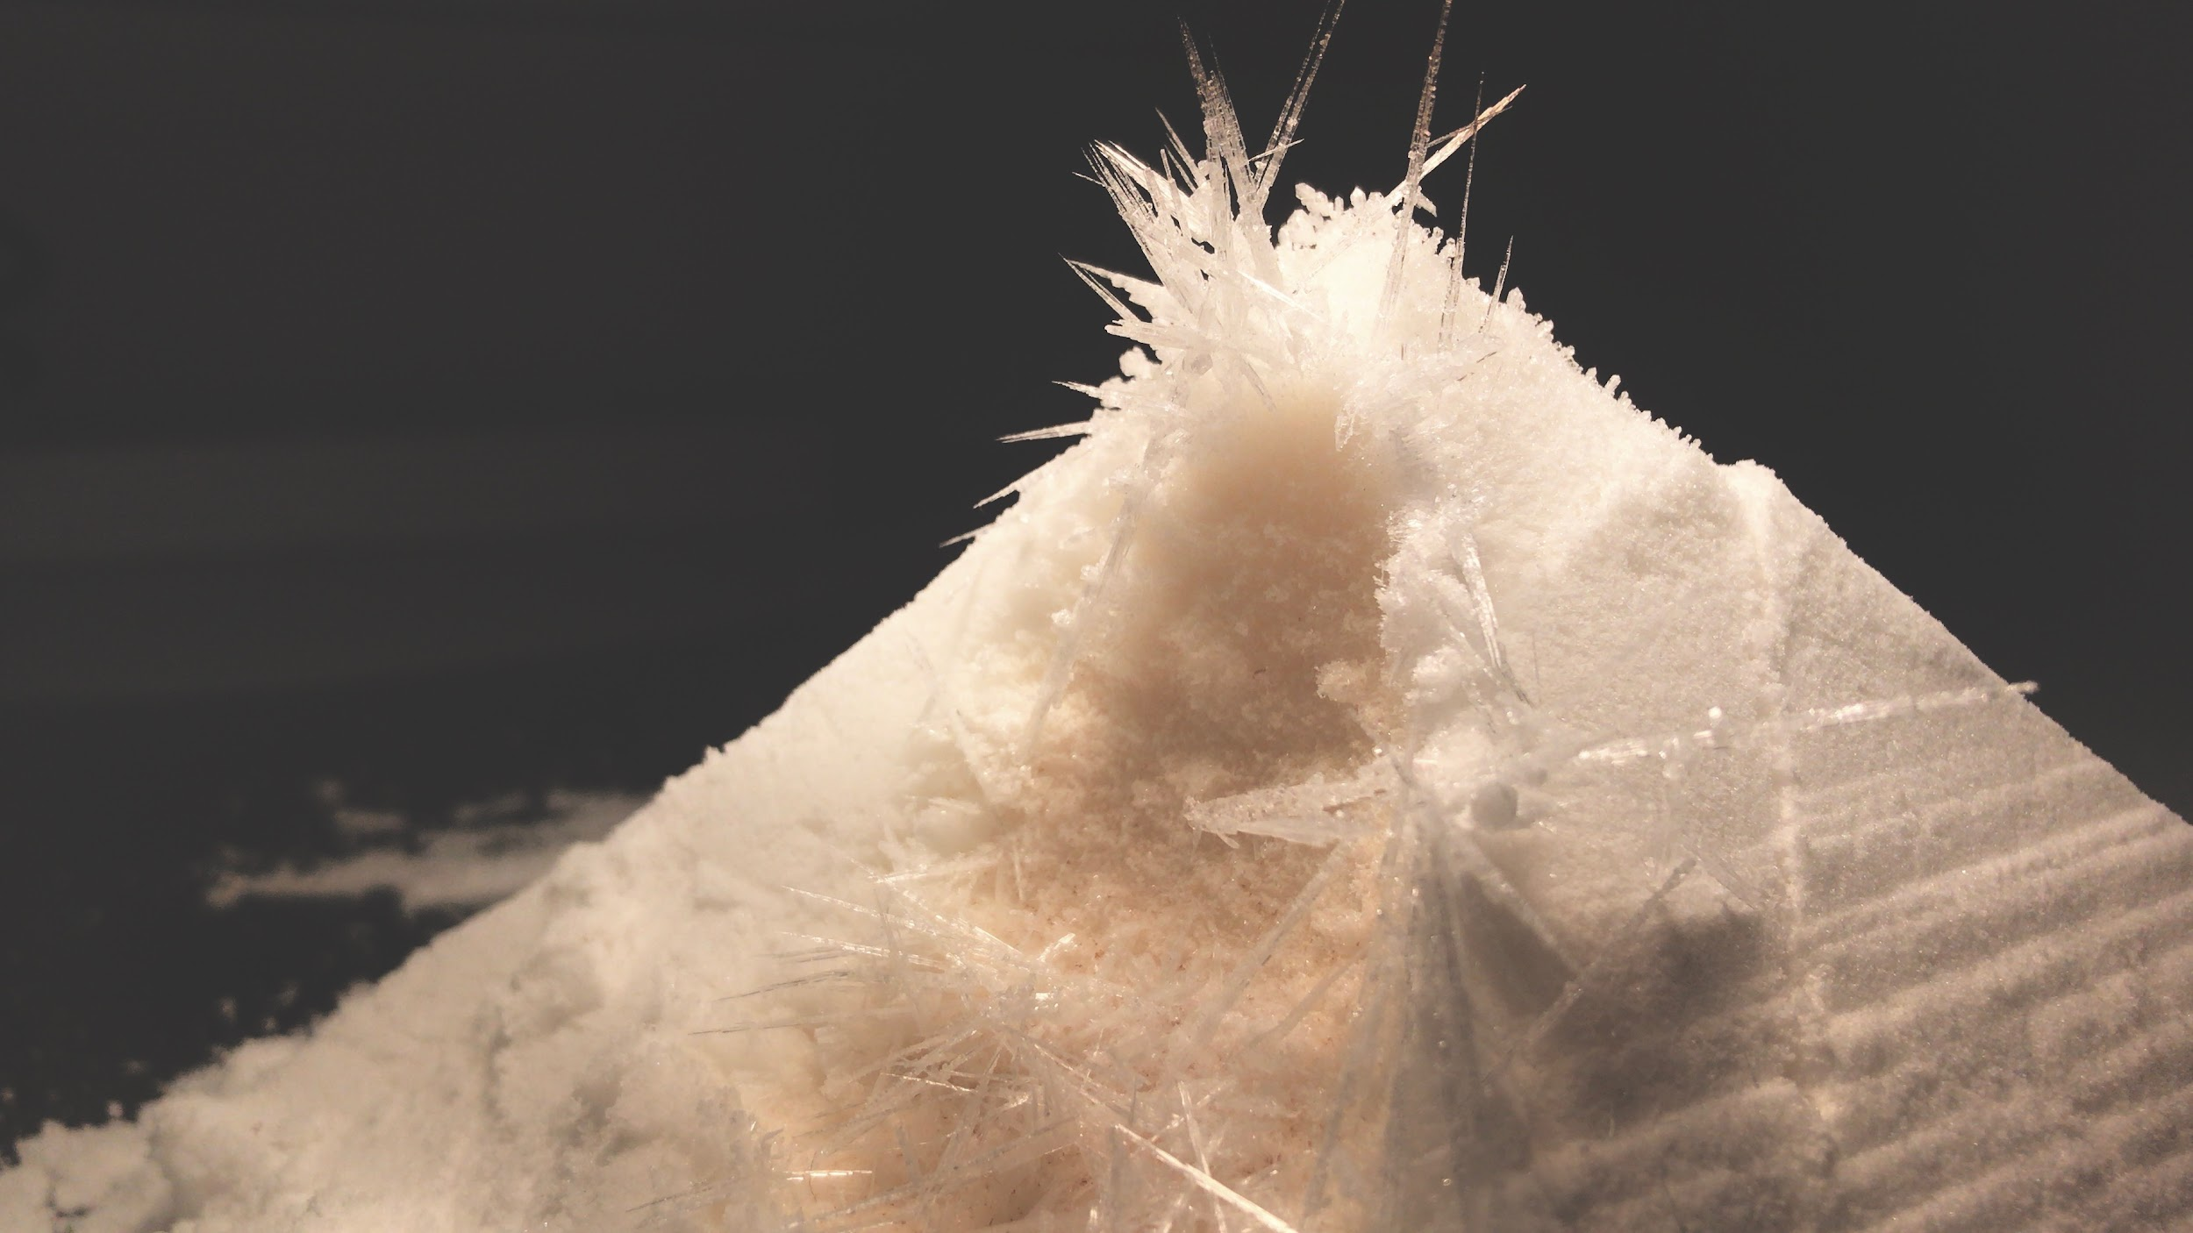
- If you weren’t an artist, what is another career path you may have taken?
If I wasn’t an artist, and I knew Scandinavian languages, I’d move to the majestic Scandinavian lands and work as a translator. Possibly even in a national park surrounded by huskies and unicorns.
- Of your own work, what would you say is your favorite and why?
I can’t really say. I like all my work and then I dislike it. I don’t know why.I do know that my camphor series has a lot of honestly, and so much more needs to come out of it.
- Do you have a studio space? Can you show us what it looks like? Any tips on sorting/organizing?
Does my mom’s old attic count? That's where I’ve been since the pandemic. It's a decent sized space with trees outside, and that’s all I really need. I do organise and clean a lot. As a minimalist, I don’t start out with a lot of material, with a big cleanup of the attic. Creation comes from staring at the trees with a cup of coffee, or that’s what I like to believe.
- Would a successful artist such as yourself have advice for underlings trying to break out into the world?
I ammm the underling trying to break out into the world. The advice is - be proud of your work, get it out there!, and that advice is really just for me.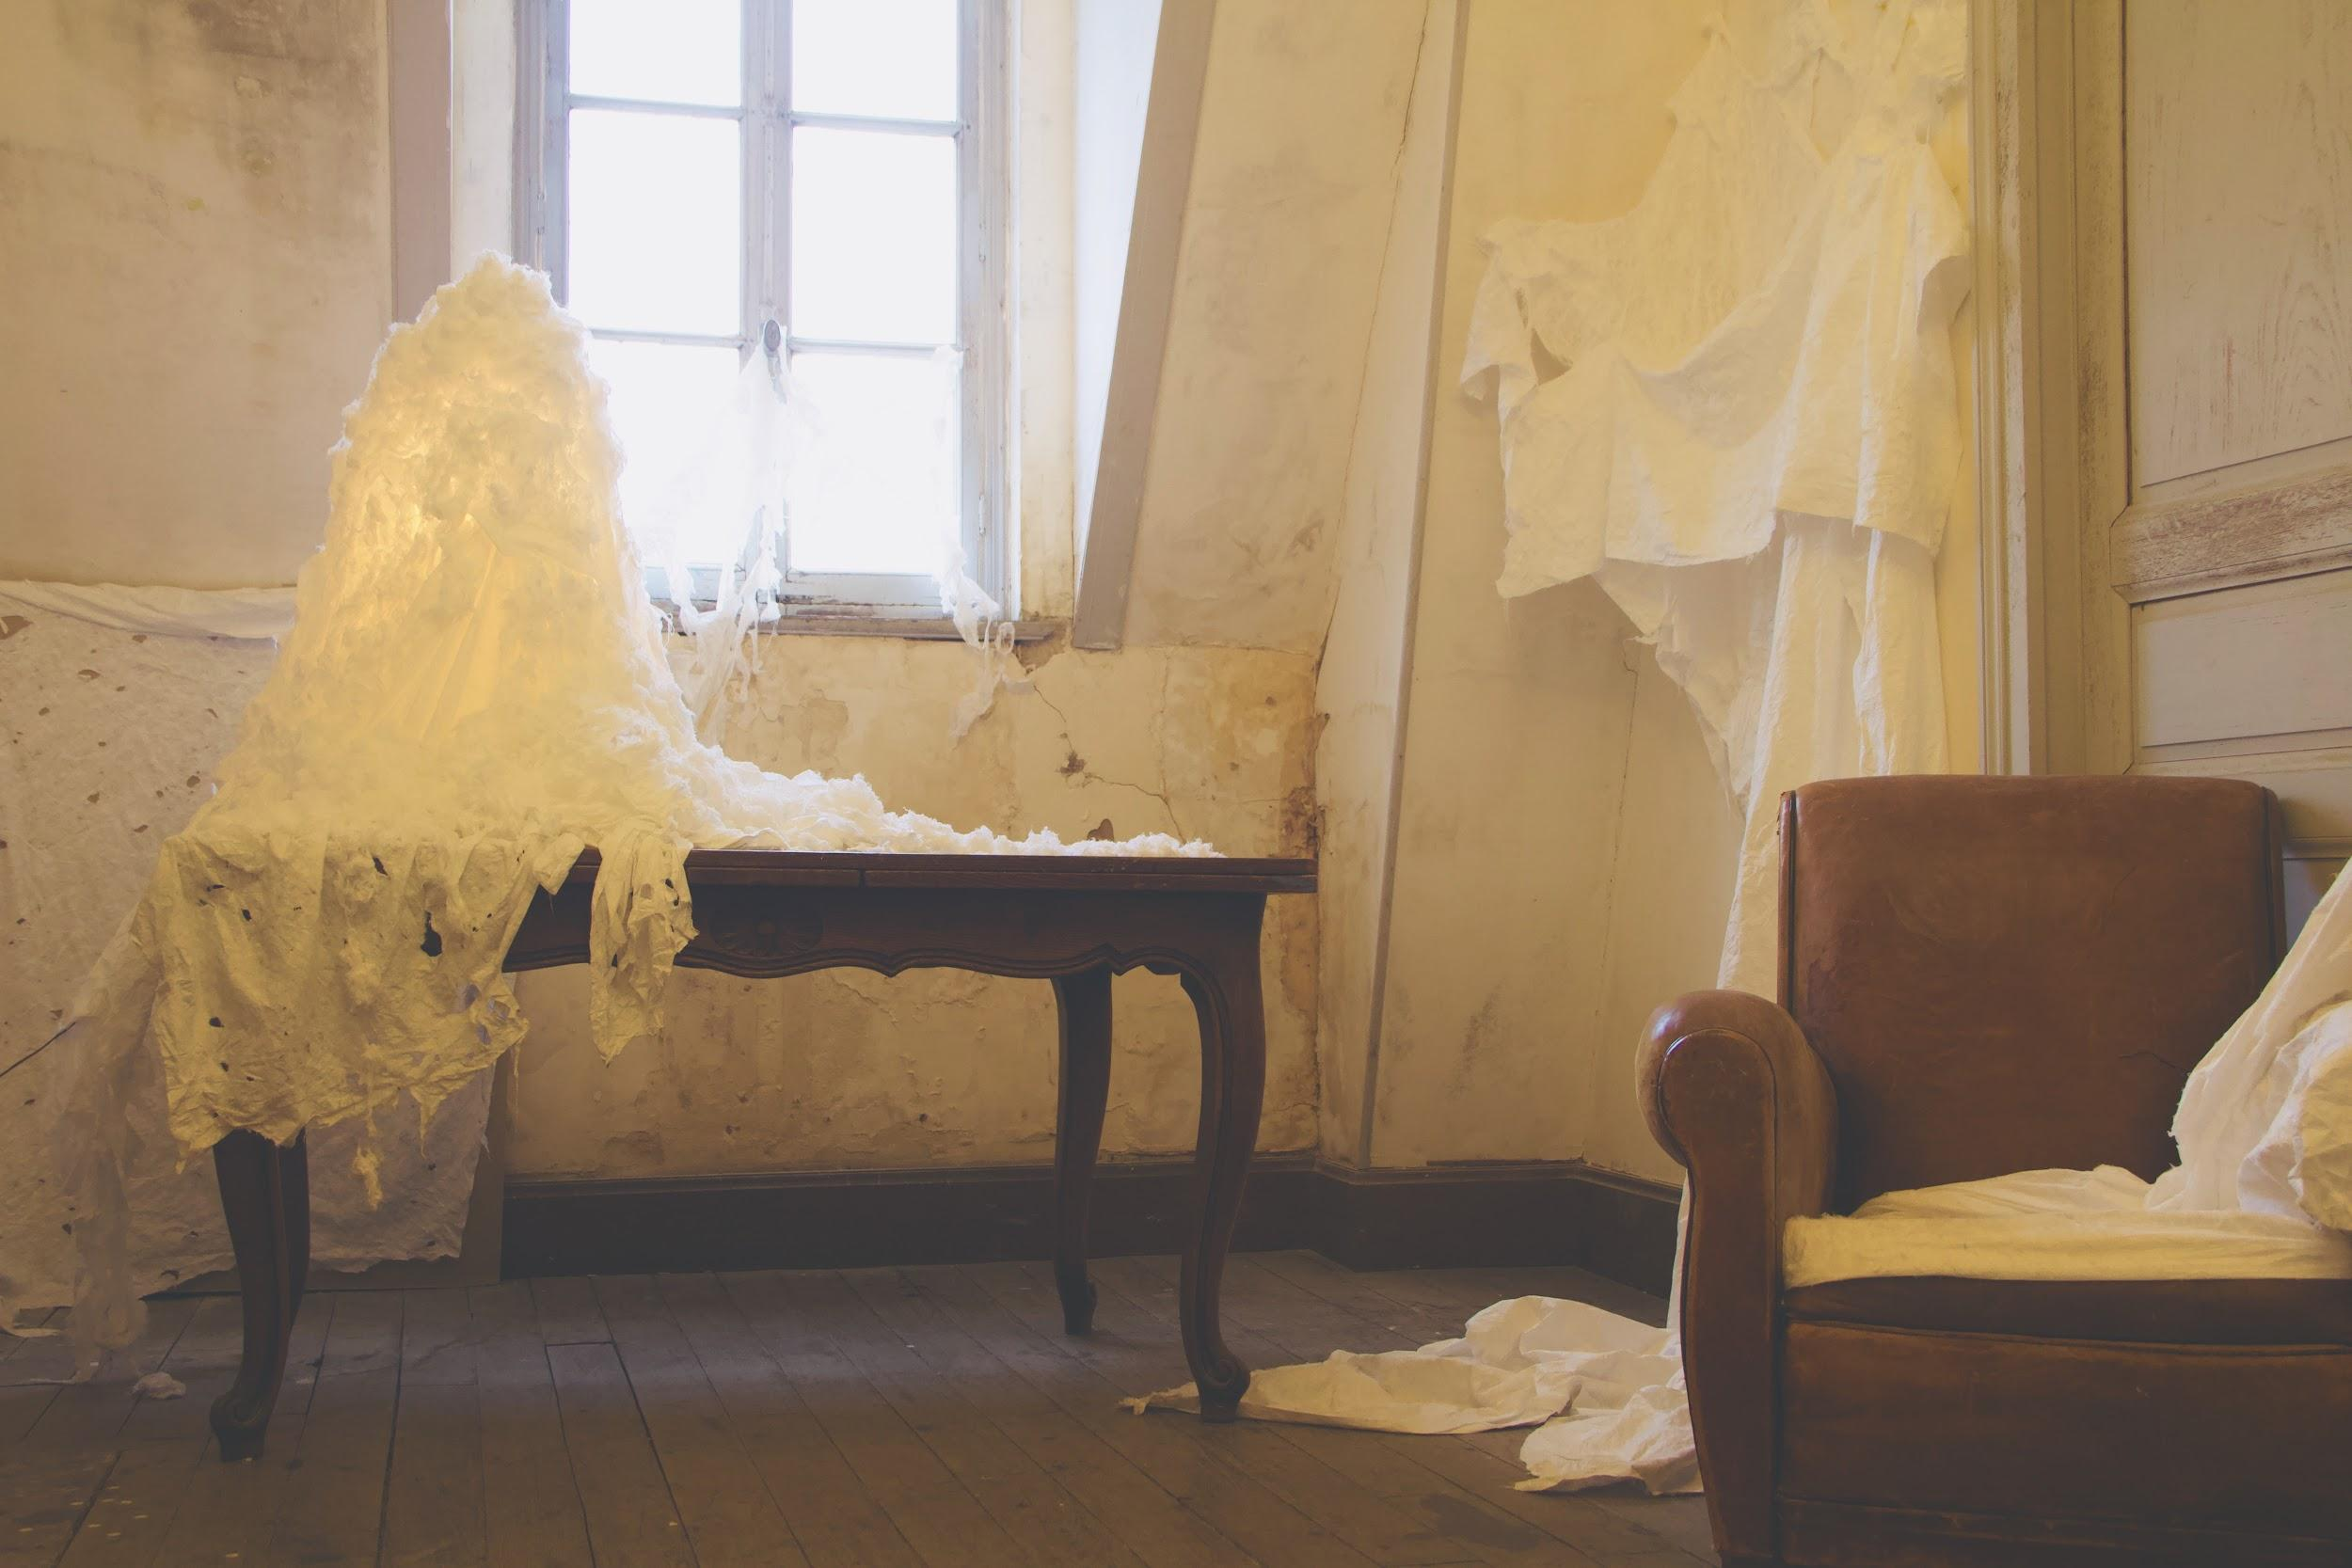
Lastly: Do you have any upcoming shows, events or projects you would like to plug?
What a shame, I wish I had an upcoming something. I was fortunate enough to have completed the Residency at Cheatueau Orquevaux in February 2020 just before the pandemic flared up. My only successful project has been playing with my dog in my mum’s attic all the damn time. I’ll plug in my website here and hope that some folks get curious.
https://www.aarushigurnani.com/

“Having grown up on a farm with nature in her multi hued splendour - constantly changing, growing, evolving, magical; I seek out the quality of impermanence in life and in the materials I work with” ~Aarushi Gurnani

