Interview with the talented team at
Cle.Photo Fest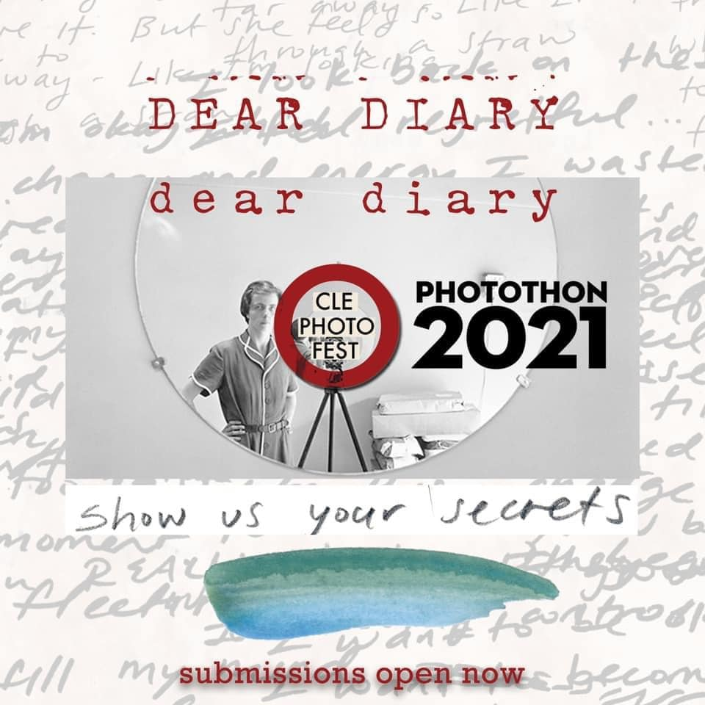
Motto: “Unity Through Photography,”
Location Cleveland, OH, USA
Website: clevelandphotofest.org
GOFUNDME: charity.gofundme.com

Ingredients
- Photographers
- Artavists
CPF DIRECTORS:
- HERBERT ASCHERMAN, JR.
- LAURA D'ALESSANDRO
- JIM SZUDY
- 440 Photography
- Nina Ripich (Executive Assistant)
- June Hund
- Randy Norfus
- Jan Vectrelis

Preparation
- First off, I want to congratulate you on what you've accomplished for Cleveland Photofest. So take me back to the beginning, how did you meet, what was the birth of the Cleveland Photo Fest Herb: Laura.
Laura: I was a professor living for 8 year New Orleans and I was involved in the N.O. Photo Alliance yearly festival in December is called Photo Nola for about seven years. Kind of like what we are doing here but a little different. They have been around for a while but it's only our second time at it. Cleveland needed something like that; something that shows an appreciation of photography and fine art.
So I approached Herb because he is the biggest business “Photo Wiz” in town. I wanted to run my idea by him. We were trying to figure out how to make that happen and happened to meet with Jim for advice on computer issues with a website and such. He said you’re going to need to do this and that and so I asked him if he wanted to do it and he came on board. So it was the three of us. Now we have a nice board. People come and go but we have our core.
Herb: Actually, Laura called a meeting at the Civilization cafe including myself, Jim and her. We sat down at the back corner table; I had known Laura , never met Jim. Two and a half hours later, we left with an outline of what to do and how to do it.
The more we grew we incorporated other people who had other ideas.
Steve Jobs was famous for saying “He doesn’t hire people to tell him what to do. He hired them to tell him what to do.” To remain open and receptive to the influence of other people's ideas. What are we doing right, what we’re doing wrong. How to expand and how to progress.
In no other organization that I have ever been in, let alone as a director…. It’s a team effort, everyone plays a vital and necessary part . Everyone voices their option and everyone is heard. They may not be listened to but they’re heard. Very subtle difference there.
- What were the goals you had your first year?
Herb: Present a series of photographic exhibitions that involved a broad spectrum of Cleveland, national and international photographers with the single objective to uplift the human condition through photography. The single largest international language because everyone “speaks” imagery.
Especially now that the Iphone has become a vehicle whose first use is taking photos and there are about five billion cell phones in the world.
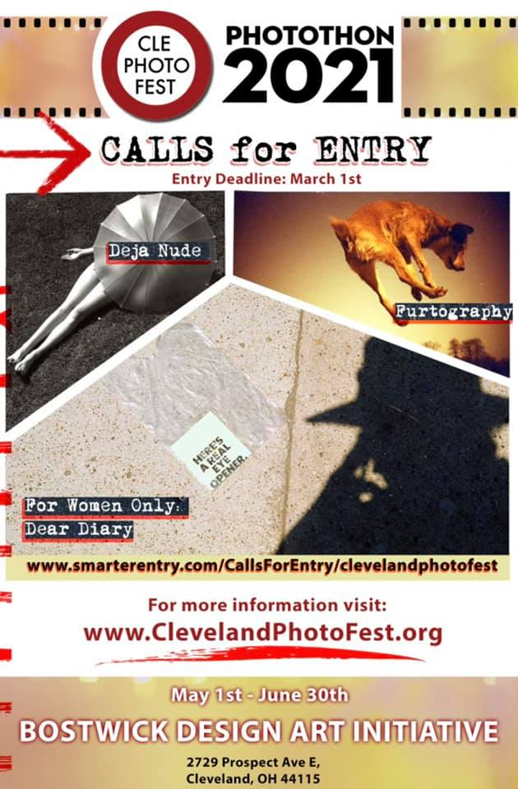
We have embraced the technology that has been presented to us with the intent of promoting photographic education. Teaching people how to look at pictures, how to look at them and expand their picture taking capabilities on a broad scale. We exhibit local, our focus is Cleveland, but we are open to national and international as well.
- Laura: One of our exhibitions this year is a collaboration with PhotoMuse, the Museum of Photography from Kerala, a state in India.
In an exchange exhibition to be held at Bay Arts in Bay Village, we sent 50 photographs by as many different photographers to India. They sent as many photographs by Indian photographers to us. We are hoping to reach out and collaborate more.
I started this… I should have on my profile under our duties for the team; “Known as the Master List Maker.” because I have a thousand spreadsheets in Google Docs for Photo Fest. I started one through researching all the other Photo festivals in the world, and there's tons of them and there are fifty different ones than you saw on another site. I started to make a list and I was hoping to reach out to these groups this year but I don't know if I’m going to have time because I’m following up with several hundred galleries and museums around Ohio. 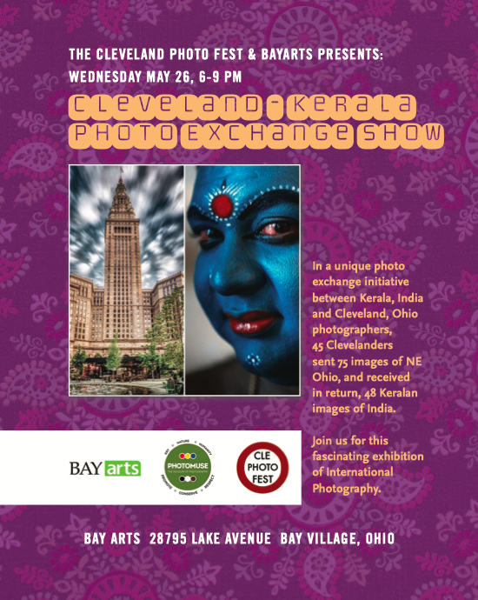
I have had my first photograph ever selected for this show
Would be nice to collaborate with some of these other groups in the future. We have a lot of future ideas. I don’t think there’s a lack of things we can do, one day, especially since I already have ties with Photo NOLA.
Our first run of Photothon in 2019, we had how many brochures?
Herb: 25,000 brochures.
Laura: So we have brochures with our events and shows and listings for anything in town photo related. So we distributed them all over town and some at Asia plaza. A couple from Toronto picked some up and came to some of our shows here in Cleveland and they have ties to the Toronto Photo Fest. There’s a lot of interesting things happening and I think.
This year we are putting our major exhibitions under one roof. Four exhibitions, three smaller, 8 programs. In 2019 we had 21 exhibitions in 16 different galleries and venues that we were personally involved in. This year we are under one roof and associating with other galleries throughout the city. Bonfoey, Foothills, the other photo galleries and other art spaces through the city. In particular Prama. In terms of promoting photography exhibitions that they are having between the May/June period. So that's our focus through the year and will expand past that date throughout the city.
Laura: Anyone can be involved, Bookstores and coffee shops, restaurants aside from galleries and museums and personal studies, the works!

- Herb: CPF is sponsoring four major exhibitions. Most timely is I Identify As which was conceived in 2019 which is crucial. So ahead of the curve. 330 black, 30 white and several of those who identify as “Other”(Native American, Latino, brown, etc). We paired them up and sent them out to photograph each other. The show will be 30 portraits of black and “others” by 30 white photographers and 30 portraits of white photographers and “others'' taken by black photographers. There’s never been anything like this anywhere. As I said our conception was so far ahead of the curve because being a fourth generation Clevelander, I’ve grown up with the racial divisiveness of the city. It was our coordinated and planned attempt to involve those into the photographic community that would have never otherwise been involved. We’ve received numerous compliments from the participants; “I would have never met you,” “ I would have never taken these pictures,” “I would have never had a chance to involve myself in the broader community.”
We went out and knocked on doors, we did not just put out a ‘Call for Art,’ we actively solicited photographers. “Well who are you?” We are the Cleveland Photo Fest and this is our mission. The follow through show next year will use the same groups of people on an entirely different theme- but we can’t talk about that yet.
Talk about a cliffhanger! I’m excited to find out more when the time comes.
Herb: CPF is actively bringing walls down in “Unity Through Photography” rather than reinforcing cultural stereotypes. We are actually on the street doing something about it in the Cleveland art community. We’ve run into static in places and issues. The success will be the biggest contribution we make to the Cleveland Art Scene this year and all due to teamwork, collaborative efforts, and the people we deal with all down the line. Meet with a great deal of appreciation for our efforts to create Cleveland as a center of Fine Art.
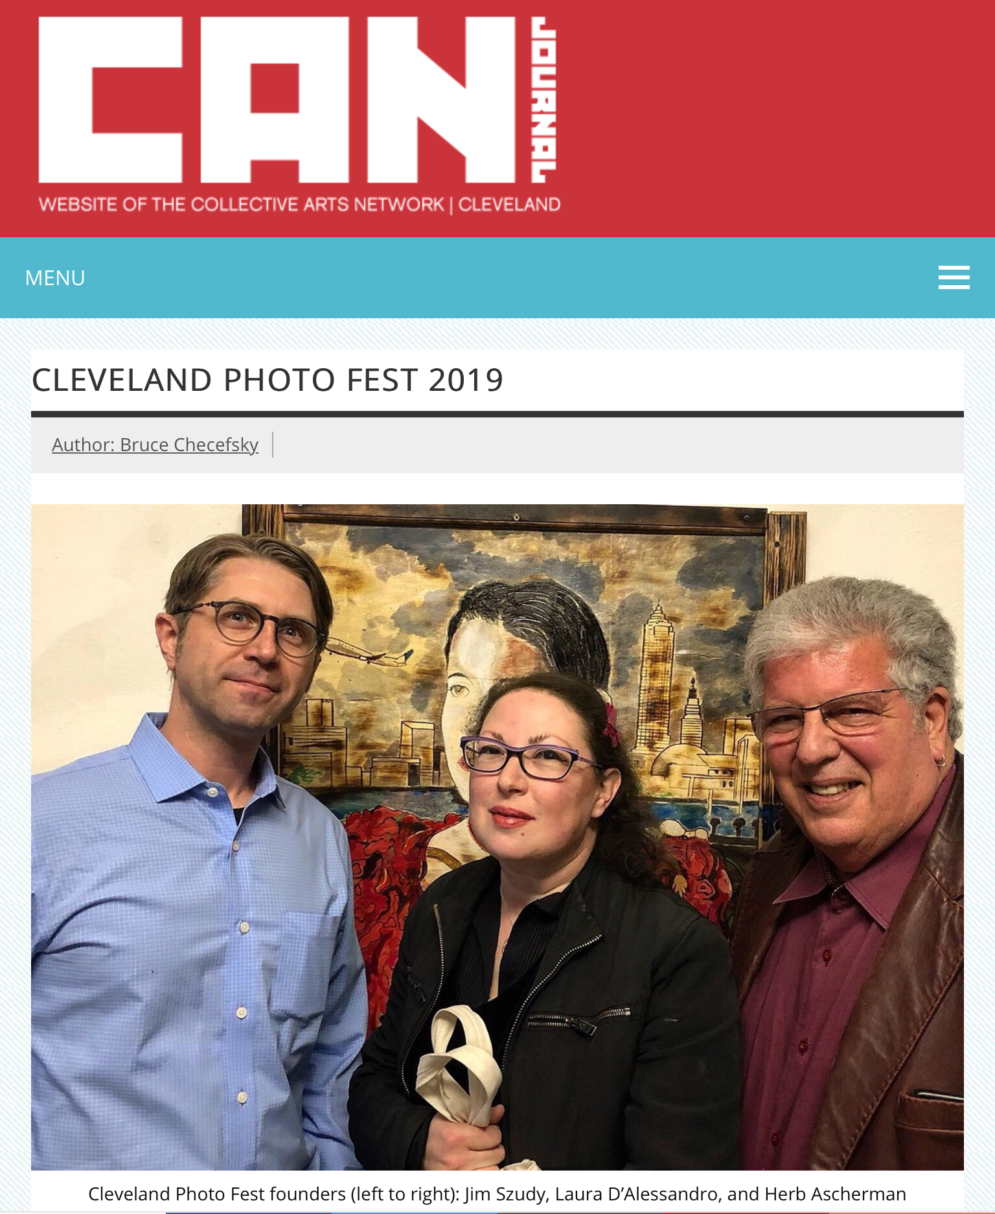
Herb: Having said that, we are on a major push for volunteers.
- That was going to be my next question!
Herb: We need gallery sitters for two months, we are open four days a week, we also need input, fundraisers, grant writers, Nina?
Nina: Going forward we need ad salesmans, gallery sitters, grant writers, ad writers, videographers. Can you give anymore Laura?
Laura: That’s a good list but we also need people to help in contacting people and places and little bits of things we are working on.
Herb: We have sponsors throughout the city: The Diversity Center of North Eastern Ohio is a Community Partner with us in the I Identify Show. Ben and Jerry’s has given us sponsorship for the FURTOGRAPHY Show. We will be featured on a WKYC’s WE THE PEOPLE Show with Leon Bibb. Numerous other individuals and companies have offered their support.
As you know, we are not a marketing juggernaut but I am curious to hear how can we help support your cause? Can you give me a better idea of a product donation and/or financial support and I can see what I can do to help if possible to help you get back on track for producing 2021 exhibitions.”
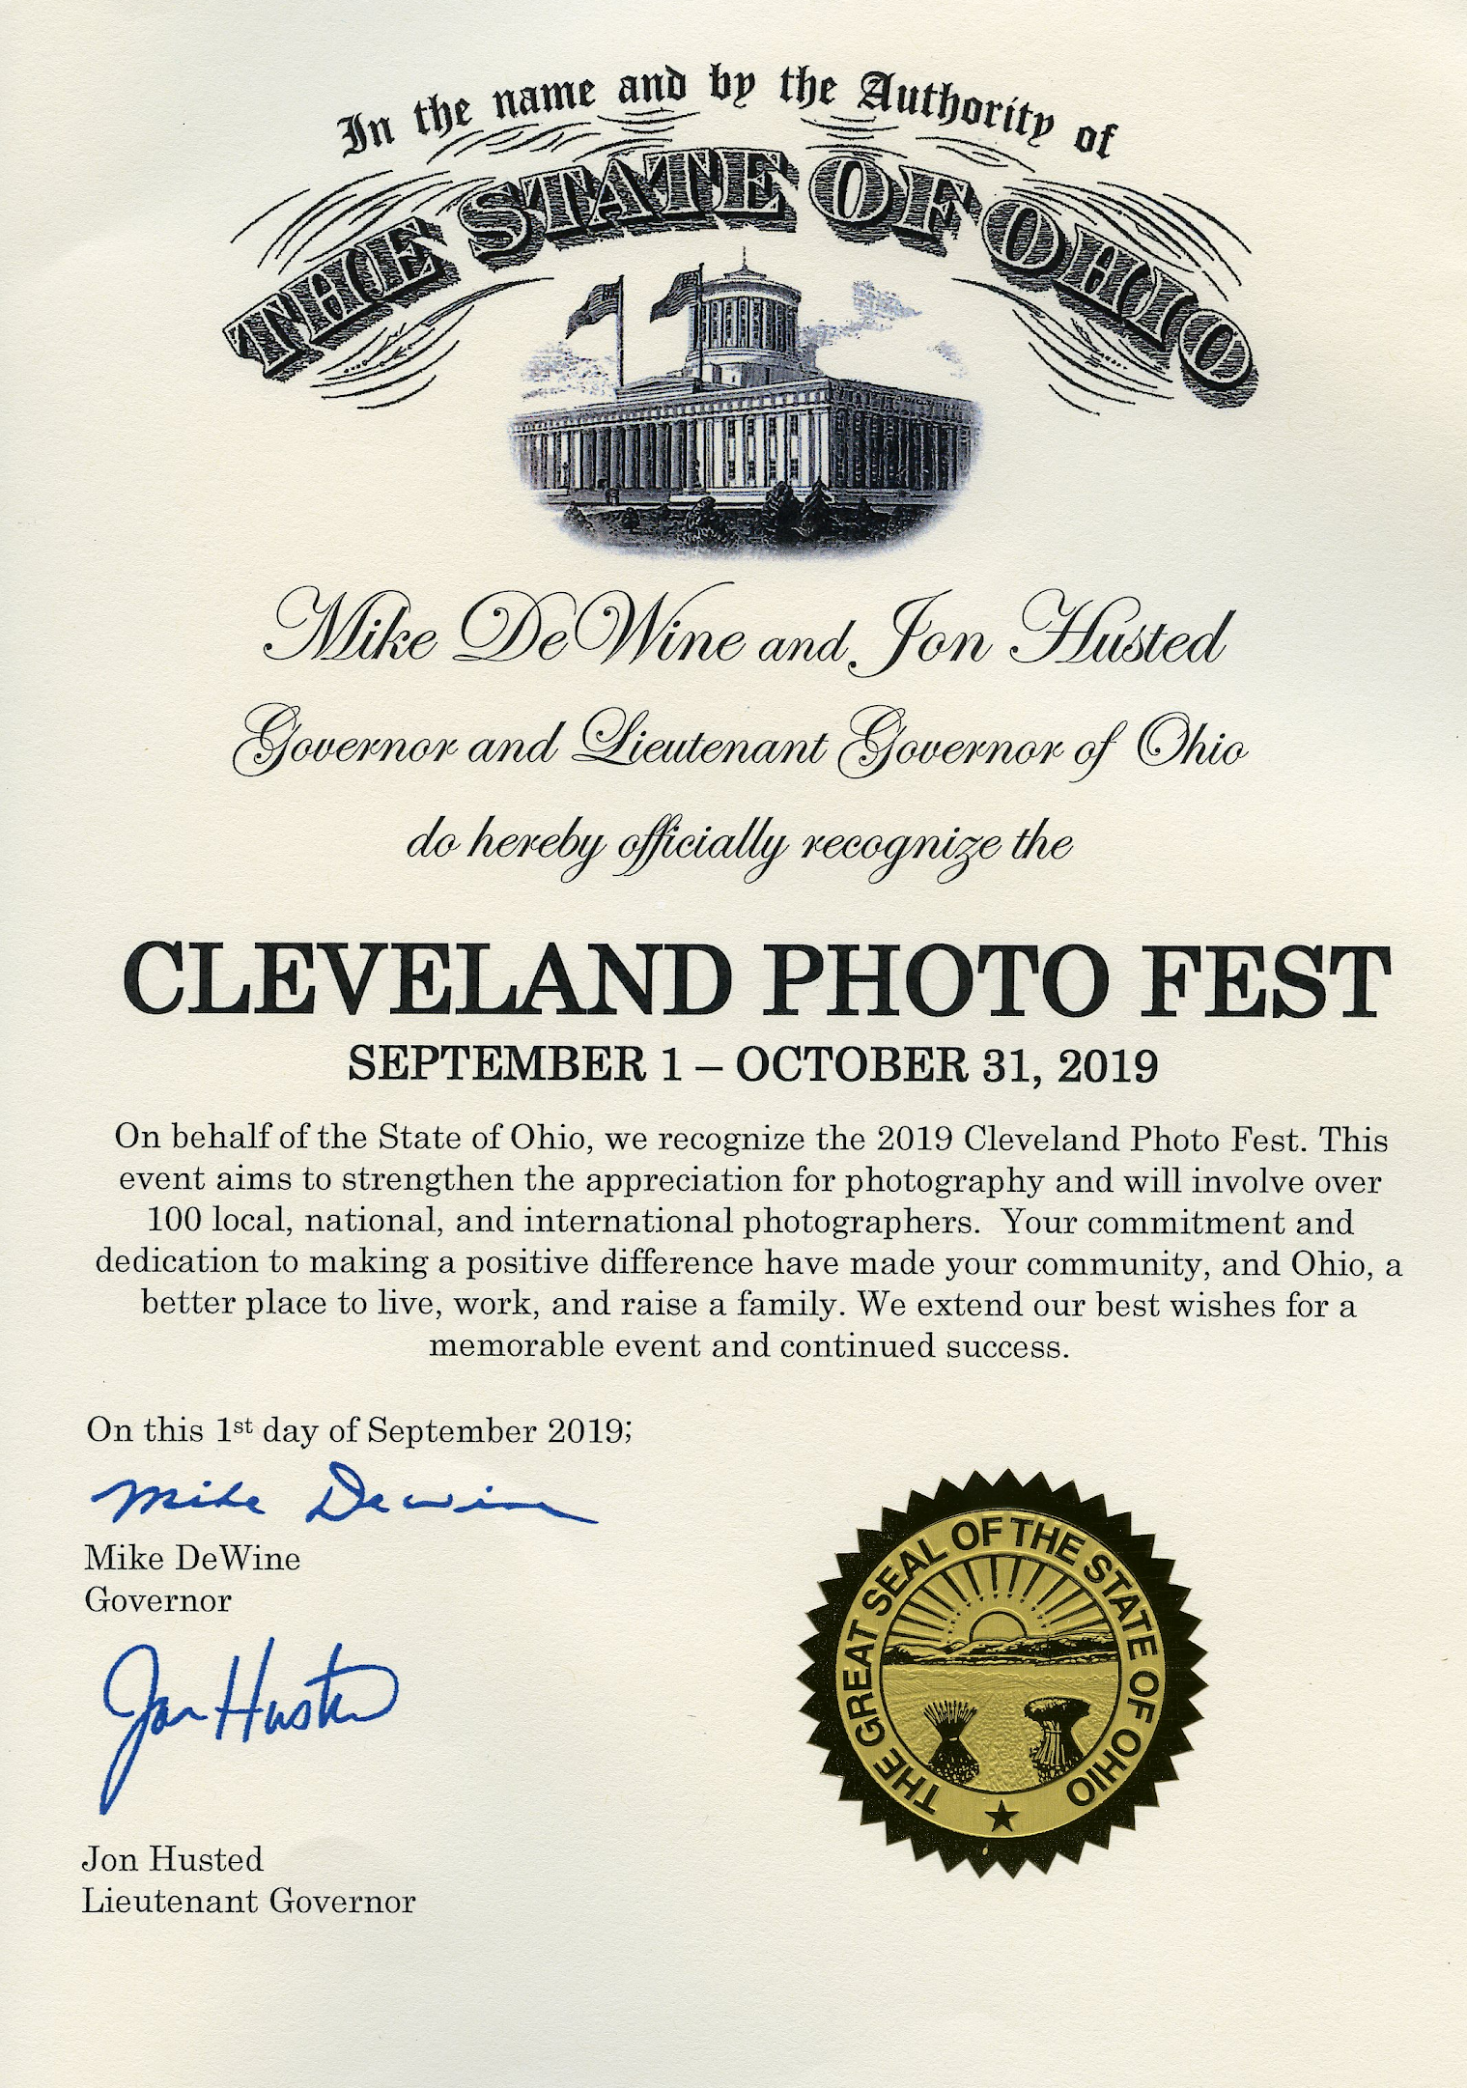
Herb: We are producing high quality exhibitions that people are responding to. Jim is the vice president in charge of media and does everything from a technical standpoint. Basically he does everything. Do you have a succinct observation you would like to make bout CPF and it’s impact?
Jim: For me personally the reaction from the community has just been nothing like I ever- In our first year we weren’t expecting the huge outpour, positive reaction and seeing people come together. Cleveland has been a strong art-based community. We have the film Festival and the Photo fest. It's just another layer or level of how rare, rich and deeply based at the community is steeped in.
Herb: The CAN Journal ran a survey during the time of Covid “what are you interested in, what do you miss, etc.” In three different places CPF was listed as one of the major events in Cleveland! They have been a major supporter and the CPF has been recognized as a major event in Cleveland.
Laura: We watched the magic happen motto “Unity Through Photography”, We watched the gallery and the public meet up and connect, while we also watched people's work grow, everyone inspired each other. All of our work blossomed and it was inspiring.
Jim: we are always trying to think outside the box. When we were together in 2019 when we had the POETOGRAPHY : a show where poets interpreted photographs. We were at Macs Backs and incorporated poetry with photography. Now we are taking it one step further this year by composing and incorporating poetry, images, photos as well as music in a collaboration which Nina was instrumental in getting that together that as well. To have poetry, photography and music come together. Also we will have typewriters set up so people can come in and type something up that will then be put together as one big piece.
Herb: We will have someone there explaining what a typewriter is and how to use it.
Nina: we got a lot of interest and submissions for it.
Jim: the first day we announced it on social media we got hit up with a lot of musicians, photographers, poets showing interest.

- I see that Photothon isn’t just one show, it’s a whole series. Is every show that you produce per year part of that Photothon?
Herb: we named it Photothon because it’s 7 exhibits and 8 programs under one roof. If we didn;t have this one gallery it would just be Cleveland Photo Fest. Photothon is our shorthand for high intensity centrally located series of exhibitions under one roof.
We are still associated with 20 galleries throughout the city. Doubting Thomas, Prama, Bay Arts. Where else?
Laura: Macs Backs and Tree House.
Herb: We are still sponsoring, collaborating and linking with any other galleries who will do a major exhibition like Bonfoey.
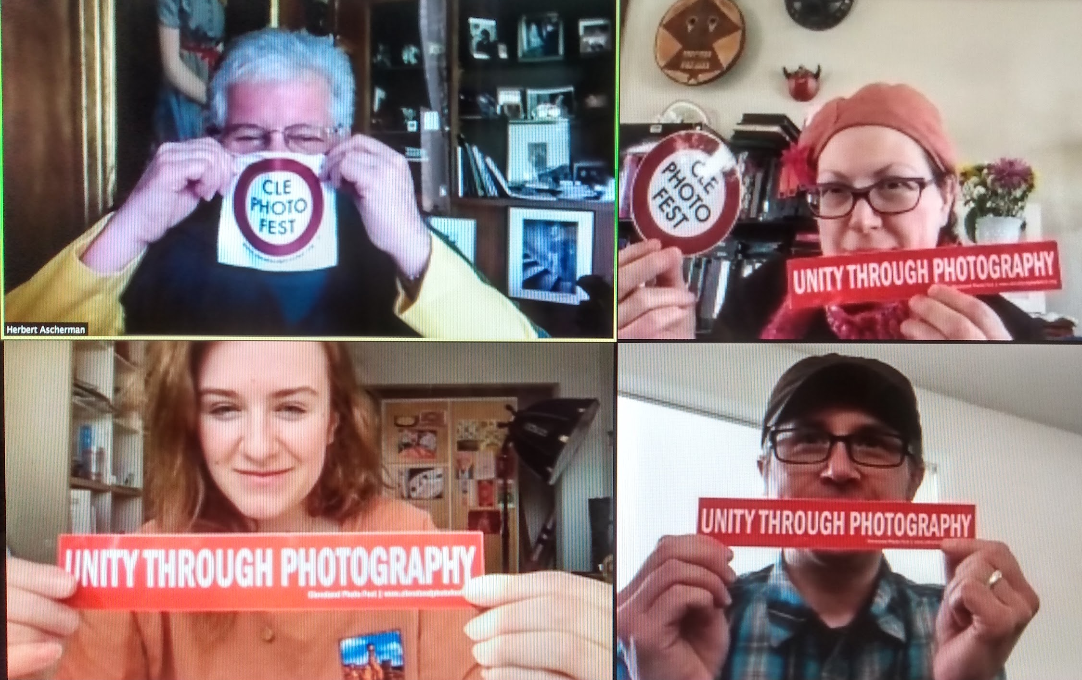
We have there approaches: we can promote your gallery through our media, we can provide you a show in collaboration with your gallery, make suggestions, who to talk to or where to go if you want a show or we can come in and take over the walls. Which is what we did in 2019. We are running our own exhibitions in our own place. Our physical outreach is less in terms of our participation, more in terms of promoting what others are doing.
Laura: It was so much easier the first time around to contact venues and get in there because we knew everyone was open and there was no uncertainty. Now with the pandemic so many establishments are not open or do not want to have live events, some won't even respond. I am glad we have our own space so that is a certainty.
Herb: we had this space last year and anticipated 1,000 people in an 8 hour opening with the seven shows. This year we have reprioritized our thinking. We will still have an 8 hour opening on May 1st. We have plenty of PPE and with the amount of space we can have 100 people in the gallery at one time with no social issues. My goal was that the pandemic would be under control at May first. We will still have an opening and welcome people but hope we don't get the surge we anticipated last year.
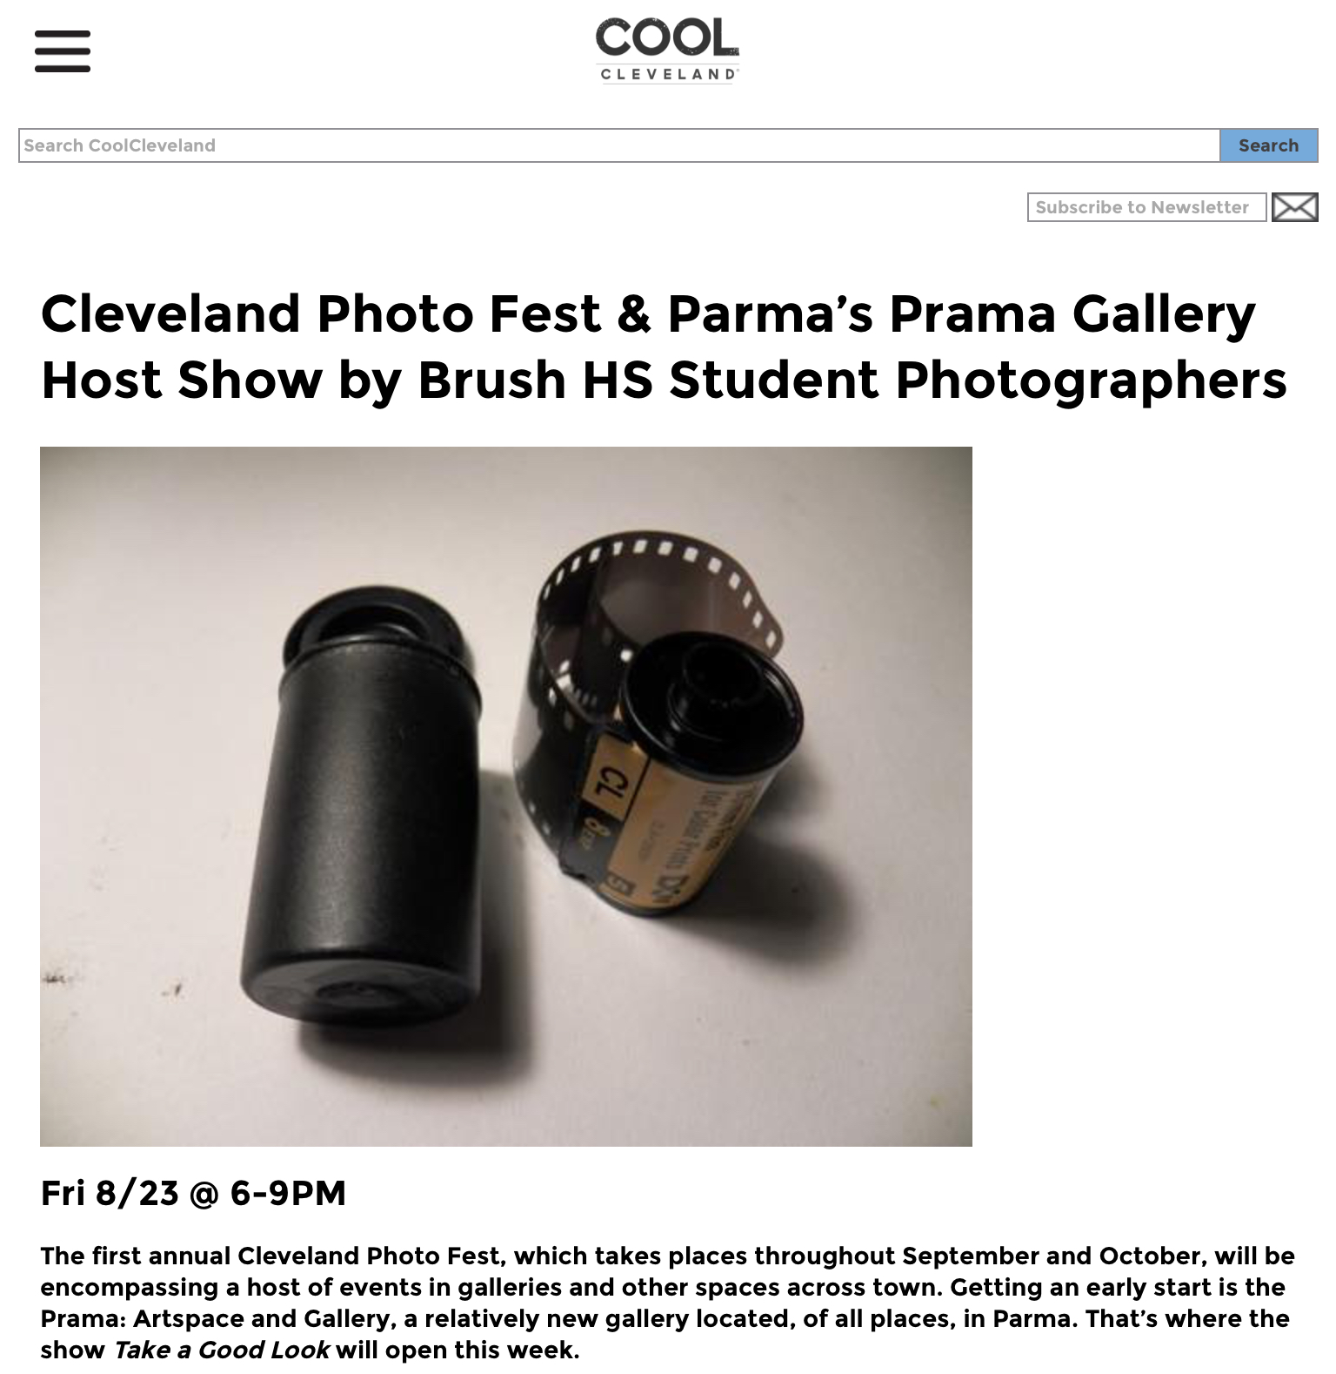
I was going to ask how you might have been affected by the pandemic.
Herb: We canceled last year, we didn't want to deal with it, couldn't deal with it, and chose to be socially responsible. We organized and used the time in a valuable sense in terms of production but would not engage the community physically. We set the date, hoping vaccines would be out enough and the public would be responsible in their mingling.
Masks will be required, someone will be there with hand sanitizer. We are immensely respectful of the pandemic. We do not want to cause in any shape, manner or form any possibility we could be a super spreader location. Everything in moderation.
For the record, dogs are welcome to the opening because of the photography show cats are not.

- Can you tell me more about Capture Cleveland?
Jim: Something I came up with as far as just not everyone wants to submit so it was something I came up with to engage all photographers to submit a photo of Cleveland, any subject was fine as long as it Cleveland based It was a way for us to give exposure to Photographers in and around the area, for free obviously. We posted their images on social media. In 2019 we collaborated with Cool Cleveland they would also post the photos in their publication and pay the photographer for their image. We have not been able to do it this year, on hiatus, and I still encourage participation. It’s been hard since people have been staying at home and things of that nature. Now that more things are open and that it is nice out we can hopefully get that going more regularly in the next coming days and weeks.
- I’ve also noticed you have been mentioned in Cool Cleveland, Live on Lakeside, Canvas, CAN Journal and the Plain Dealer and even an Official State Ohio Gov. Proclamation, how did these publications and partnerships come about? Did they contact you or the other way around?
Herb: we are very aggressive, we contact them, we contact everyone that knows someone we suggest they pass our name on. As in any business “What you know is important, who you know makes it happen.” Just asking, “Can you get us on the radio?”. I’ve known Carl Hunt from WRUW for years so that was just a phone call. Live on Lakeside (watch that interview here), I knew someone and Jim knew someone, they knew each other and they called us. Cool Cleveland, I’ve known him since he started (Thomas Mulready,) Stephen Litt at the Plain Dealer has been a supporter of mine for 40 years since I opened my first gallery.
Publicity has come through friends over the years, decades and contacts we’ve made in terms of promoting aggressively because we have a quality product. People see who we are, they see what we have done and they accept the fact that we are actively contributing to the fabric of Cleveland, Ohio. We are improving it artistically, visually, aesthetically, socially. We make good media.
And Jim has done an absolutely phenomenal presentation of getting us out, he is the single moving factor in our media. We can talk to him on a daily basis and it’s done. Media promotions: we have the right people in the right places and they do their job to contribute because we are “Unity Through Photography.”
Jim: That’s our slogan.
- How do you come up with the names & themes of the shows and schedules?
Herb: they seem like a good idea at the time. FURTOGRAPHY Jim came up with Deja Nude, I came up with, For Women Only: Dear Diary, Show Us Your Secrets. Laura and I came up with it.
The I Identify Show went through eight or ten different iterations of names until we came up with one we all agreed on. You know, one we felt was socially acceptable. So it was a collaborative effort.
Laura: I don't think we will lack in exhibitors or ideas. I mean there’s so many amazing people that are photographers and also like I said we’ve been trying to incorporate other people because not only do we want to show local people we want national and international so locals can see what they are doing and be inspired. We love curating. I mean we had how many people were involved last year?
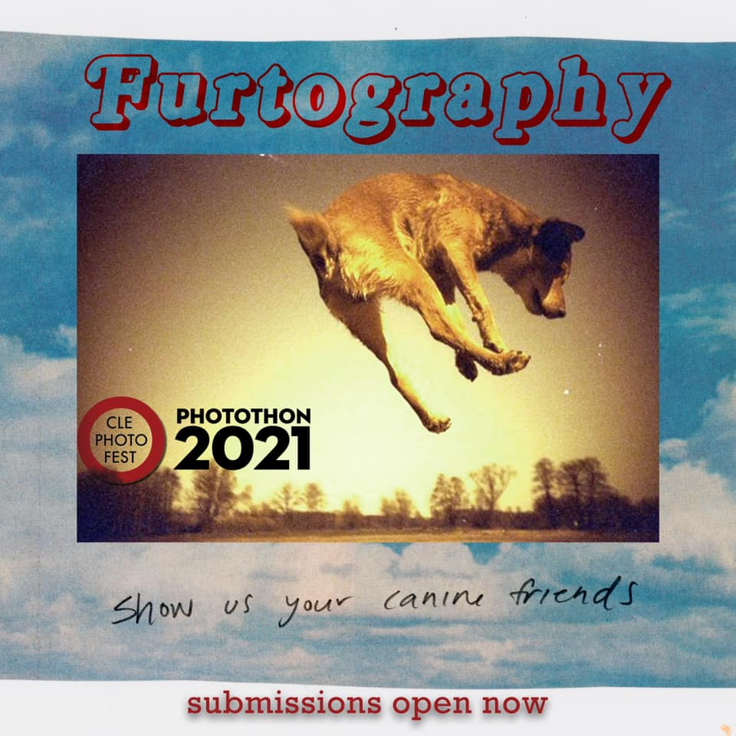
Herb: 256 photographers.
- I wish we could show more than that! You know Photo NoLA, which has been around for a while, people would know when it was happening and people would start procuring places somewhere. We encourage that too. Find a space and we will promote you for free. We have all our listings on our brochure for free. Anything photo related, exhibits, events.
If you have something going on we will list what we want people going on. We will prompt it. Taking to LGBQ to see if we can have something going on. There’s a lot of possibilities. The pandemic has been a little small as far outreach.
Everything is open and an option. If you are booked now write us in for a year or two from now. Many galleries plan years in advance.
Herbs: Planting the seeds is exactly what this is all about.
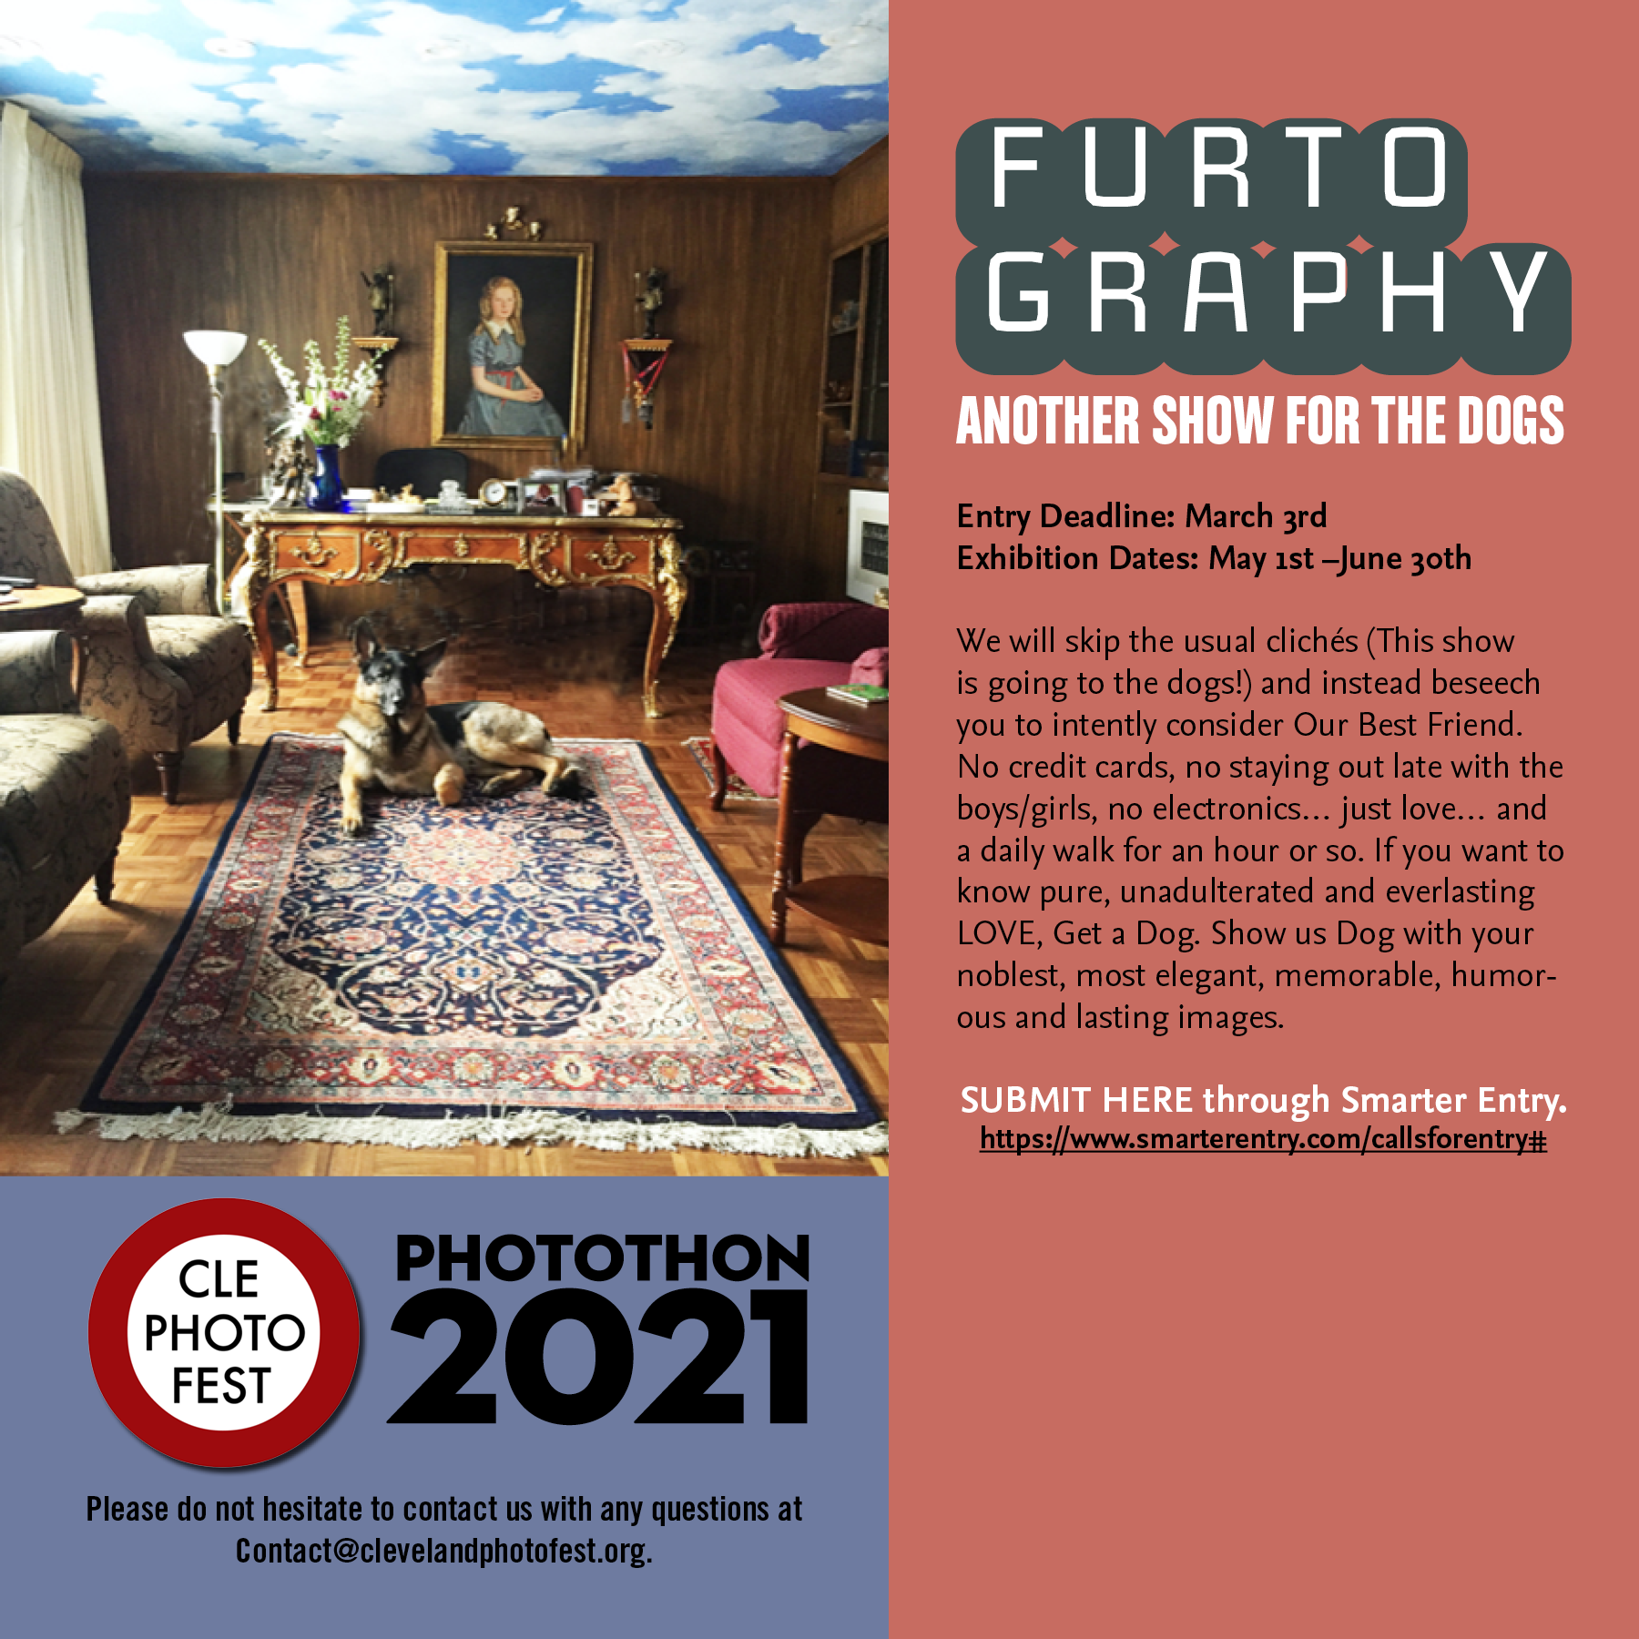
- Do you have any advice for photographers on their paths?
Herb: Don't quit your day job.
Jim: Put your phone down.
Herb: It’s a cold industry at the moment. Unless you are a young woman who has a good looking partner, male or female, and the Wedding business is the only growth sector in the growth industry.
As far as being an artist your success is dependent on how hard you work.
Jim: Do what you love.
Herb: Got to get out, got to promote, show yourself, show your work, make friends, make contacts.
What you know is important and who you know is what makes it happen.
Laura- Sharing opportunities and experiences with people not being stingy about if you know about a show or event, sharing it creates unity and brings people together instead of being competitive. We are trying to bring the community together for a good cause. We love photography and want others to appreciate it as well. It's not like we are not competing with other galleries or festivals. We want to include them and we are looking for ways to do that. Everyone is welcome.
Herb: Well put.
Laura: And like Jim said we have had poetry and incorporate other different kinds of art. We are talking about doing something with dance, music, projections-
Herb -German shepherds.
Laura: Animals! Videos maybe.
Jim: Shaun Slowburn and myself, we have a project in May on a Thursday. Projection of images from Photothon and doing a soundscape, atmospheric, noise and we go under the project name Nihil Omnia.
We are incorporating more and more, thinking outside the box. We aim to incorporate as many people as we can in as many ways as we can. It’s all about community. We are always thinking of new inventive ways to get more people involved as long as it’s photo based. 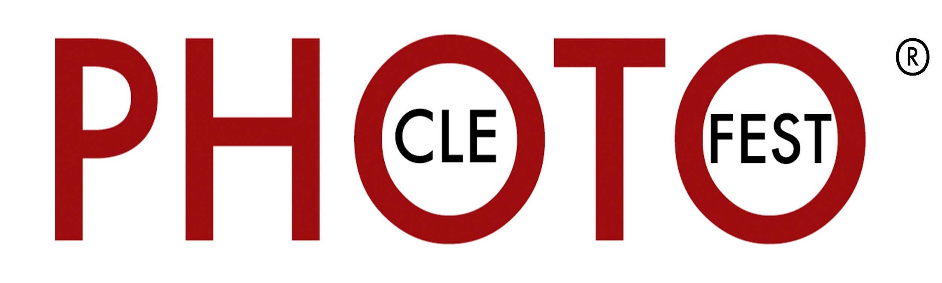
- Are you looking for volunteers?
Volunteers are the minds, hearts and hands of our organization. The list of opportunities is almost endless: from arranging and hanging exhibitions, staffing openings and educational events, gallery docents, gallery staffers, office organization workers, media contacts, consultants and caterers. We welcome all civic minded collaborators and contributors.
If you are interested in volunteering, please contact us at: contact@clevelandphotofest.org

Upcoming Shows:
- Kerala Photo Exchange Wed, May 26th 6-9pm at Bay Arts
- I Identify As
- Furtography (A DOG SHOW)
- Dear Diary (WOMEN ONLY)
- Deja Nude (NOT ANOTHER NUDE SHOW)
- Tim Lachina
- Lydia Bailey
- Bruce Checefsky
- Randy Norfus
At Bostwick Design Center,
2729 Prospect Ave. Cleveland

Chef-d’œuvre

