Interview with illustrator
Emily Splain
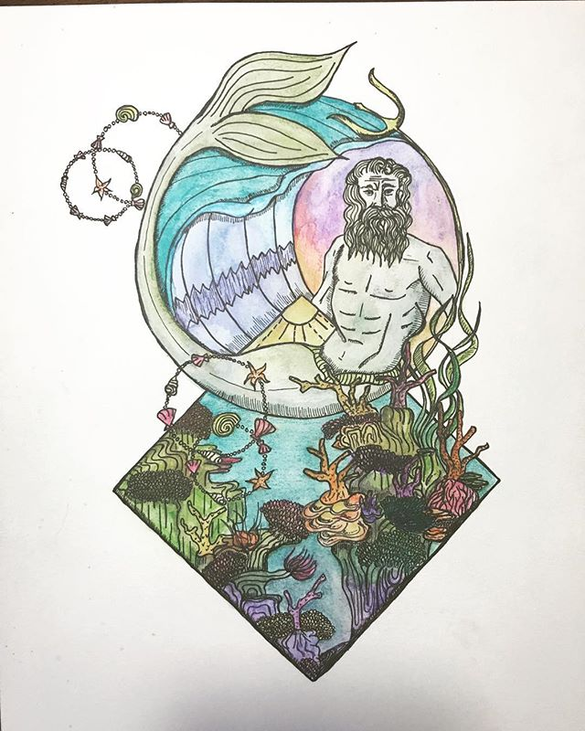
Location Cleveland, OH, USA
Website xsplaindesigns.com
Instagram: XSplain Designs
Etsy: Xsplain Designs

Ingredients
- Illustrator
- Educator

Preparation
- Artistic Weapon of Choice: Watercolor (pencil, gouache) and pen and ink
- How did you get your start in the art world?
I interned originally with Parade the Circle and Robin Van Lear- this really opened my eyes to the Cleveland art scene.

- As far as experimentation I see so many things going on your Instragam, CelluClay, fabric paint, wood ornaments,
Yes, I love to challenge myself with different kinds of projects- though I am definitely more of a 2D artist.

- Who/what are your influences? I believe we discussed that you’re all (or part native American), which I think shows through in your portraits. Do you make up the face paint designs or are they from a specific tribe?
I have a very small percentage of Cherokee and Lakota in my bloodline but I am not fully indigenous. I learned of my heritage from my biological grandmother- my dad was adopted and our “bio grandma” came into our lives when I was around 8 years old.
- She spoke a lot about her beliefs and it really made me curious about the different tribes. I researched different tribes’ facepaint and kind of mixed from different peoples. I did not wish to insult anyone from the various tribes that I pulled from- it also gave me creative freedom to play with the colors and races of my portraits.

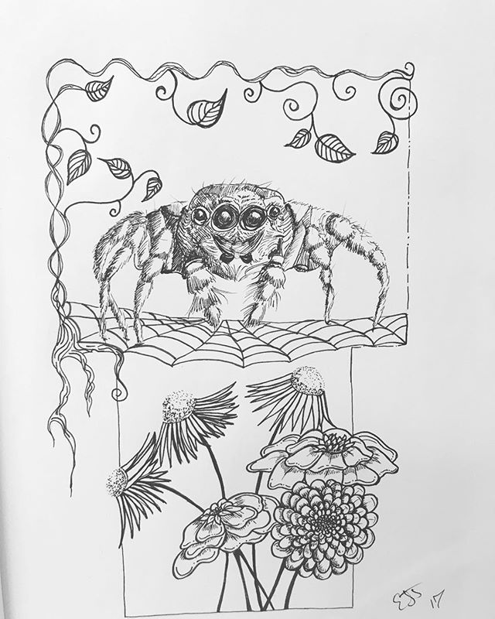
- know you work for Art House, how did you get your foot in the door there? Do you have any other jobs that offset your artwork?
An artist friend mentioned to me that Art House was hiring a Program Coordinator- I had recently graduated from my Master’s program at CSU and wanted/needed a job! They hired me and I have been working there since. I do have to work other jobs even when I became full time as the Program Director. I worked as an artist and social media manager at Wine and Design, a tutor and babysit. I also try to send my art in to various galleries, contests and functions. I definitely keep busy!
Due to COVID things have been slow so though I am working at Art House I am now doing Virtual Learning for a family friend- the two kids 1 st and 3 rd grade are at my home during the school/workday. I am lucky to still be working from home as it has really helped me be more productive.

- How has business been during the past few months with the pandemic and what are you doing to adapt? I noticed you have a make arts and crafts Zoom/Instagram thing going, is this new or did you do this before COVID?
Business has been good at Art House we have really stepped up and tried to make art as accessible as possible due to COVID. We have started doing more virtual programming and have reached over 2000 people with our videos. It has been a new experience for all of us but we really love the engagement it allows.
- If you weren’t an artist, what is another career path you may have taken?
I probably would have been an archeologist. I love history and have been fascinated by the ancient world since I was a kid.

- Of your own work, what would you say is your favorite and why? My recent series combining indigenous peoples and the endangered animals that live near them has been a new kind of challenge that I love. Of the 5 pieces I have made, the Dinka African Elephant are probably my favorite- I love the colors and elephants are one of my favorite animals.

- Do you have a studio space? Can you show us what it looks like? Any tips on sorting/organizing or are you of the mindset that creation comes from chaos like myself?
I do! I recently organized my enclosed porch into my studio- I love it when things are organized. I am the kind of person who creates lists, schedules and has a planner with me at all times. I like order and when I have this in my life it allows mental space for me to be my most creative.

- Lastly: Do you have any upcoming shows, events or projects you would like to plug?
How about a book with your Native American artwork?
I was accepted into the “Art from a Distance” show held by MetroWest- there will be an opening on the 19 th of September with Phunkenship. I am hoping to do a book at some point but I have recently started school to get my Masters in Education which has taken up my extra time.

Upcoming Shows:

Chef-d’œuvre
