Interview with Woodworker:
Gadi Zamir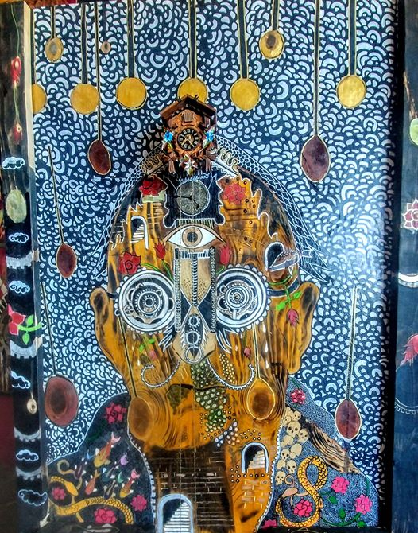
Location Cleveland,OH, USA
Website Gallery Cleveland Negative Space
Facebook Negative Space - Home
Gadi Zamir

Ingredients
- Woodworker
- Painter

Preparation
- Artistic Weapon of Choice: A wood burner, Dremel, and a butane torch.
- Can you tell us more about your artistic process Gadi? I usually go right into attacking my work directly, and I let it grow as I go along. At times, I have a theme, or a topic, which I want to illustrate. I am always amazed how well it falls into place and works with the wood grain, or surface texture.
- Of your own work, what would you say is your favorite and why?
It is extremely hard for me to pick a favorite. I consider all my creations as one large extended family. Even when I sell a piece, I miss it dearly, as if I sent a part of me with it. One piece I have missed especially, was a piece I called “Spill”, an art collector purchased it a few years back. It was very intricate and had to do a lot with my mixed emotions and feelings about my experience as a soldier.
I have always been interested in finding out more about your background and how you ended up in Cleveland from Jerusalem, Israel?
I was born and raised in Jerusalem, Israel, to a secular family in the Kiryat Novel neighborhood. At the age of 18 like most of Israeli youth, both male and female, I was drafted into the Israel defense forces, where I served as a combat soldier for three and a half years. Being a soldier was a stressful experience on the one hand, and very beneficial on the other. On the positive side, I learned a lot about myself, to appreciate and cherish life, and those periods of peace much more. On the negative side, I also learned how life is fragile, and how fragile those periods of peace truly were. Like many children growing up in and around war, I developed PTSD, and would eventually turn to counseling and used my own art as an outlet to cope with my condition, which seemed to take over my life at inopportune times.
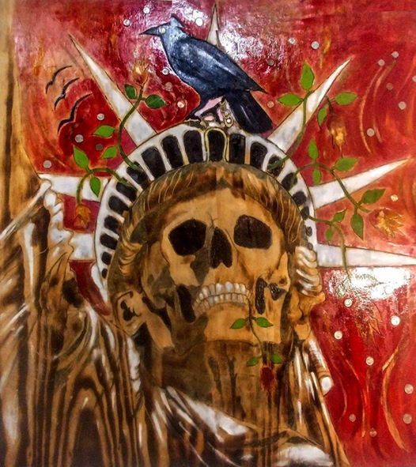After the army, I traveled to the far east, and visited Thailand,Cambodia, Vietnam, Nepal and China. Upon returning to Israel, I lived on a kibbutz, where I met my ex wife, who is the mother of my three children. Her family lived in Cleveland Ohio, and we moved here when our first child was a baby in order to be close to them. I started classes at Tri-C and later enrolled at Ursuline college where I graduated with a Bachelors of Arts in Psychology. Although we eventually divorced, we are amicable and remain friends to this day. Approximately six years ago, I married my second wife, and we enjoy life together, in the Cleveland Heights neighborhood.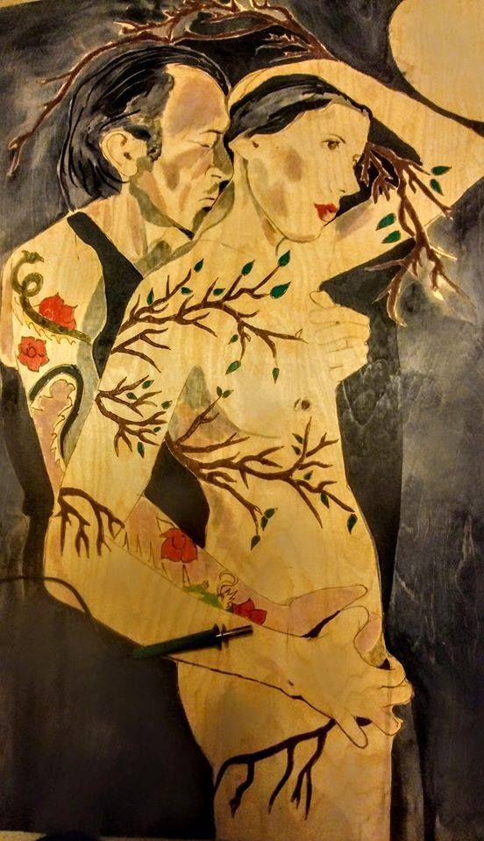
- Do you have a day job?
I am fortunate enough to be a full-time artist. I live very humbly, keeping my expenses to a minimum, so that I can keep engaging in what I love: creating art.

- If you weren’t an artist, what is another career path you may have taken?
Originally, I pursued a degree in Psychology. I wanted to be an art therapist, but disagreed with the fundamental aspects of analyzing art, and to use it as a diagnostic tool. Art should be used as therapy, as a means of expression, not a litmus test for how disturbed an individual is. I would have loved to have helped people to ease their suffering, to understand what we are going through as human beings, and to make sense of the world we live in.
Currently, I’m amusing a thought to gain a certification as a chemical dependency counselor, because I think that it’s a growing problem in our society. Wherever it is, it always hits close to home. It can tear families apart, and ruin lives.
Wow! That is an incredible path you have taken to arrive here. I myself, was very interested in becoming an Art Therapist and was enrolled to attend Urusline before the pandemic.
- Who are your influences, I gain inspiration from living. I can get inspired by a song, a conversation, something I saw, etc. My favorite artist growing up was Salvador Dali, Gustav Klimt, MC Escher, and the entire surrealist movement from the early 20 th century.
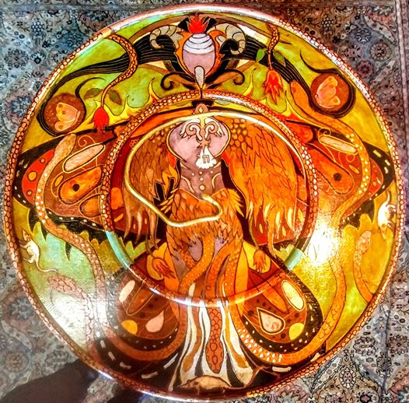
"Infinity Phoenix"
- Some artists only stick with one media or theme at time while others experiment, would you say you experiment?
Everything that I work with is an experimentation in some form of media. I use whatever tools and materials that I can in order to illustrate my ideas.

- Your studio space is also the gallery space you have called Negative Space. How long have you been there and what made you decide to open up your space to help other artists such as myself?
On August 28 th , it will be exactly 10 years since I opened Negative space studio and gallery. As my career grew, and I gained notoriety, I wanted to make the gallery process simpler and more profitable for the individual artist.
I recognized that there were a great many artists who had a lot to share, but no place to share it, and that galleries were charging such high commission, that it would be nearly impossible for a novice artist to start their career let alone sustain themselves. I opened a studio and offered a commission free gallery space, among my own work. It was a passion project, and I financed it by myself, through my day job. Even though I did not get monetary compensation for doing so, I was privileged enough to inspire and be inspired by other artists.
A few years later, we became a full-fledged nonprofit, which follows the same mission statement to this day:
to provide a platform for emerging artists and musicians from the northeast Ohio area. We remain commission free, and run solely on grants, paid events, and donations from the public.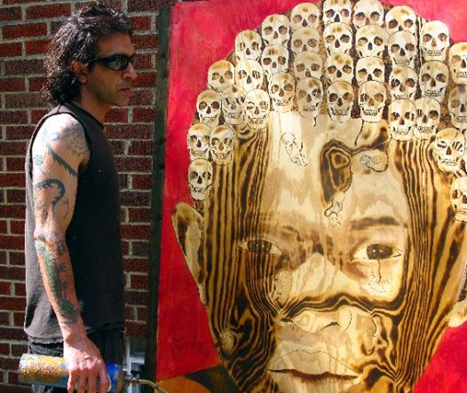

- Would a successful artist such as yourself have advice for underlings trying to break out into the world?
What I find fascinating about art, is that it is one of the only fields that you can have full control over. My biggest advice for upcoming artists will be to be genuine and to create whatever channels through them, without worrying about how it will be perceived by the public or their imaginary audience. Very often an artist will compromise the integrity of their art piece to make it more sellable, or relatable. The only way to be genuinely happy and fulfilled is to get it out and not to censor yourself. Do not let it sit inside of you and rot. Keep sharing your work, even if in the beginning you will not get paid. Remember that even if you do not receive monetary compensation, your work will still be valuable to you and to others. You never know when you can touch someone with your work.
- Lastly: Do you have any upcoming shows, events or projects you would like to plug?
On a personal level, I do have a coming show. I will be having a solo show in the Vue Gallery. For upcoming shows and events at Negative space, you can find out details on our facebook homepage. Since the restrictions are slowly being lifted from the pandemic, we are slowly reworking our calendar to bring our monthly events back in order, which includes, our open mic night, sketch night, and third Friday concert series, and more.
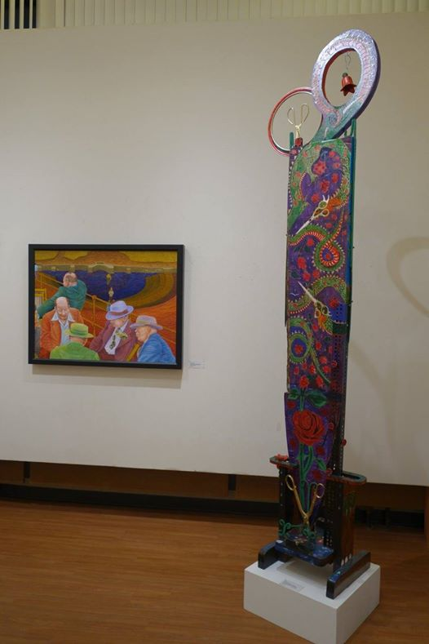
Gadi Zamir's incredible monolithic, "Scissors Head Dragon Trimming May's Flowers" with Joe Stavec's "The Decision was Made" Honorable Mention winner.

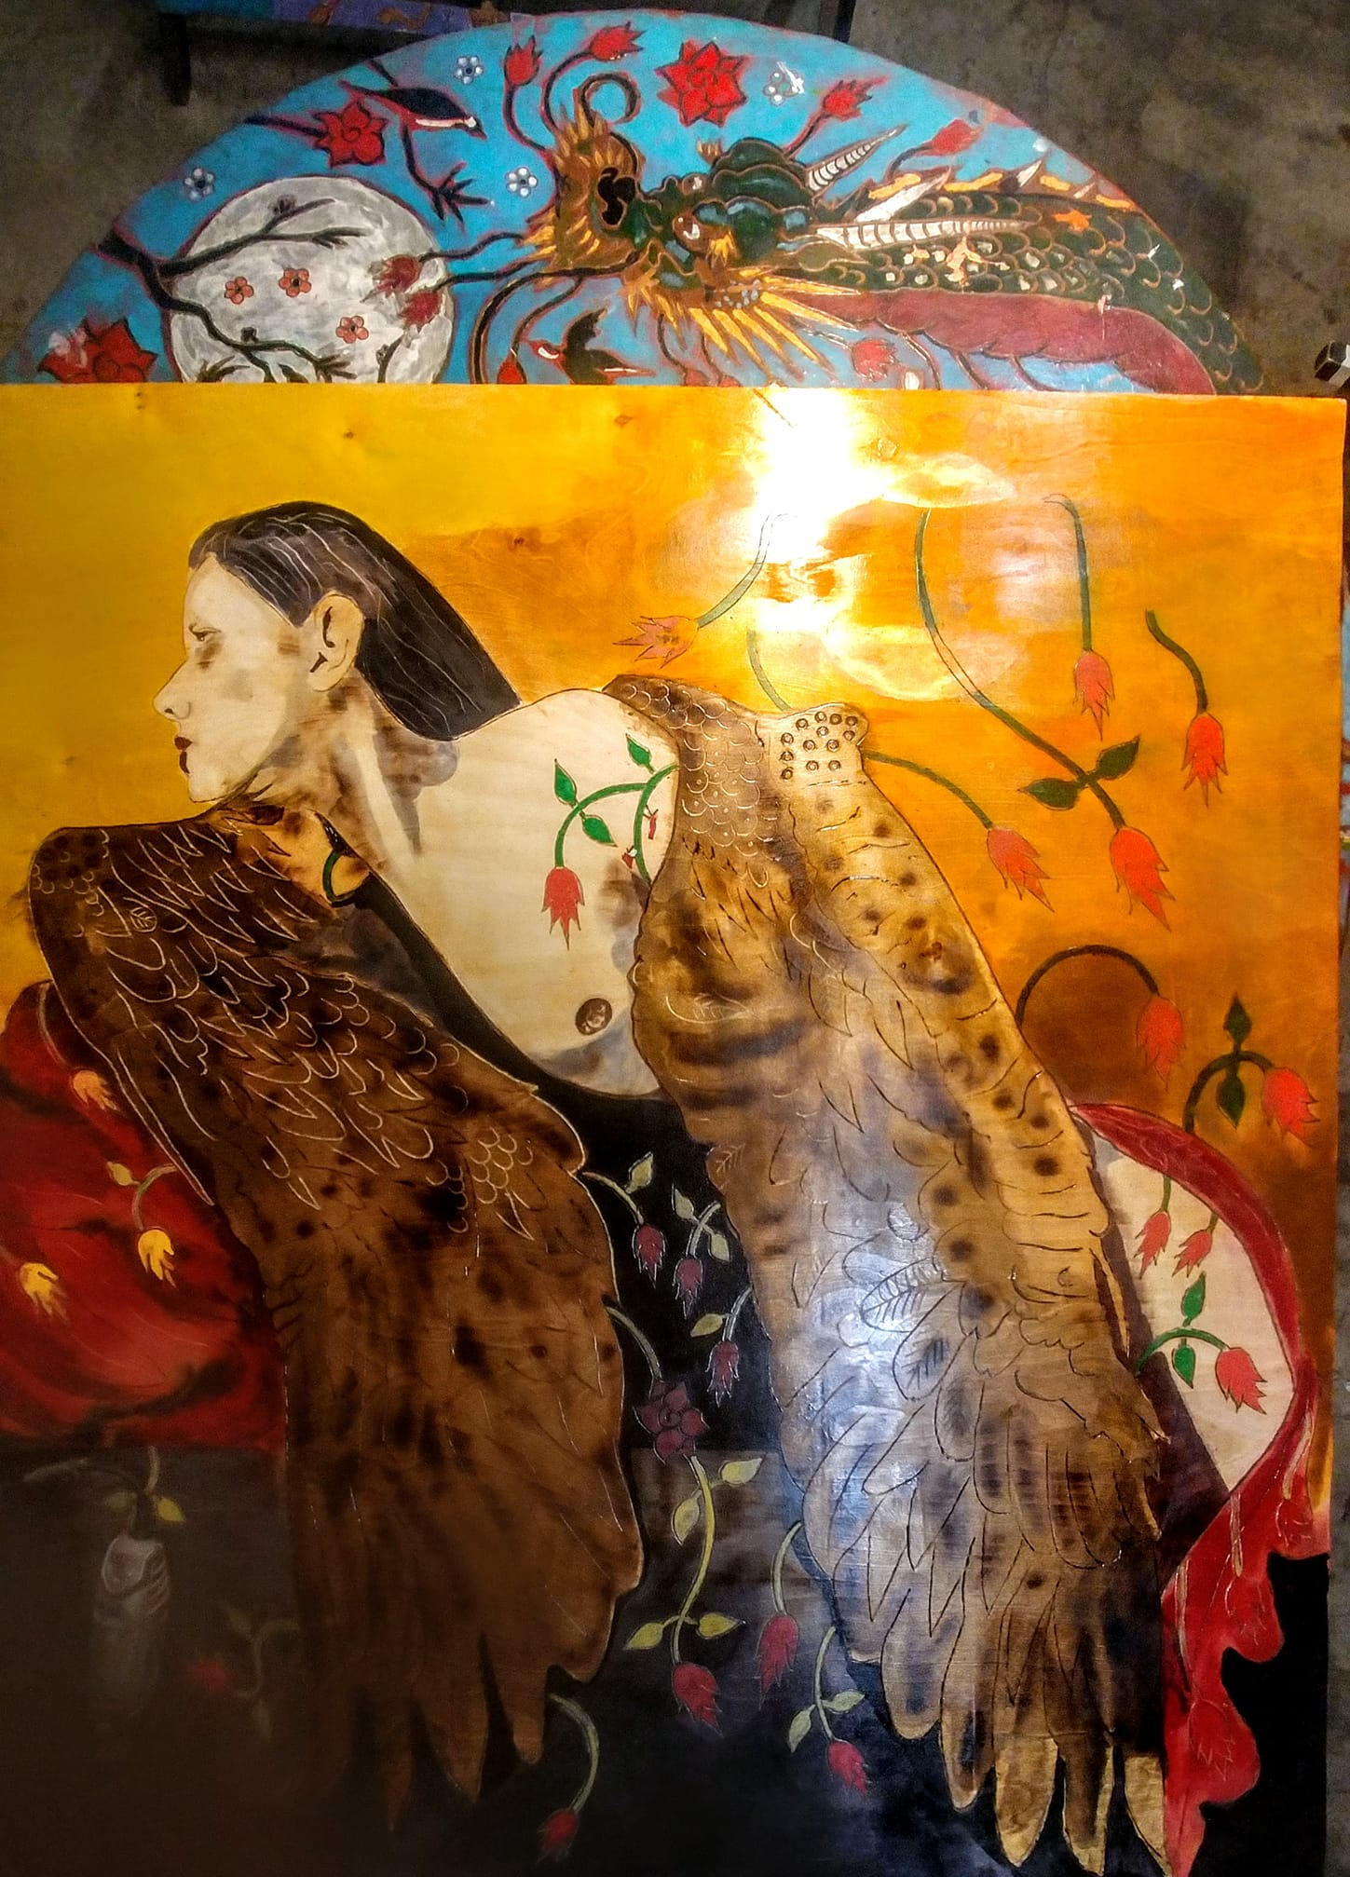View Gadi in action: "Angel in quarantine"

Upcoming Shows:
The Vue Beachwood
23220 Chagrin Blvd Beachwood, Ohio 44122
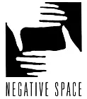
08-10-19 JAM NIGHT
08-15-19 SKETCH NIGHT
08-16-19 THIRD FRIDAY CONCERT SERIES
08-31-19 OPEN MIC NIGHT

Read “Inside AsiaTown's Art Scene” an article in Cleveland Magazine:
Inside AsiaTown's Art Scene

