Interview with painter
Glori Feliciano
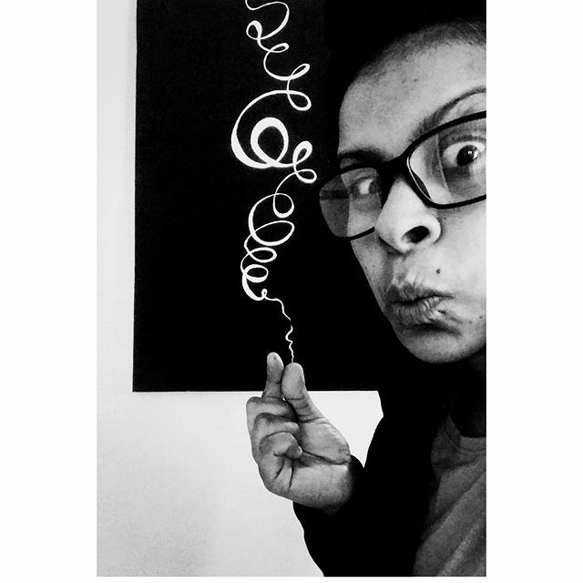
Location CA, USA
Instagram Messy FELICIANO (@messy_curly)

Ingredients
- Painter
- Traveler

Preparation
- Artistic Weapon of Choice? Also if you don't mind telling us about how you approach your work, for example do you create sketches or Photoshop references first, do you go right to attacking the media,
I have to feel it. I have to be inspired by something or someone and then I just wanna paint you. I begin to zoom in on the perspective I’m trying to convey in my art.
- How did you get your start in the art world??
I started doodling as a child, my father was an artist, he tried to push art on me when I was young. I think he saw the potential or his future protege. He died before I could ever show him my true talent. Now art is the air I breathe and because I’ve lost most of my family, art is all I have. I’ve started painting full time in 2016-2017 and I don’t plan to stop anytime soon.
So sorry to hear that. I do love that you are continuing his legacy now!
- How has moving from place to place influenced your work?
Different environments invoke different colors, different views. I’ve been inspired by my Latino culture and so the last series, most of the paintings had Spanish names. And the numbers meant something to me at a special time.
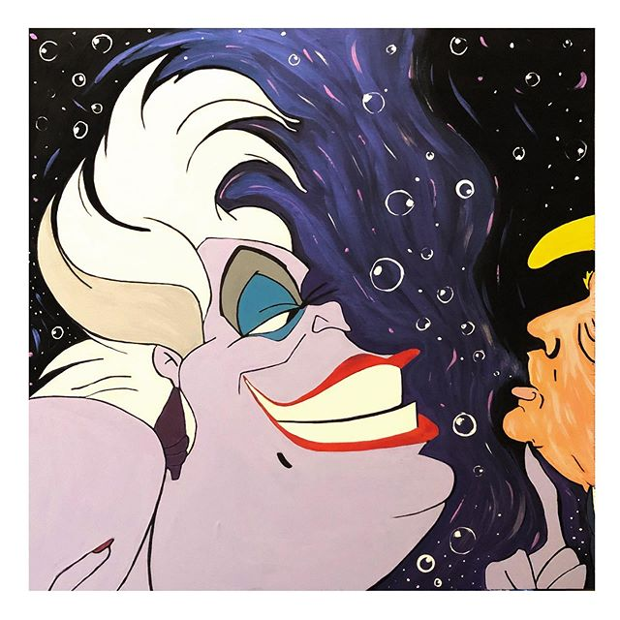Take His Breath Away, 2ft by 2ft , Acrylic on Wood
- Also I believe you used to live in Brooklyn, when we met you were in Cleveland and now you are in California? Are you moves related to your art and finding work
Yes! New York City is my home for life. Cleveland embraced me and loved me and let me do all the art and put it out for the world to see. I owe Cleveland so much. One day, when they write about me, I’ll talk about Cleveland because Cleveland brought my work to life. California has been a bit different especially due to the coronavirus. I had one show and then everything went upside down. I can’t believe we are living in these times where people have to question wearing a mask.
I know, it’s unbelievable! It’s unfortunate that you only got one show out before this happened. Hopefully things will be back on track soon.
- Do you experiment with other art forms and media?
I love oils but because my art sells so quickly, I can’t wait for a painting to dry and then varnish. I work really well with acrylics but I’m good at watercolors and pastels.
- Who/what are your influences? (This does not need to be limited to other artists, if licking lead paint inspires you then by all means...)
LoL. I try to be heavily influenced by older artists who have passed. Frida. Basquiat. Picasso. Kooning. Yayoi! I even painted my favorite artists because I could not stop speaking their into existence while I paint.
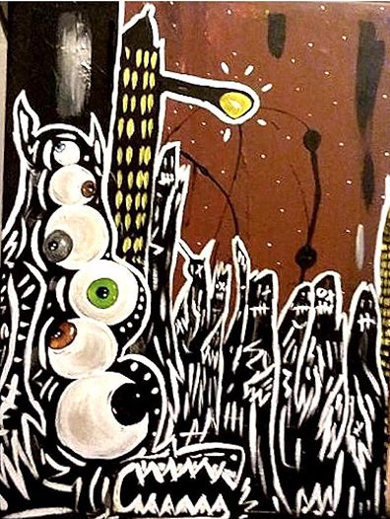Invasion Insane collaboration with @picassoismyrealname
- Do you have a day job or are you able to live off your work?
I work a basic job to help build my brand. I hate it. I love making art. Sometimes, work can tire you out and leave you uninspired. I try my hardest to overcome my daily obstacles so that I can paint my ass off.
- How has business been during the past few months and what are you doing to adapt?
It’s been tricky but I’ve built my art brand online so business is as usual. Not having shows where many people can see my work personally is the hard part. I’ve sold through my heart series and my curly series so now I’m back at the drawing board. And California still hasn’t seen my work. All we have right now is social media.
La Gloria , 18x18, Acrylic on Canvas
- If you weren't an artist, what is another career path you may have taken?
I would’ve been a cop but I think I would’ve retired by now due to the climate of the world right now.
- Of your own work, what would you say is your favorite and why?
I have a painting called 919, it has a total of 982 hearts. It’s the symbol of my birth, it’s also the symbol of birth for my better half. So that painting is like the top of the top and it sold two weeks ago! I cried because I didn’t realize it’s significance until it was gone.
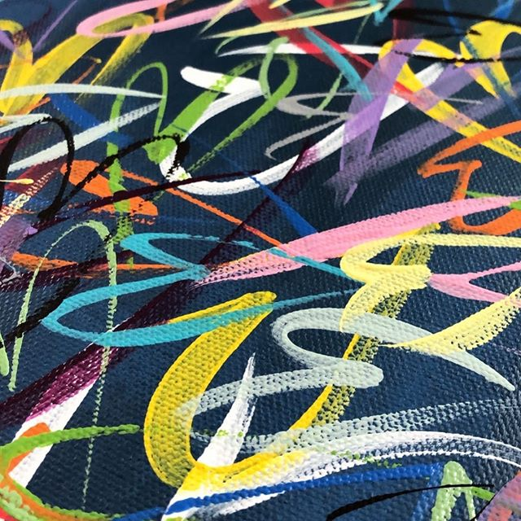
Dirty Denim Detail
So sorry to hear that! Paintings are painters babies! So many do not realize the emotional investment we put into work. But Congrats on the sale!
I also recall being told early on to base your prices on what point you wouldn’t be emotional when they left. That is however, not an easy feet.
- Do you have a studio space? Can you show us what it looks like? Any tips on sorting/organizing or are you of the mindset that creation comes from chaos like myself?
I had a studio in Cleveland but now I’m working out of my apartment. It’s a mess. I’m still getting my life together. I don’t paint with an easel, all I have is the floor and bed. Some of my paintings on the wall.
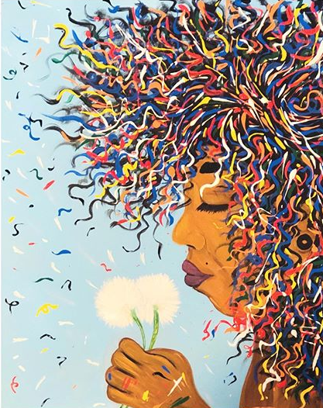
Curls & Dandelions, 16x20, Acrylic on Canvas
- Lastly: Do you have any upcoming shows, events or projects you would like to plug?
I’m still trying to connect with people here and Cali is a different breed. It’s truly who you know here and I don’t kiss ass. Wish me luck!
Good luck! Although I don’t think you need it! When the dust settles you will find your niche and make your mark in the Californaia sands.

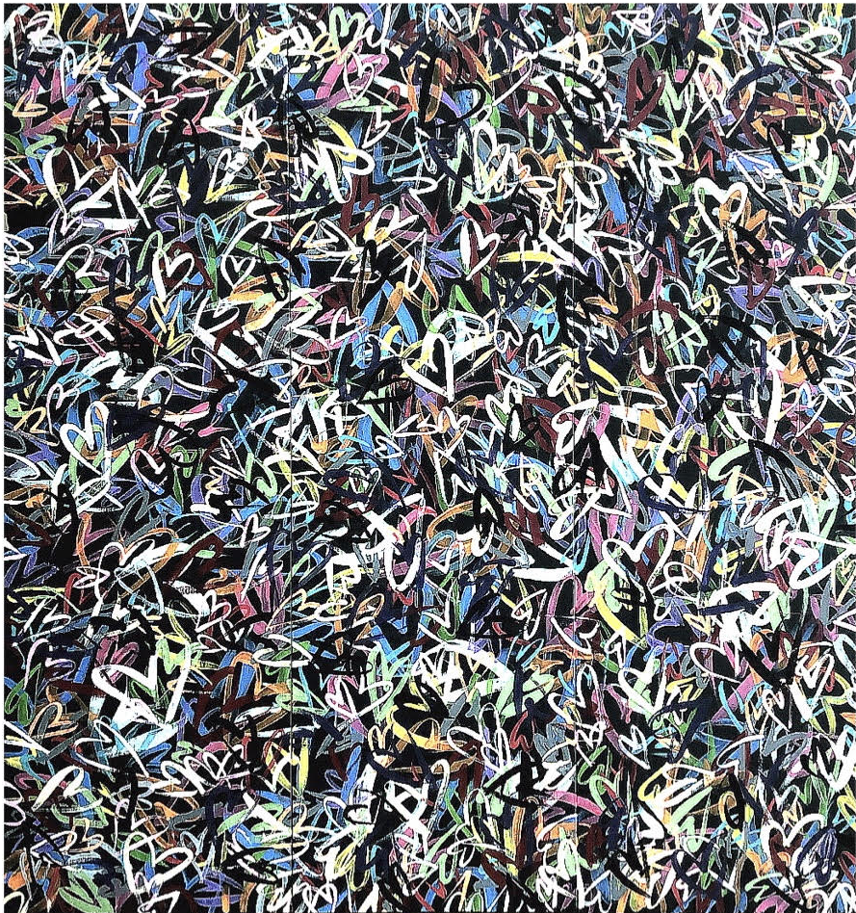919

