Interview with photographer
Jamie
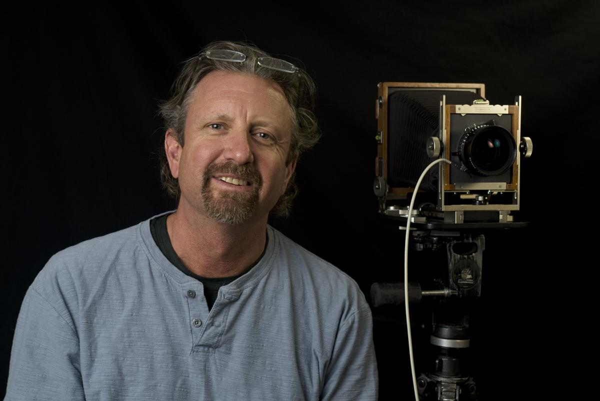
Location Fredonia, NY, USA
Website Jameshoggardphotography.com
Facebook James Hoggard

Ingredients
- Photographer
- Nature Lover

Preparation
- Artistic Weapon of Choice: For me to carry out the art of film photography I need multiple “weapons”
Weapon 1: I use a 4x5 inch view camera with both color and black and white film. I love the quality it gives me, just amazing amounts of detail. The combination of sharp prime lenses (of which I have five) and large sheets of film makes for sharp and smooth enlargements. The camera itself is flexible which means I can correct for perspective and alter the plane of focus. For instance, I can have the flower at my feet and the mountain five miles away in focus at the same time just by tilting the front standard of the camera. Neat stuff!
I got my first view camera in 1996 in a trade for a Hasselblad lens. It was so cool! But it was huge, 10 pounds, and came with its own wooden box and a bunch of accessories – a few of which I still use now. It even had its own camera smell, a mix of leather and old plastic (digital photography doesn’t have a smell, which is too bad!). I have had two view cameras since the first and each is smaller than the previous. My camera is now down to 3 pounds and folds up nice and small(ish). I have taken each backpacking, and am certainly glad not to have that first camera anymore since I am no longer in my 20’s. I bring my camera to art festivals and am often asked how old it is. They are always surprised and maybe a little disappointed that it was bought brand new in 2012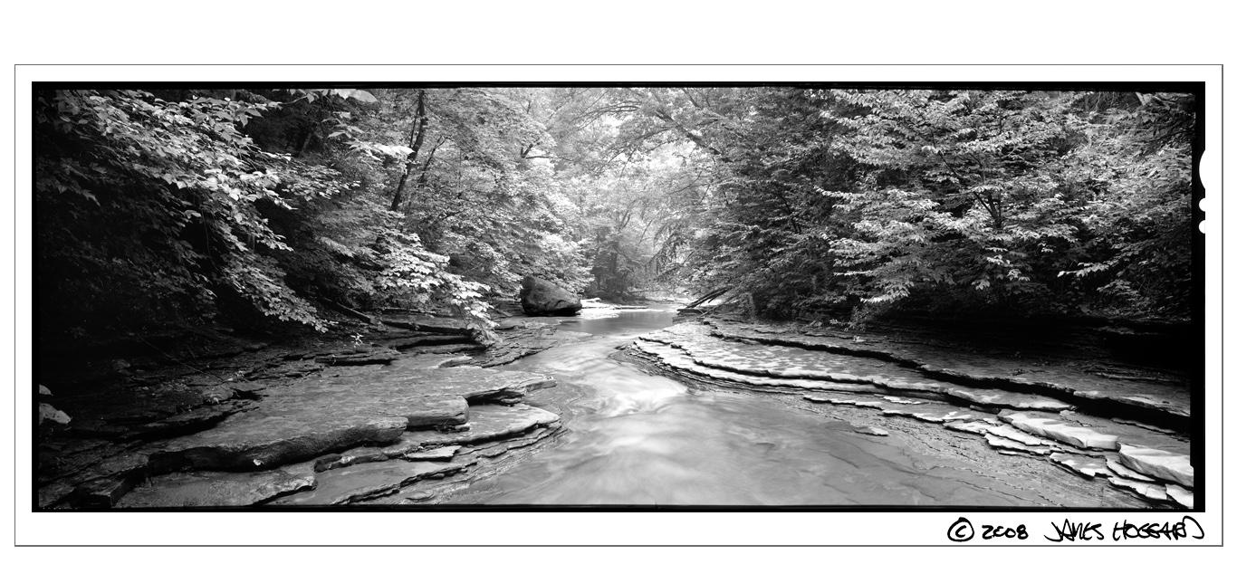
Weapon 2: The film shot with Weapon 1 is then brought to my film scanner to be digitized. The scanner I have is the high-end Howtek HR8000 Drum Scanner and it is capable of high-resolution scans that are very sharp. It allows me to choose from several apertures based on the size of the film grain in order to reduce pixel noise. In other words, it allows sharp yet smooth high-resolution scans. The film is mounted to an acrylic drum in a unique way; with oil, mylar, and tape. The drum then spins very quickly and passes a light source where the film is scanned slice by slice.
Weapon 3: The now digitized film is brought by flash drive to a more modern computer and the rest of the photo manipulation is done in photoshop. Prints are made with an inkjet printer on cotton rag paper.

- If you don’t mind telling us about how you approach your work, for example do you take several shots or wait for the perfect moment?
With that camera I use, I can’t take many pictures of the same thing like I do with a digital camera (which I also use). It is simply too expensive. I have to be more deliberate and shoot scenes that I know will likely have high rates of success. With color film I might take two shots of a scene that I am not super positive of the exposure. With black and white film, I will most often take one exposure unless I am trying different looks with different contrast filters.
I look at weather reports to choose days that will most likely fit with the subject I plan to shoot. For instance, if I’m looking for spring flowers, I’ll hope for a cloudy and windless day, maybe with some drizzle as a bonus. There is nothing worse than being set up on a nice clump of White Trillium and having the sun come out. The flowers disappear in the contrast. For a sunset at the beach, it’s the opposite. I want the sun, low in the sky, lighting up the waves with its warm contrasty light.
- How did you get your start in the art world?
I got a few photos framed and put a bunch of prints into simple bins and started attending local art shows like Victorian Dazzle in Fredonia and Art in the Park in Westfield. I had homemade displays and no canopy. The first time I made $500 I thought I had hit the jackpot. In 2009 I was accepted into the Clothesline Art Festival in Rochester, so I had to spruce up my image with new displays (still homemade) and a decent tent. I added more shows in the region as my confidence grew, but Clothesline is still the best show for me to this day.
- Do you experiment with other art forms and media?
Nope
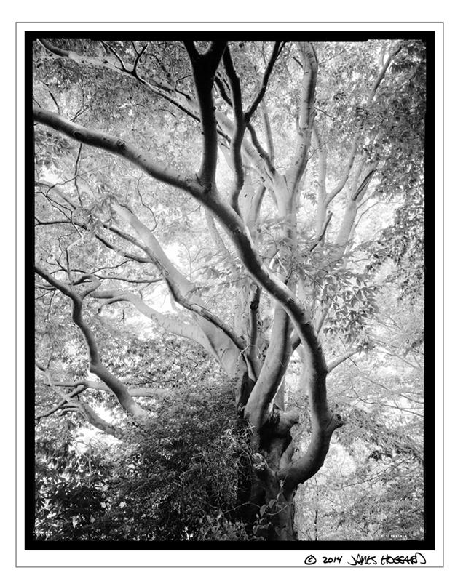
- Who are your influences,
I have to be boring here, but Ansel Adams is a big influence because he was interested in a lot of the same subject matter and he had black and white view camera photography down to a science. In the 90’s there were a few photographers who worked in color with view cameras whose work I really respected. Namely, David Muench, Carr Clifton, and Larry Ulrich. They all did amazing wilderness landscapes.
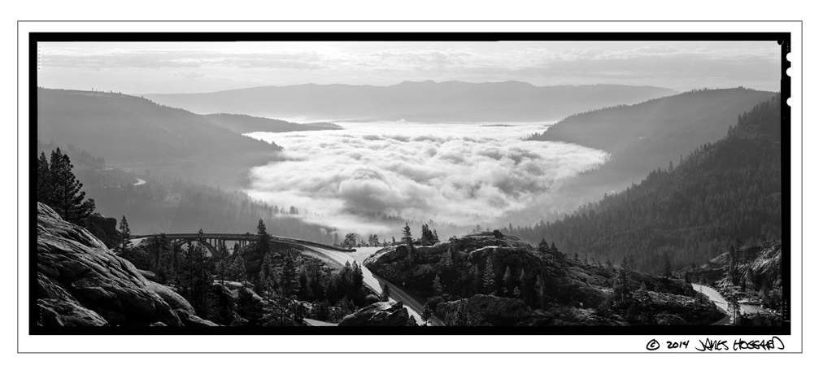
- I believe you are a full time photographer? If not what do you do to supplement your
I am a full-time photographer, but I don’t just do the fine-art style photography that brings me to art festivals. I also work for other artists, mostly painters, who need prints done of their work. I have also photographed pottery, sculptures, and furniture. Once in a while I will do portraits or other assignments. This is all done with a digital camera.
- How has business been during the past few months and what are you doing to adapt?
Business was dreadful in 2020. All my shows except for one were cancelled. I have been adapting by getting to know my digital camera better since I can’t afford to shoot film without as much money coming in. I’m hoping to be more marketable for assignments and more people-related photography and relying less on art festivals.
- If you weren’t an artist, what is another career path you may have taken?
I graduated college with a degree in Geology and I did work related to that for many years. I could theoretically go back to doing that if I had to. But if I had that to do again, I would choose to study geography and pursue a career in climate or weather or GIS.
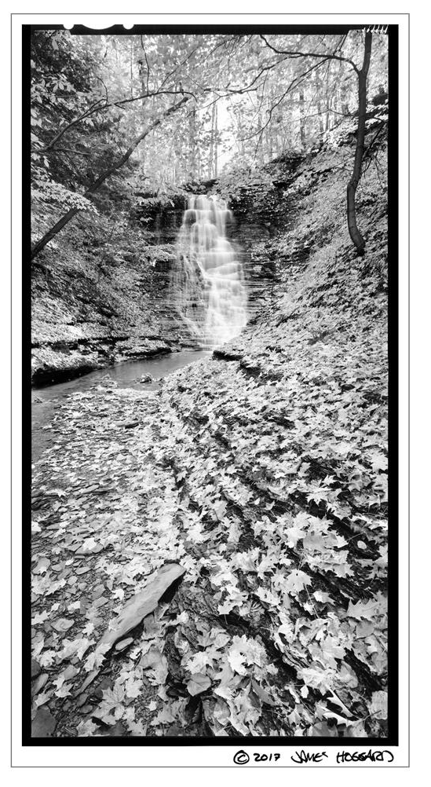
- Do you have a favorite photograph that you have taken? Or maybe a favorite place/thing to photograph?
I suppose my favorite places are those where I have taken my favorite images. I like that place on Canadaway Creek with the layered rocks where I took the boulder image. I like Sheridan Falls because it’s beautiful and I have many shots of it that I like. I like Eagle Bay on Lake Erie for its sunsets and icy cliffs. I like the SUNY Fredonia Campus Woods because it is the first place to have spring wildflowers in this area and it gave me the image of the Beech trees. But nothing beats Sequoia National Park and the rest of the Sierra Nevada for its incomparable scenery and endless opportunities for exploration.

- Do you have a studio space? Can you show us what it looks like? Any tips on sorting/organizing or are you of the mindset that creation comes from chaos like myself?
I do have work spaces in my home, but they are not what you could consider an example for organization and cleanliness. Sorry, can’t help you there…

- Would a successful photographer such as yourself have advice for underlings trying to break out into the world?
I guess successful is a relative term…
There is so much information out there these days about how to do all kinds of photography on the internet. Start watching videos about how to do the nuts and bolts of whichever kind of photography you are interested in. Get to know your camera about what it can and can’t do, but start with what you have. Shooting digital means you can keep pressing the shutter, seeing your results, and correcting your mistakes on the fly. The days of not seeing the mistakes you made photographing a far-away place a few weeks ago until you get your film back are officially over.

- I know when I last saw you, you were at Cain Park, I think it was in the Cleveland area selling there. Do you have any upcoming shows, events or projects you would like to plug?
This is the time of year when I start applying to outdoor festivals for the following spring, summer and fall. Right now, I have only one show on the books, but I believe most of my shows that were cancelled last year are simply letting the artists who were qualified for their show to reapply and be automatically accepted.
- I know what draws me to cemeteries but I am wondering what about the cemetery tickles your fancy?
I like the Foresthill Cemetery in Fredonia for its old weathered headstones and their history, but I keep going back for the big old trees. In fact, it has some of the biggest trees I have seen anywhere around the area. There is a tulip tree that looks like a sequoia. It is so big. The stone buildings at the entrance are also beautiful and unique. The cemetery is across the street from my home so it's an easy place to catch fall colors on the big maple trees and spring blossoms on the many dogwoods.

Upcoming Shows:
Chautauqua – Lake Erie Art Trail: Memorial Day weekend and Labor day weekend
Allentown Art Festival (Buffalo)– June
Cain Park Art Festival (Cleveland) - July
Clothesline Art Festival (Rochester) – Sept
Gaithersburg Art Festival (Maryland) - Nov

Chef-d’œuvre
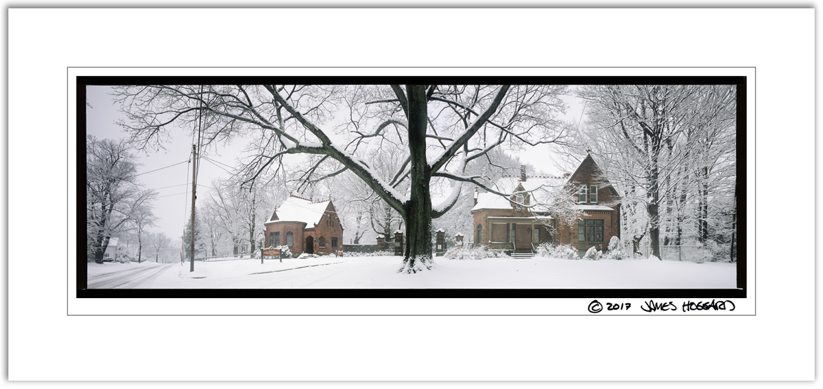
Forest Hill Cemetery in Fredonia, NY

