Interview with Crafter
Jason Braun
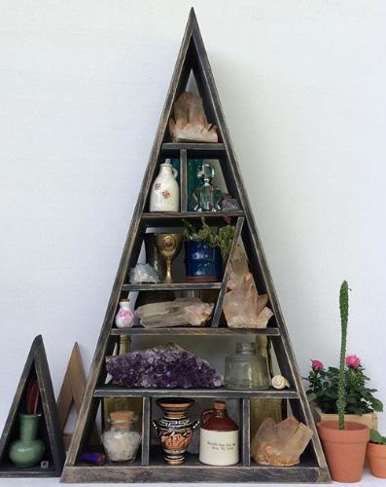
Location Lockport, NY, USA
Instagram: @jasonbraun

Ingredients
- Crafter
- Plant enthusiast
- Mental health Care Aide

Preparation
- Artistic Weapon of Choice: It’s kind of difficult for me to choose one thing! I’m a bit of a dabbler, when I see something new I usually want to try doing it. Most recently it has been wood though.
- How did you get your start with woodwork? I think it had a lot to do with the fact that it was just around me. Growing up my dad always had scrap wood laying around in the garage that I would play around with. Then one of my first jobs was in a home improvement store, so again it was just around me. The construction of stuff always interested me as a kid, so I guess wanting to build things was just innate.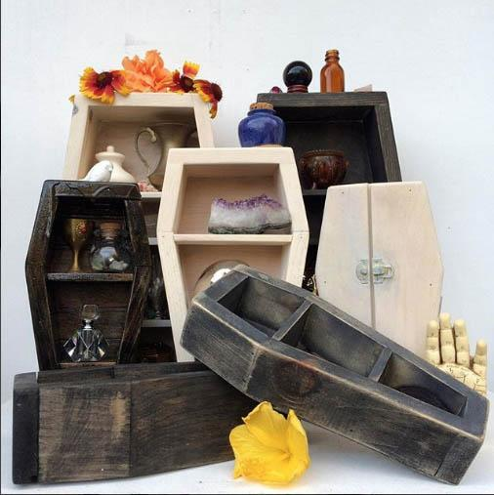

- Of your own work, what would you say is your favorite and why? Right now it has to be my mini triangular shelves with double drawers in them. I love stuff with drawers for some reason! I like to thrift and collect Knick knacks, so it makes a good little altar to display and store any mini treasures.
I of course am a big fan of your coffins :-) You have a bit of a green thumb, I am wondering if that plays into your work at all? Absolutely! I’m very passionate about horticulture and love taking care of and collecting plants. It definitely plays into my wood work a lot. I’m always building stands and displays for my plants. I’m very inspired by Japanese bonsai and Kamidana, so I love to rearrange and display things.
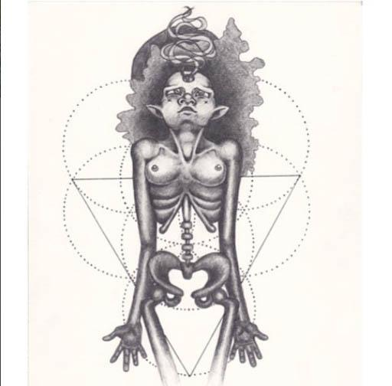
- Who are your influences, I really love Esao Andrews paintings. I might not paint as much as I would like to, but his subject matter is so eclectic and weird. It’s not hard to feel inspired to make things after looking at some of his work!
- Do you have a studio space? Can you show us what it looks like? Any tips on sorting/organizing or are you more of creation comes from the chaos like myself? 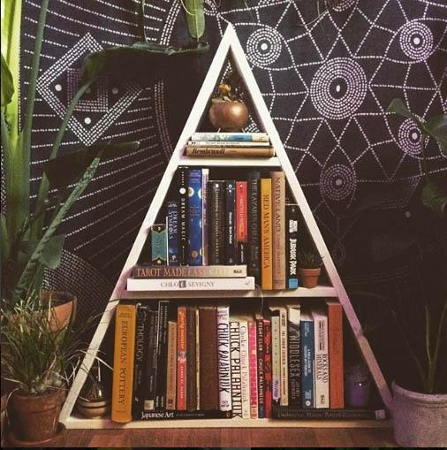 The closest thing I have to a studio space is my garage right now. This is actually one of the main reasons I work so much right now, I really want an old Victorian home with a finished attic space that I can use as an art studio. I know that’s weirdly specific but it probably ties in with my fascination of construction and wood work! I’m a very organized person by nature but I absolutely find creative inspiration from chaos and disarray. I think that’s why I love thrifting and upcycling old wood so much. you can find something in a mess, something that might be garbage to someone else, and turn it into artwork. I had a professor that said using black matte board to frame out artwork was a copout because anything looks good in black matte board. But I love that! Anything can look good and be artwork if it’s presented and displayed carefully and with some effort.
- Do you have a day job? I know at one point you were working at the hardware store and I think you were able to play with some of the scrap supplies from that? Yeah, currently I work full time in a gym and part time at a mental health care facility. At this point in my life my artwork has really been kind of put on the back burner. I find ways to stay creative but it’s difficult to find time to make art for the sake of making art right now. I’m hoping that by being so busy and working a ton right now, it will secure me more free time in the near future to start creating art again. 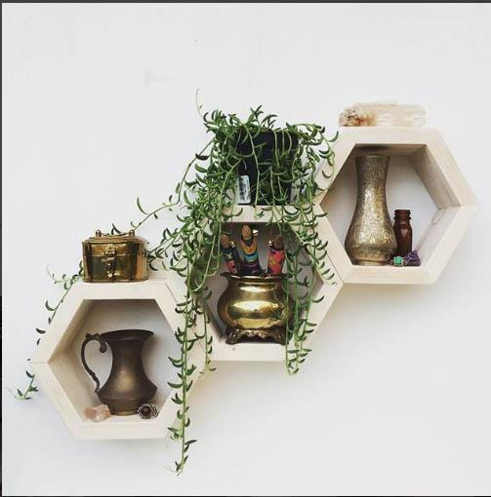
- If I recall you are Native American? Does that play a part in your work or artistic process at all? I think it does! I think it’s very important that I don’t market myself as a native artist though. My mother grew up on the Mohawk reservation in Canada but I myself am somewhat removed from that culture. I’m biracial and grew up off the reservation with minimal participation in any real native traditions. Im white passing and I don’t think it would be appropriate for me to try and claim that niche and put myself in the same category as people who still practice traditional crafts and keep them alive. That would be a complete injustice to real traditional native crafters. I don’t share the same struggles, adversity and hardships as my native family on the reservation, and I think those are powerful things that can influence a person’s art. My family’s culture is something I am very deeply proud of though and I think the core values and beliefs of indigenous people shows in most of my work. My crafts and art feel very feminine and nature inspired, and I think that undeniably comes from a bloodline that was historically matriarchal, and nature worshiping.

Upcoming Shows:
I currently don’t have any shows or events coming up since I’ve been kind of out of the art loop lately. I bought my first home last year so all my creative energy has been put into remodeling and fixing it up to hopefully resell it in a couple years. Right now I’m working on turning one of the porches into an enclosed sunroom for all my houseplants.
If someone wanted to purchase something from you should they just browse your Instagram?
As for selling my work, instagram is the only place I somewhat regularly use. My Etsy career was short lived and unsuccessful and I really don’t make things with the intent of selling it, BUT if anyone ever finds them self interested in something I made I am always open to offers and art trades.
