Interview with photographer
Laura D’Alessandro
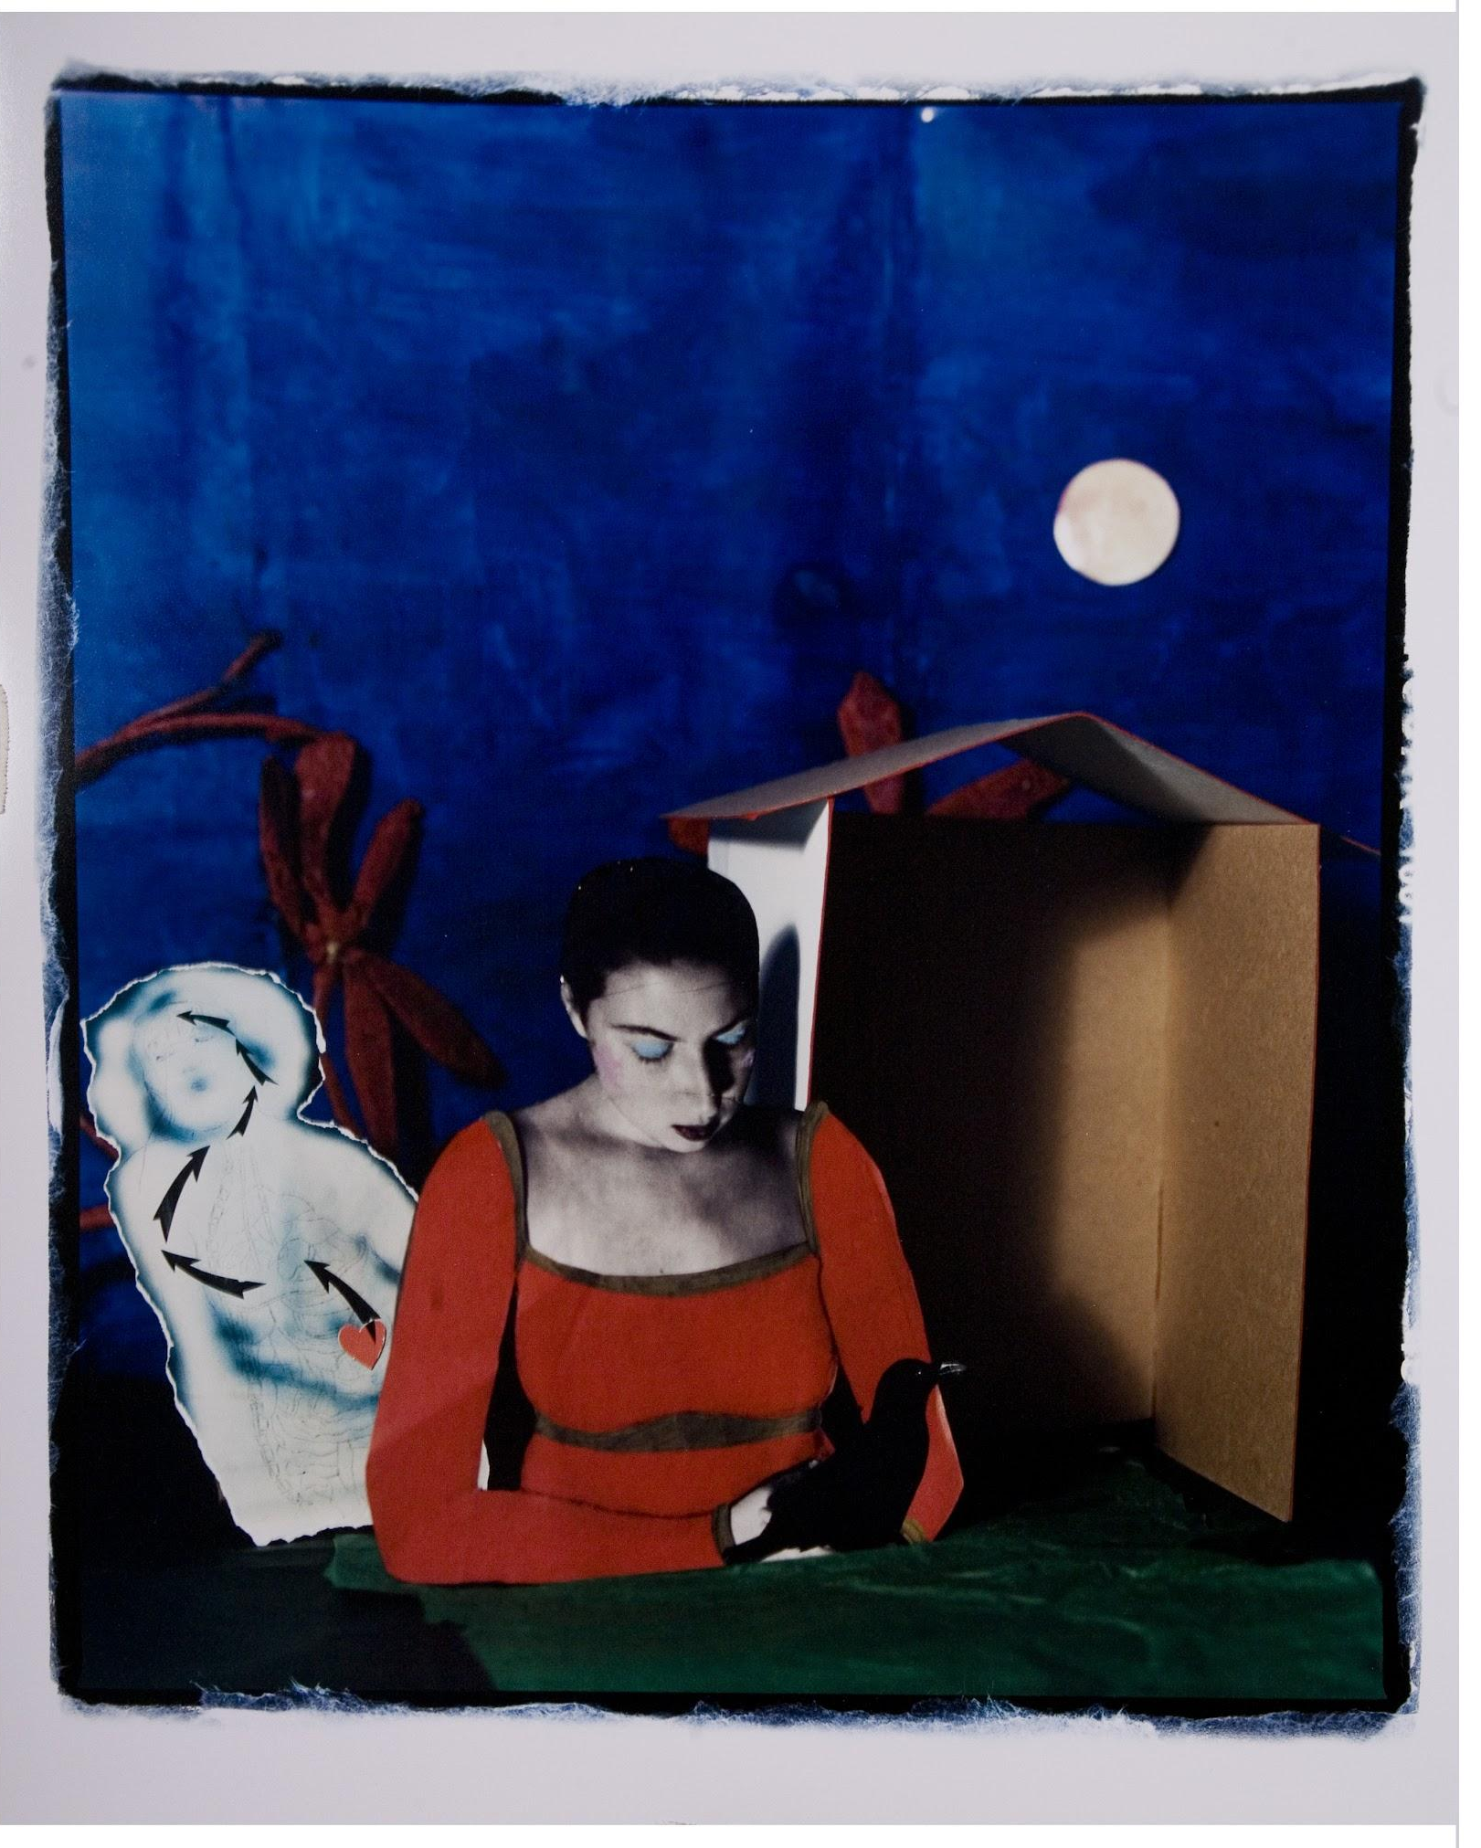~Chrysalis (Summer) self portrait
Location Cleveland, OH, USA
Website Laura DAlessandro Photography
Instagram @laura_d_alessandro_photography
Facebook laura.dalessandro.56

Ingredients
- Photography
- Photo constructions
- Nostalgia

Preparation
- Artistic Weapon of Choice?
If you don't mind telling us about how you approach your work, for example do you create sketches or Photoshop references first, do you go right to attacking the media, etc...
Laura: I am a very visual person. I love to "fill the well" on a daily basis. I used to pour over books in the library for inspiration. Now...we have Instagram, which is a wonderful tool for that. I do still subscribe to Raw Vision magazine, however, and have my personal collection of art/photo books to look through. I usually get ideas from these visuals, or work directly from my journals/sketchbooks. It evolves from there.
I am such a packrat--I have so many bits of materials to work with (and I do!). I have been using my mobile phone as a "sketchbook" of sorts--it is a quick and creative way to document my world and wrap my mind around these crazy times we are living in. I try to be mindful everyday--looking at my personal space and the world with fresh eyes. It motivates me so much!
- How did you get your start in the art world?
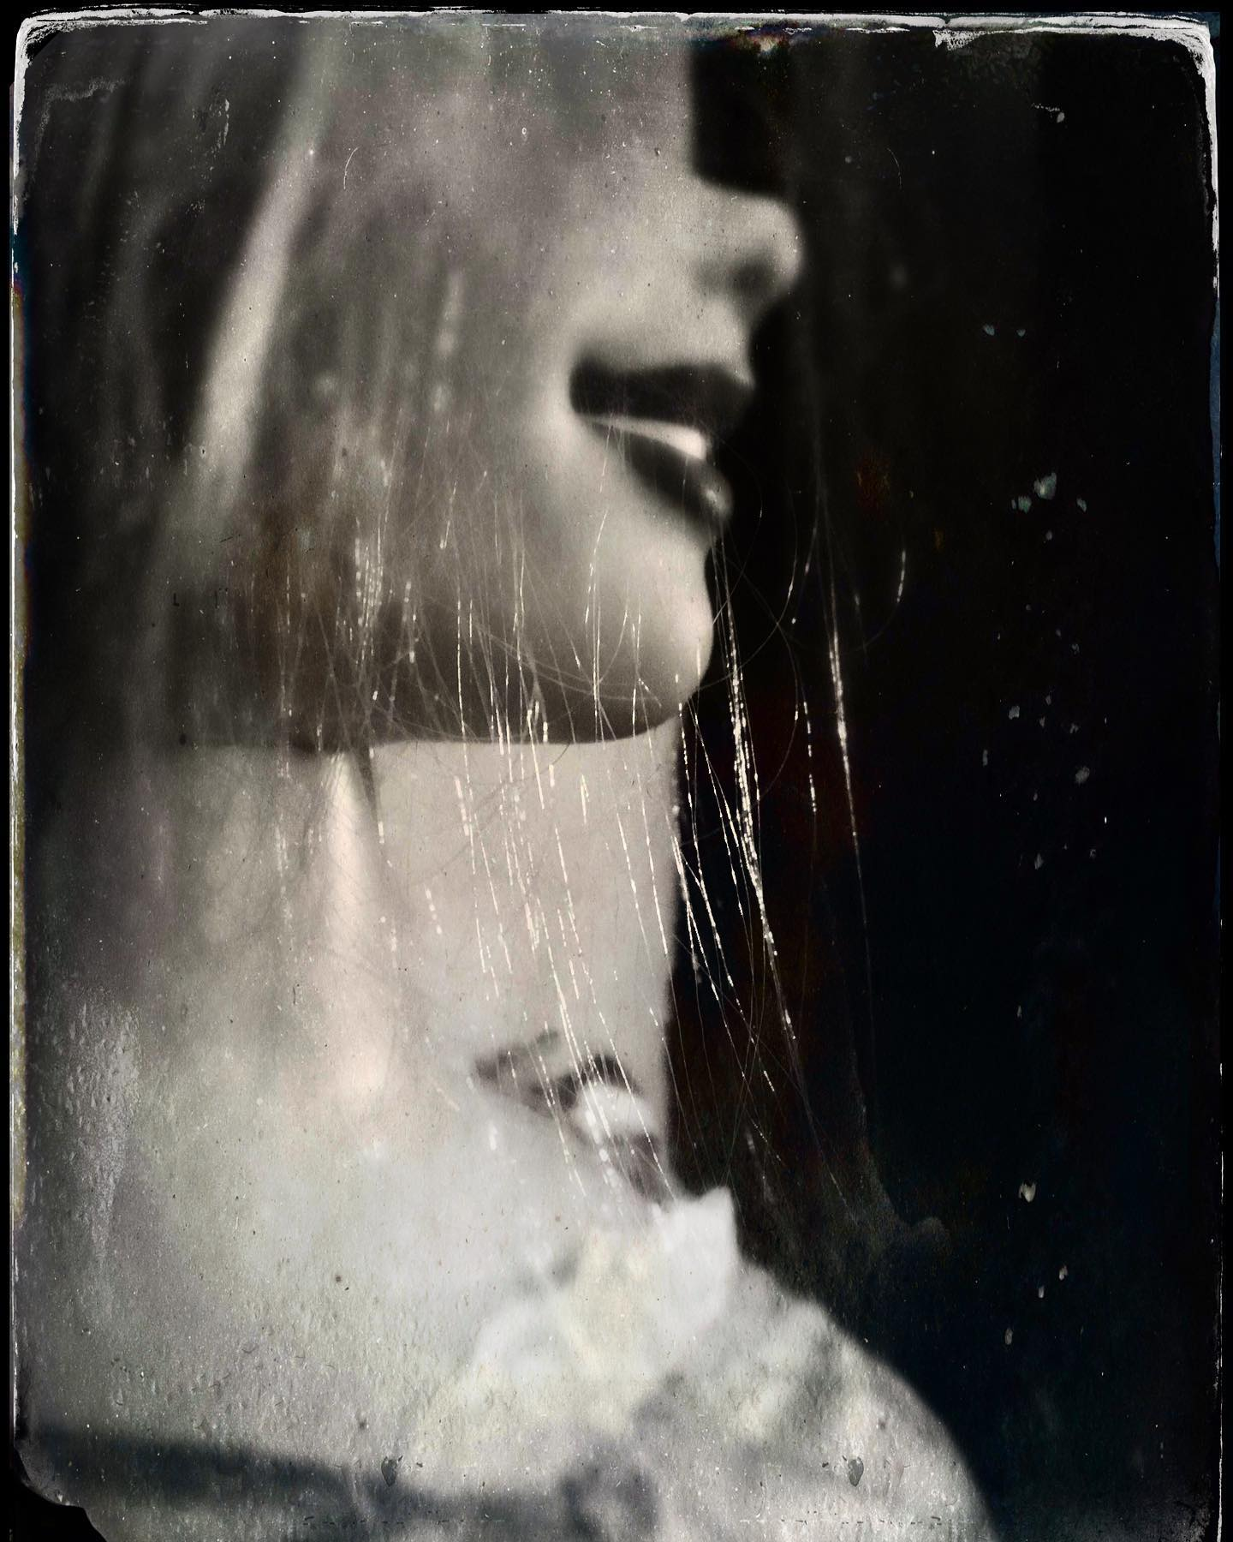
Rapunzel
Laura: I have always been interested in art, since as long as I can remember. I used to make little books with drawings and stories, and have kept a journal/sketchbook since age nine. I guess I used to draw on my sister and the walls when I was little, too. ;) We never had art in grade school--maybe about three crafts per year (for holidays or what not). I went to a Catholic school that was so focused on religious studies and sports--we never had art or music. It's a wonder I ever got into art at all. But, perhaps, that drove me towards it more--I am a stubborn Leo.
My first high school wasn't much different--we had limited art instruction. I remember the art teacher once told me I should be a "coloring book artist" (because I had NO clue how to shade anything, and I stuck with outlines). Thankfully, I transferred to Beaumont School, which had a very strong art department. They were very supportive of me and I was able to get a strong portfolio together, and was ultimately accepted to art school for college. I was torn between art and medicine (did I make the right choice?? hehe).
Also, I give my design teacher at the Cleveland Institute of Art (CIA), Richard Fiorelli, a ton of credit, for teaching me to approach my art with professionalism. Most of my teachers at CIA and The School of Visual Arts, NYC, have taught me a lot. 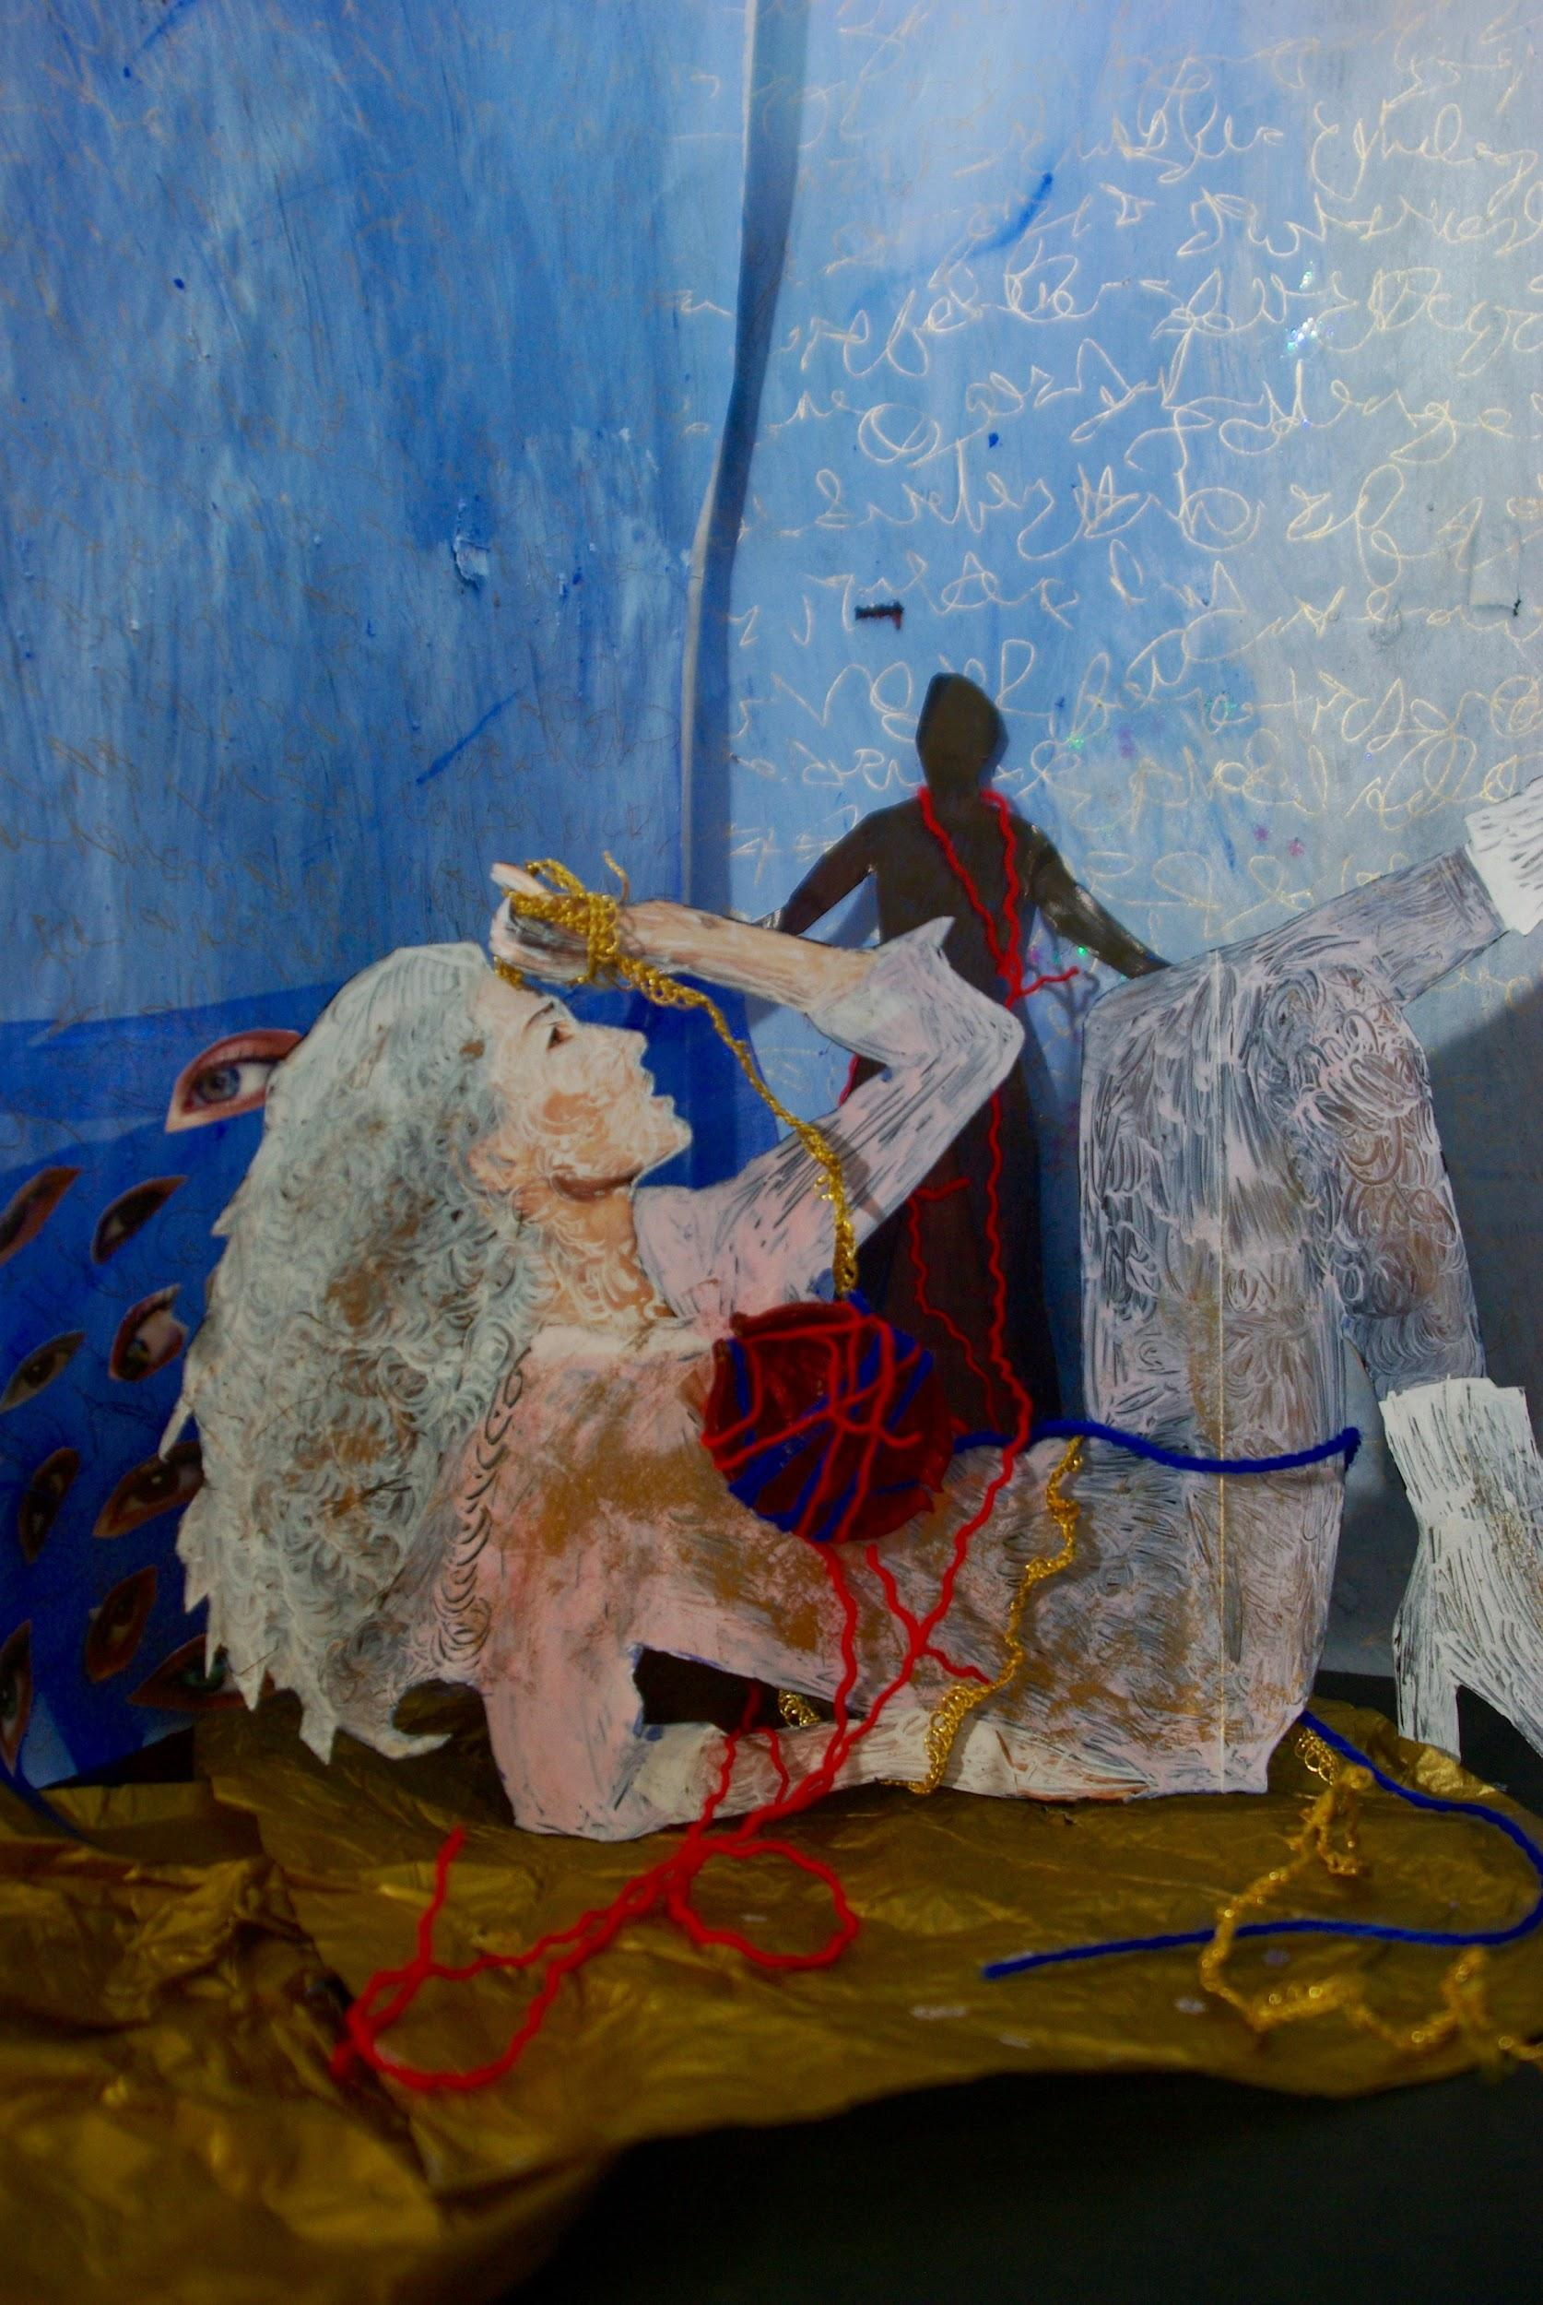
Quixotic Heart
Richard Fiorelli, I’ll have to look him up!
- Do you experiment with other art forms and media?
Laura: I use a variety of art media within my photo constructions. I always joke that I have to get my $ worth from attending art school. My photo constructions are like my little stage sets (I was told I should be in theater, but I was too shy for that). I have often used myself as characters in my photo constructions, so in a way, I feel like I still am involved in theater.
Many elements make up my work--drawing, painting, collage, sculpture and puppetry... which I ultimately rephotograph. I still love to draw and write. I have been pretty absorbed by automatic drawing and writing within the past few years. And, I have a drawing group that I attend on Fridays (put on hold for now). Also, I have been photographing people in my life with my vintage twin-lens camera for 30 years now--I will have to photograph you one of these days soon. .
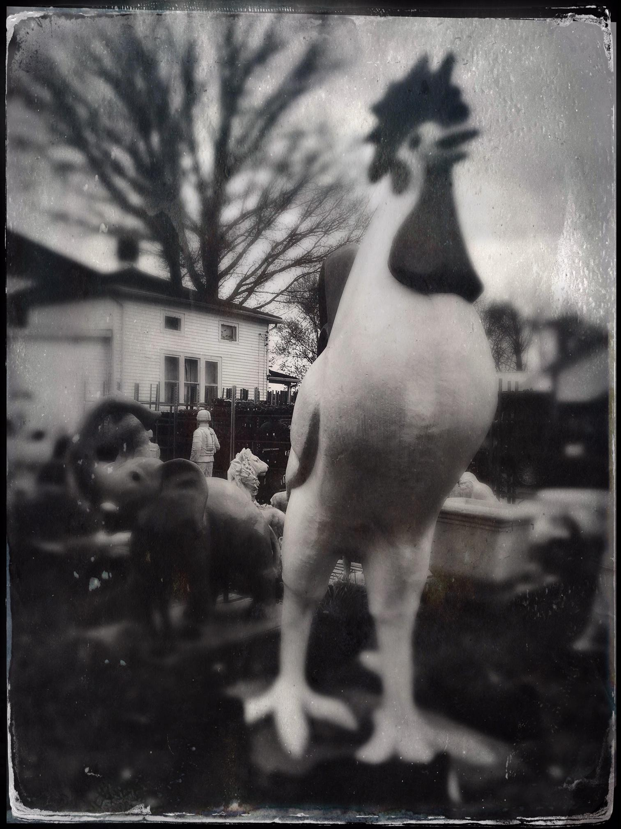
Creature 3
I used to attend The Murray Hill Art Group regularly before this all started.they do Zoom now though! Photograph moi? Looking forward to it!
Also I do see the theatre influence
- Who/what are your influences? (This does not need to be limited to other artists, if licking lead paint inspires you then by all means...)
Laura: Wow! Where do I start?? EVERYTHING inspires me!!! I do miss traveling--that was (is) very important to me--hopefully someday again soon it will happen. Like I mentioned earlier, I have my Raw Vision magazines and art/photo books on hand. Raw Vision is a magazine featuring outsider/visionary art. This has always been very inspiring to me--the fact that these (mostly untrained) people would do art solely for the passion of it--without the overarching aim of becoming famous or concerned with the drama and business of the traditional art world. I love to look at automatic drawings and writing (especially Austin Osman Spare) and spirit photography. I love seeing other artists' sketchbooks.
Collage has always inspired me--especially Romare Beardon and Hannah Hoch. Vernacular photography and stereoscopic images have always inspired me, as well. I find the intimate portraits of Dorothy Norman intriguing--going against the norm that "bigger is better." Often I find that going to a museum/site with something entirely different than art will inspire me--medical or natural history museums or visionary art landscapes. Film (most especially Czech animation). Food. Writers and writing. Music (and maybe dancing at The Chamber gothic dance club on occasion-hehe).
Why am I just now hearing about this club?!
New Orleans (where I lived for 8 years) and the urban brass bands there. Pretty much anything with an element of passion attached. And, of course, I am inspired by my friends in the Cleveland art community (including YOU!). Also, my dear friend Stephen Kasner (RIP), who gave me a kick in the butt to start creating my art again after several years struggling with cancer treatment with a baby in tow. I haven't licked lead paint yet though, fortunately.
Sorry to hear about the cancer :-( I’m so happy you are here today to tell us your story though! Kick ass woman!
And your work has inspired me to! It was hard at first to find the community in Cleveland, but once I got there, I knew I was part of an artist family!
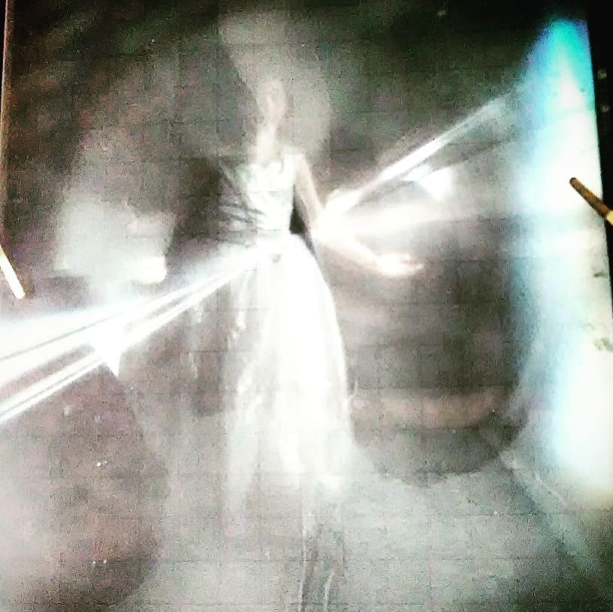
Sabina
- Do you have a day job or are you able to live off your work?
Laura: This is a complicated one. I loved both my graduate and undergraduate schools, but I still have an issue with the fact that they never adequately taught us about business. They made it seem that if we were talented enough, galleries and opportunities/jobs would come to us. This just isn't so--at least not for quite some time. It took me many years to learn anything about business on my own. I was a professor and educator in New Orleans, Minneapolis and Cleveland. Being an adjunct professor was not worth it to me based on the stress/pay to the ratio of the work.
For some reason, I tend to work quite a bit on a volunteer basis. I am an advocate for breast cancer survivors; I still teach and write a bit; I am a curator and also the co-curator of Prama Artspace and Gallery; I have worked with puppetry and instillation; I have sold work to various museums and collections/collectors; and, I am one of the directors/founders of the Cleveland Photo Fest, a non-profit (along with Herbert Ascherman Jr and Jim Szudy)--sometimes these gigs pay; sometimes they don't pay. I am working on that. Any suggestions?? ;)
Um no, sounds like you’re already spinning plates!
- If you weren't an artist, what is another career path you may have taken?
Like I mentioned earlier, I was interested in medicine, but the art won out. Maybe being queasy at the sight of blood isn't a good sign. I suppose I could have gone into nutrition, genetics or ophthalmology--those fields always interested me. My 8-year-old daughter told me that she would like to be a scientist. I am all for that--perhaps she will come up with the "cure" for breast cancer.
I hope your daughter does what she loves and maybe you’re right!
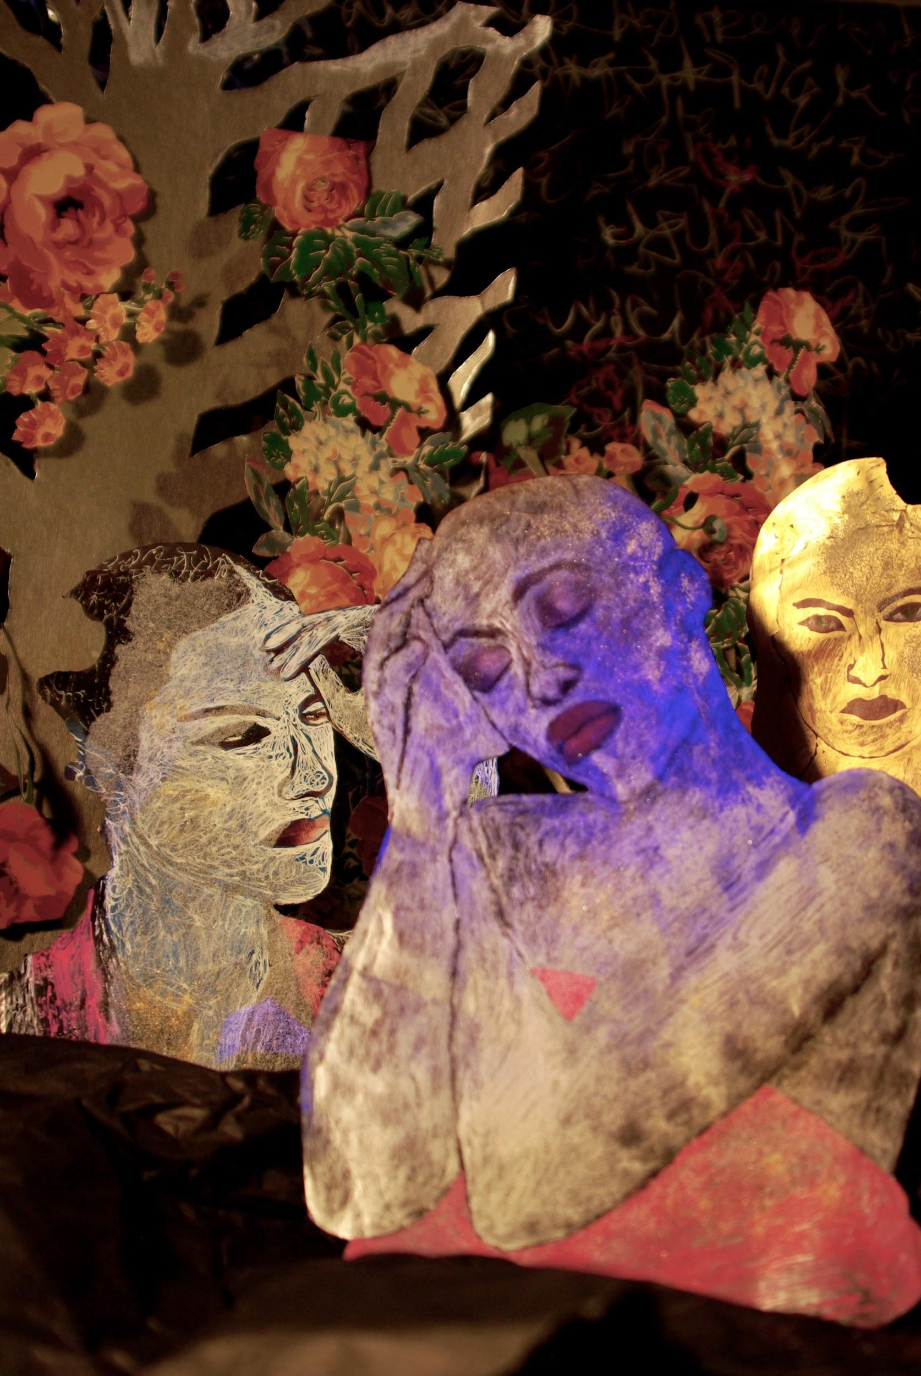
Meds 1
I love writing creative non-fiction and working on puppetry, as well, so maybe I would pick one of those careers (especially if I planned on starving. ;) ). I found out a few years back that I was born on World Photography Day--August 19th...I will take that as a good sign.
I used to really want to draw Medical Illustration as a career which would be a fusion of medicine and art, but I heard you had to study just as much as a doctor (I’m I’m sure you do not get paid nearly as much)
My business partners and I had a successful first year run of Cleveland Photo Fest in 2019, but we have had to postpone 2020 Fest because of the pandemic. We have enjoyed bringing artists together, offering them opportunities, and sharing the appreciation for photography in Northeast Ohio and beyond. I consider that a fulfilling career move. When I was a child, I had a longing to be a soap opera actress. I have ZERO interest in that idea at the moment.
I’m glad I got to be part of the CLE Photo Fest and Kerala Exchange!
- Of your own work, what would you say is your favorite and why?
It's always the current piece I am working on. When I get absorbed in building one of my photo constructions, I can do it for hours--without eating or taking a bathroom break. My work has gotten darker, and I like that. I think after going through a life threatening illness & treatment, that can happen to someone. I was reluctant to face that bit of myself for a long time. My friend I mentioned above, encouraged me to embrace all sides of myself and my art.
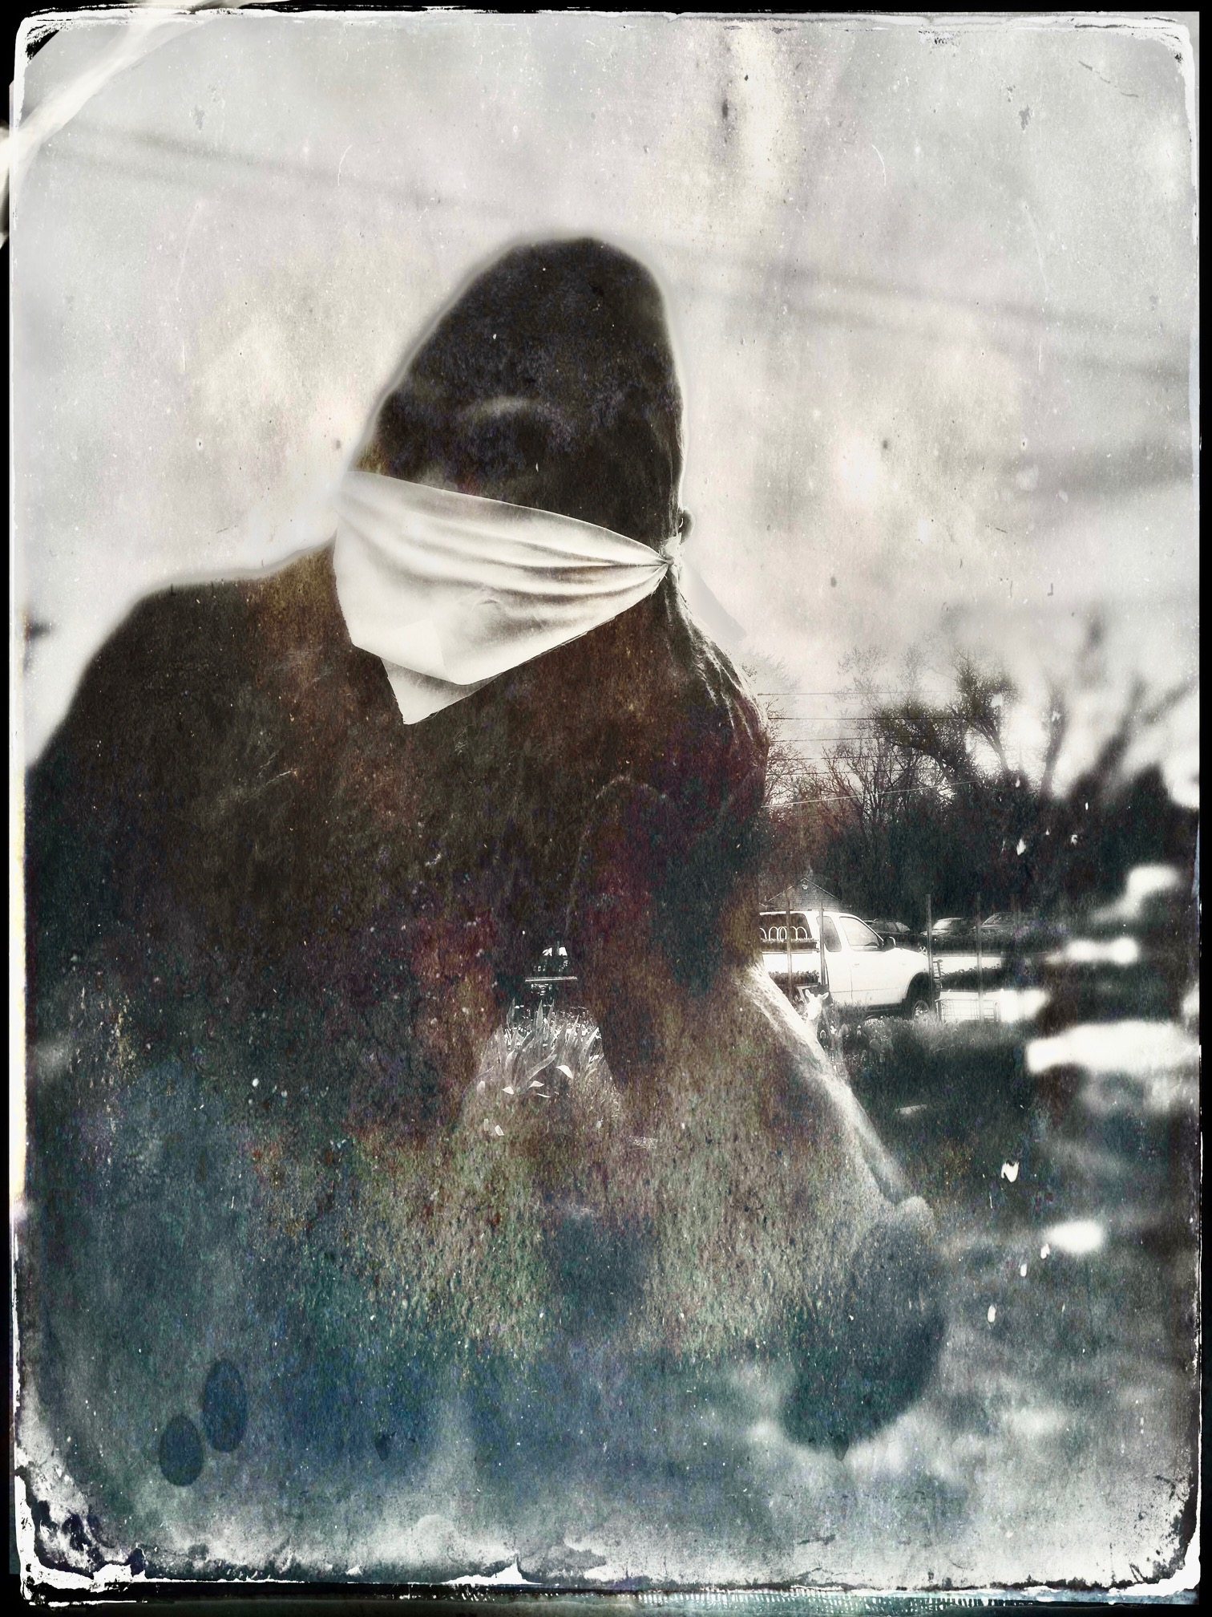
Creature 2
- Do you have a studio space? Can you show us what it looks like? Any tips on sorting/organizing or are you of the mindset that creation comes from chaos like myself?
Oh lord! Part of the reason I chose my house is because it has a huge attic that would be a perfect art studio for myself, my partner Tou, and our daughter. We have been here several years and it is still a wreck--I have been just too busy to finish that project, as of yet. So, for now, any empty space on the floor is working for me. The glitter tracked around the house can be a problem, however. ;)
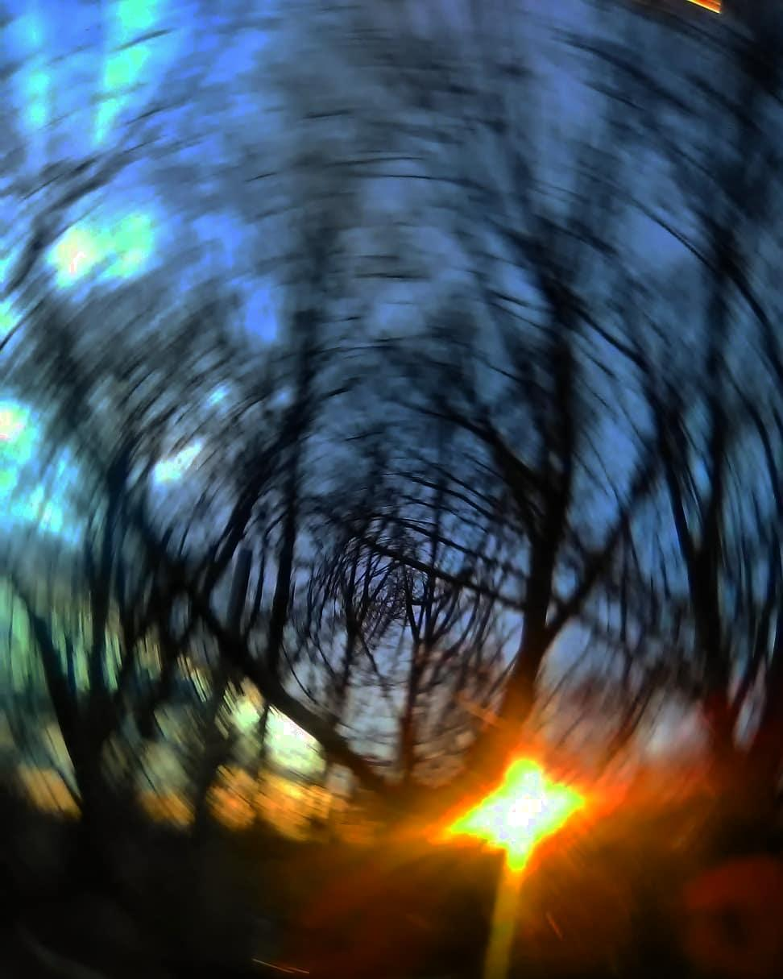
Fried Egg Evening
Oh boy, glitter is just as bad as our cats hair! It must be awesome to be a part of such an artistic family!
- Would a successful artist such as yourself have advice for underlings trying to break out into the world?
Well, thank you--I appreciate that comment, well deserved or not. I would advise to "fill the well" of course---to look at art, quality films; to read; to explore. See the world and you will learn and be inspired by so much. Go to art openings and network. Follow artists you like on Instagram or wherever. Buy/trade art and have it in your home to inspire you.
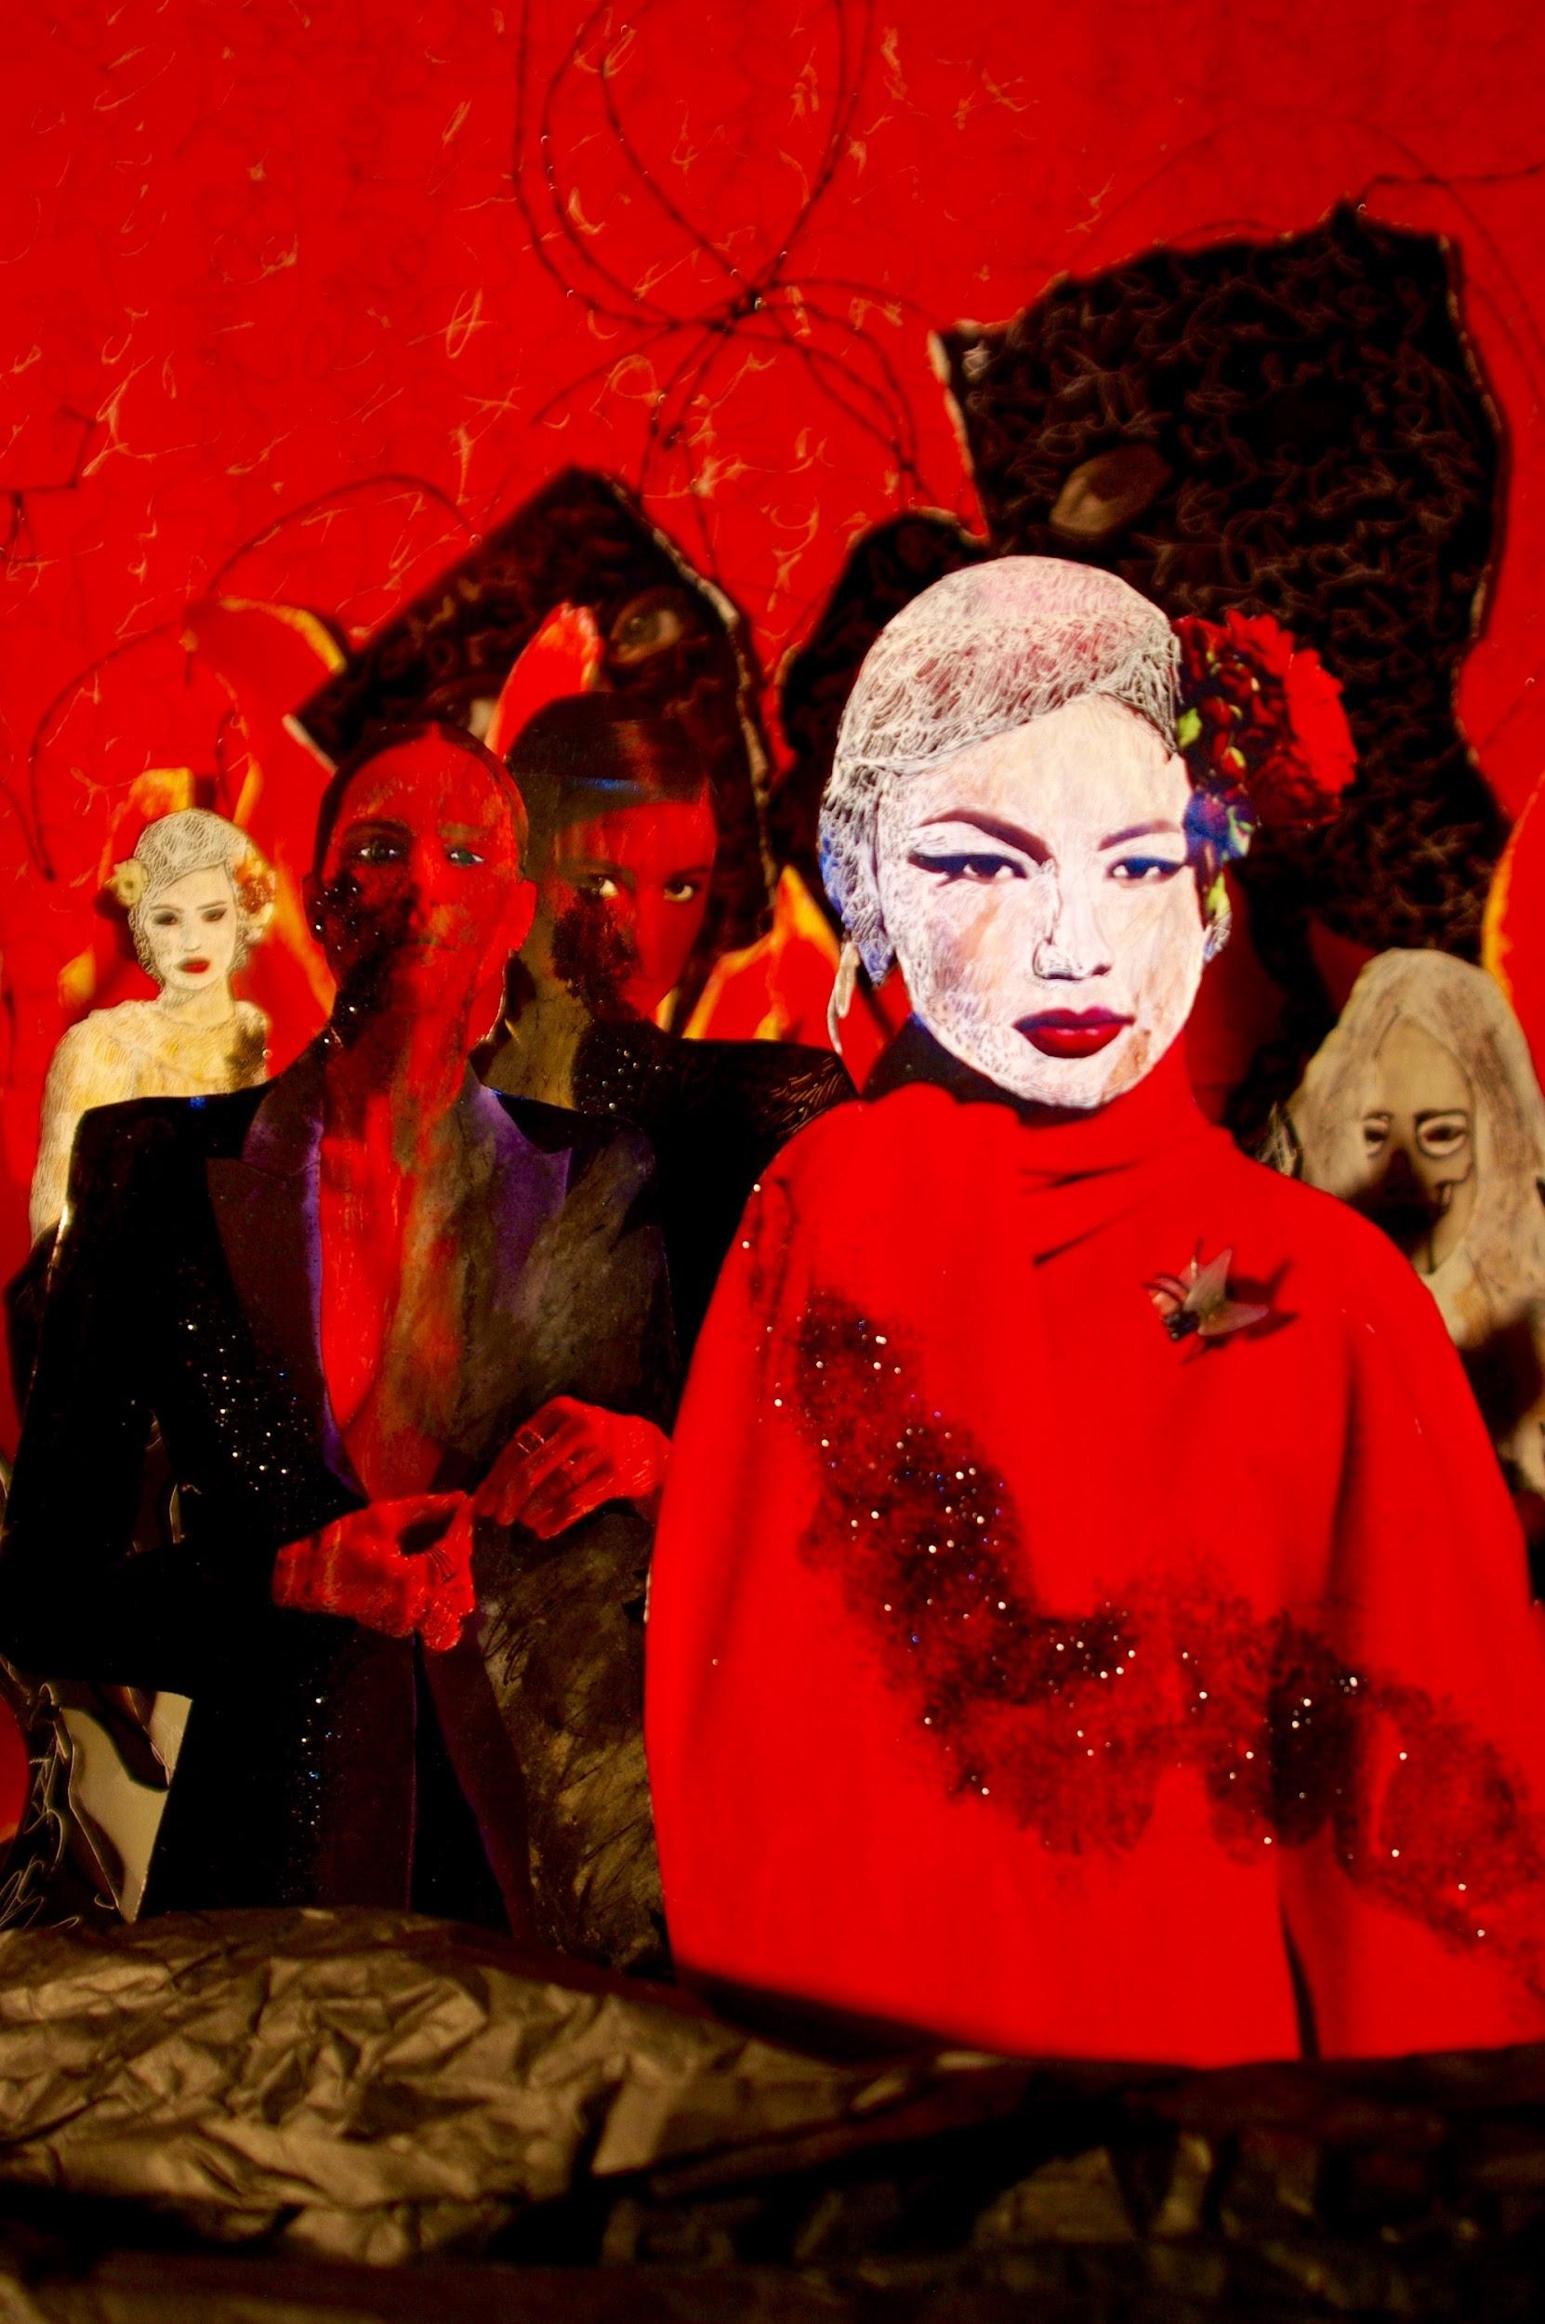
Meds 2
Apply to everything at first--saturate your town so they know your name & your work; then be more selective, perhaps (I don't pay to be in exhibits any longer). Keep a sketchbook and write down/draw/collage your ideas and thoughts. Brainstorm. Study with a great design teacher. Learn to draw and to SEE. Join a drawing group if you find that helpful. Try drawing with the opposite hand once in a while.
Help support others and share opportunities and resources. This is why I started the "Artists and friends barter group" on Facebook, and why I worked full-time without pay creating the Cleveland Photo Fest. If you are going to be competitive, be competitive with yourself--anything else will only make you miserable and bitter. There is no competition, really--we are all different and have our own gifts--there is room for everyone.
“Be competitive with yourself” Great advice!

- How did you get involved with Prama Art Space?
Sean Mabin and I went to the Cleveland Institute of Art together. We lost touch over the years, but thanks to social media, we became reconnected. He always had a dream of starting an art gallery (the FIRST gallery in Parma, OH), and he gives me credit for inspiring him (giving him a kick in the butt) to go for it--let's keep that inspiring spark going!
I am proud of what he is doing there. I was helping him find artists and with ideas, so it just evolved from there. He gave me the nifty title of "co-curator". ;) I love it. I am looking forward to seeing your work up in Prama, Cecelia Ivy Price, opening on September 25th.
Thank you! The pressure is on!
Sean is pretty awesome, I met him at the Skull and Skeletons show in Lakeland without realizing who he was, and I even bought a cemetery photo from him!
- Do you have any upcoming shows, events or projects you would like to plug?
Indeed! Thank you! I currently have work up in Yards Project at the moment (Liz Maugins and Amber Ford), and will be in their women's photography show (curated by Liz Maugins) in September. I have work up in Foothill Galleries of the Photo-Succession (curated by Amanda King and Michael Weil).
I will be having a solo exhibition "Creatures in Quarantine, " featuring magical and intense moments from my experience during the pandemic--opening at the Doubting Thomas Gallery on August 14, 6-10pm. Doubting Thomas will also be open on August 19--for World Photography Day/my birthday), 5-8pm. And, I am collaborating on a performance with June Hund, Tou Cha, and Norbert Ziebold for the City is our Stage event (you may contact them for tickets), on August 15th.
My dear friend, and prolific artist/art critic, Douglas Max Utter wrote a wonderful review of my exhibit "Creatures in Quarantine" intro to a forthcoming "chapbook" to accompany the exhibition.
Thank you so much for this opportunity. I loved having the chance to step back and reflect on my art, inspiration, and process during such hectic times.
Thank you very much for allowing me to pick your brain as well as allowing me to interview you!

Upcoming Shows:
Please come to the opening of “Creatures in Quarantine,”
at the Doubting Thomas Gallery --856 Jefferson Ave, Cleveland.

A solo exhibition by Laura D'Alessandro

Opening events include: August 14, 6-10pm and August 19 (World Photography Day) from 5-8pm. Because of the pandemic, we will be allowing under 10 in at a time, for 20 minute slots.
Please email Laura at lucys_eyes@yahoo.com to reserve your time slot.

Also open by appointment. Masks required.

