Interview with Horror Humorist
Monster Matt
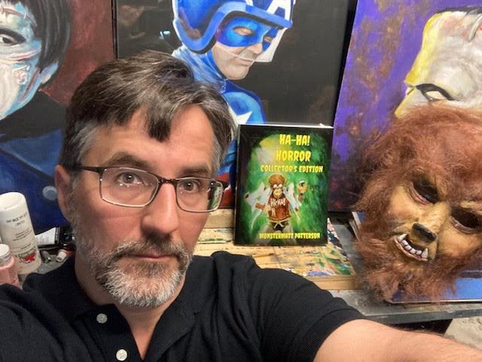
Location Buffalo, NY, USA
monster-matt.com
: Ha!-Ha! Horror: Collector's Edition
@MonstermattPatterson & HaHaHorror
Matthew(Monstermatt) Patterson
Monstermattpatterson

Ingredients
- Comic writer
- Artist

Preparation
- Artistic Weapon of Choice:
I usually prefer pencils- cheap mechanical ones by Bic? Bag of 10 or whatever.
With my smartphone, I can search for all kinds of reference images, whether it’s something exact or adjacent to what I’m looking for. Sometimes I find things have no relation to the subject matter, but there’s something I see that I can use. Edit/crop/expand pieces of the reference photos and utilize that to guide me. That’s about as high tech as I get.
- How did you get your start in the art world? I'm interested in finding out if the art or the writing came first? I’ve been drawing on and off since I was a little nugget. The first art show I was featured in, was at a shopping mall and I guess I had pictures of superheroes hung up in the display. I don’t totally remember what my work was, but I do recall my aunt and mom being there. I would’ve been in 1st grade I think. Not too long after that, my mom passed away from a sudden illness.
A few years later, our first step mother was a graphic design student at a local college, so she had tons of supplies to show me. I never got the gist of everything. We moved to a new town and the school displayed a bunch of my drawings. They were on various papers, 3x8 index cards, steno pads, stationery, etc. Her daughter would bring me bundles of computer paper (plain on the front, green and gray bars on the back) and I would draw images I found in comics or Mad Magazine. My dad’s friend would give me company stationery from his job, too. So I just gravitated toward drawing on stationery. I loved getting small stenographer pads and fine tip markers. I don’t know that I had a proper sketch pad until I was in my upper teens. It was kind of foreign?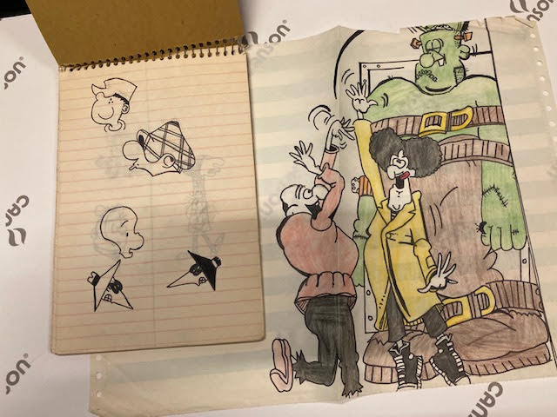One of the stenographer pads and one of the computer paper drawings I found- I was roughly 11 or 12 years old when I did these.
What’s odd, is that it’s all I ever wanted to do and if I started drawing and not doing chores, homework or practicing drums or piano, I’d get in big trouble. It’s like I wasn’t allowed to pursue it. Weird, in a musician’s household.
I didn’t paint until the early 90’s- I did a painting of a cartoon character on the side of a barn and took a Polaroid of it, showed it to a local comic shop and that turned into me painting their window once a month with various characters. I got paid in comics. I dabbled in college art courses, but got turned off. That was it - I didn’t paint on a canvas until more than a decade later.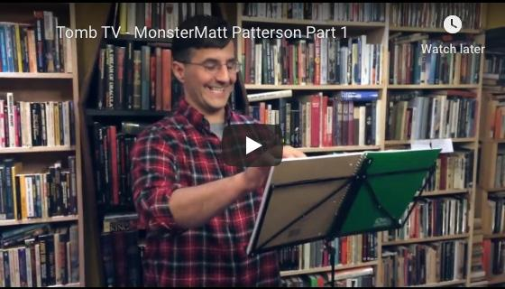
Tomb TV - MonsterMatt Patterson Part 1
However, an injury (rotator cuff surgery) the following decade, turned into a different story…
At the end of my physical therapy, I was strengthening my hand with balls of clay at home. One day I goofed around and made some faces. Then, as a horror film fan, I thought, gee, what if I make a mask? That year, I made a Fly mask by using duct tape, two metal pasta strainers(for eyes) latex, tin foil and my ice hockey helmet. But, the real test came when I bought an actual mask making kit- (a foam face, clay, mold material, latex) then I made a half head Wolfman mask. I kept experimenting and hooked up with a local filmmakers, making them masks for their projects- films, etc. After a break from that, I’m dabbling again with mask making.
Now where does writing come in?
My extended family is very funny- a gathering doesn’t take place without some major “busting of the chops” and very bad jokes. It’s gotta be in the DNA! So, I’ve always been known to say dumb things for a laugh, since my early teens- I’m not afraid of making myself a target either.
I was writing a humorous poem for school and had a movie monster trading card that I was using for a guide. I had read similar stuff in Famous Monsters and Mad Magazine, etc. but I wasn’t happy with it. The poem I copied from the card accidentally got turned in (not by me- the teacher collected the work when I wasn’t there) and got included in a poetry anthology. I was accused of plagiarism, but at age 11, I don’t think I had heard of the word and it wasn’t my intention. My family did not treat me kindly and said right to my face, that I couldn’t possibly have written anything that intelligent. Oh- I wish Hallmark made a card for that. That was the last time I wrote anything until 2010. I had no desire to be ripped apart or accused of something that I hadn’t done.
Anyway- I started writing jokes online and it got noticed by some folks. That turned into a writing gig with HorrorNewsNet and my column alternated between jokes or vintage items. That got me a publisher. The first book came out and a friend of mine volunteered to illustrate it. I was already way over my head- I didn’t know how any of this worked. We had problems with that publisher ( due to their undesirable conduct) and left with other writers and illustrators. I found another publisher. They closed up shop due to health issues. My illustrator wanted to leave. And I was sitting there with a heavy heart. But I did a logo for this new publishing company that got left in the wind as I did, with publisher number two. They took me on and they are still my publisher since several years ago. Whew!
Painting came back to me in 2012 and for the first time I used a canvas panel and acrylics- making the Terminator. I didn’t use an under drawing- I didn’t know that was a thing. I have almost zero formal training. Then, it got noticed and I just started painting in acrylics, then tried watercolors and haven’t mastered any of it but am enjoying each project as it comes.
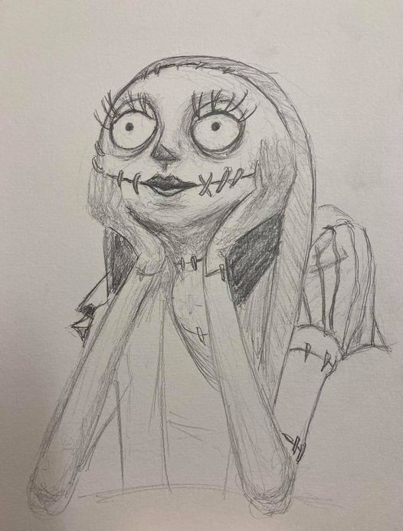
- Do you experiment with other art forms and media?
So - I write, draw , paint and sculpt. One day, I hope to figure out how it’s done! I also appear on podcasts telling my jokes, act as an extra in films. I play drums, sing. My family is full of musicians- I was a band geek (Freshman band president) and started off as a music major.
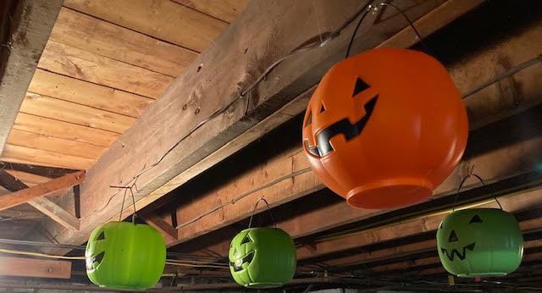Just some of the 20 or so candy buckets hanging from the ceiling near my space.
- Who/what are your influences? Because I’m kind of spread out over various things, I’ve got various influences.
Art- Rita Letendre, Basil Gogos, Jim Aparo,Norm Saunders, Steve Rude, James Bama, Tex Avery, Chuck Jones, Jack Davis, Don Martin, etc.
Mask Making/Creatures- Ray Harryhausen, Don Post, Dick Smith,Ed Edmunds, Rick Baker, Tom Savini.
Music - Neil Peart, Johnny Cash, Louis Armstrong, Luis Prima,Buddy Rich, Gene Krupa.
Writing- Most of the old school Mad Magazine writing staff. Others include Forrest J Ackerman , Henney Youngman, Rodney Dangerfield, Rod Serling,HG Wells, Zacherley, etc.
- Do you have a day job or are you able to live off your work?
I have a day job- I’m in a union and have been there for 23 years. I don’t know if I could survive off of my artwork and books.
- How has business been during the past few months and what are you doing to adapt?
Business hasn’t been so great due to Covid -19. I do way better in person than online- it might be my personality or demeanor as I ramp up with the jokes and chitchat.
- If you weren't an artist, what is another career path you may have taken?
If I weren’t set on trying to do this? I did want to pursue being a history teacher or truck driver. Different ends of the spectrum there. But I do have a class 2 commercial driver’s license.
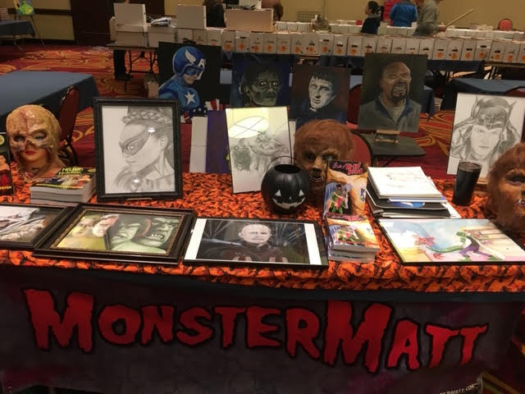One of the last shows before Covid-19 hit the fan. February or March?
- Of your own work, what would you say is your favorite and why?
I really like my first book with my publisher- “Ha-Ha! Horror “ as it won an award for humor books. It’s the first book that I wrote and illustrated. It was a real pleasure and dread to do, as all the blame or praise was on me. It meant a lot!

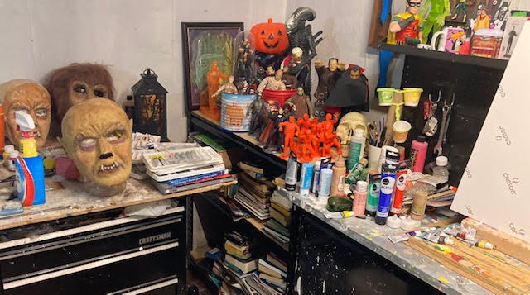Some of my work area- books, collectibles, stuff that makes me happy while I paint or sculpt. I tend to draw upstairs, unless it’s for a painting. A bit messy, but me and the spiders dig it.
- Do you have a studio space? Can you show us what it looks like? Any tips on sorting/organizing or are you of the mindset that creation comes from chaos like myself?
I have a work area in the basement- and it’s half collectibles, half work space. It’s not totally setup yet, because we’ve always had problems with flooding. But it’s my area and happy space- I veg out or work down there, like a mad scientist!.
- Would an artist/writer such as yourself have advice for underlings trying to break out into the art or writing world?
Do everything you want to do artistically. Don’t worry about if you’ll ever do it- know that you will. It might take time but it will happen. You gotta make it happen. I’m not formally trained and have been figuring it out this whole time. There‘s still projects in my mind that I haven’t gotten to, but will. Things sometimes fall into place. But you have to keep plugging away at it. I write or draw nearly every day- whether it’s something big or small. It’s just working that brain of yours and doing it!

Upcoming Shows:
http://6ftplus.gravediggerslocal.com/
Buffalo Punk Rock Flea Market Geek Garage Sale Comics Vinyl Toys
Sunday, September 20, 2020 at 10:00 AM
Halloween Tree And OPEN PAINT night Event
Thursday, September 24, 2020 at 6:00 PM
Meet & Greet with Monster Matt!
Saturday, October 17, 2020 at 12:00 PM at CatsLikeUs
October 24th Joe Dee’s Collector’s Show.

Me with some paintings and my (newest) 4th book- “Ha-Ha! Horror Collector’s Edition”

