Interview with paper artist
Priyanka Sagar
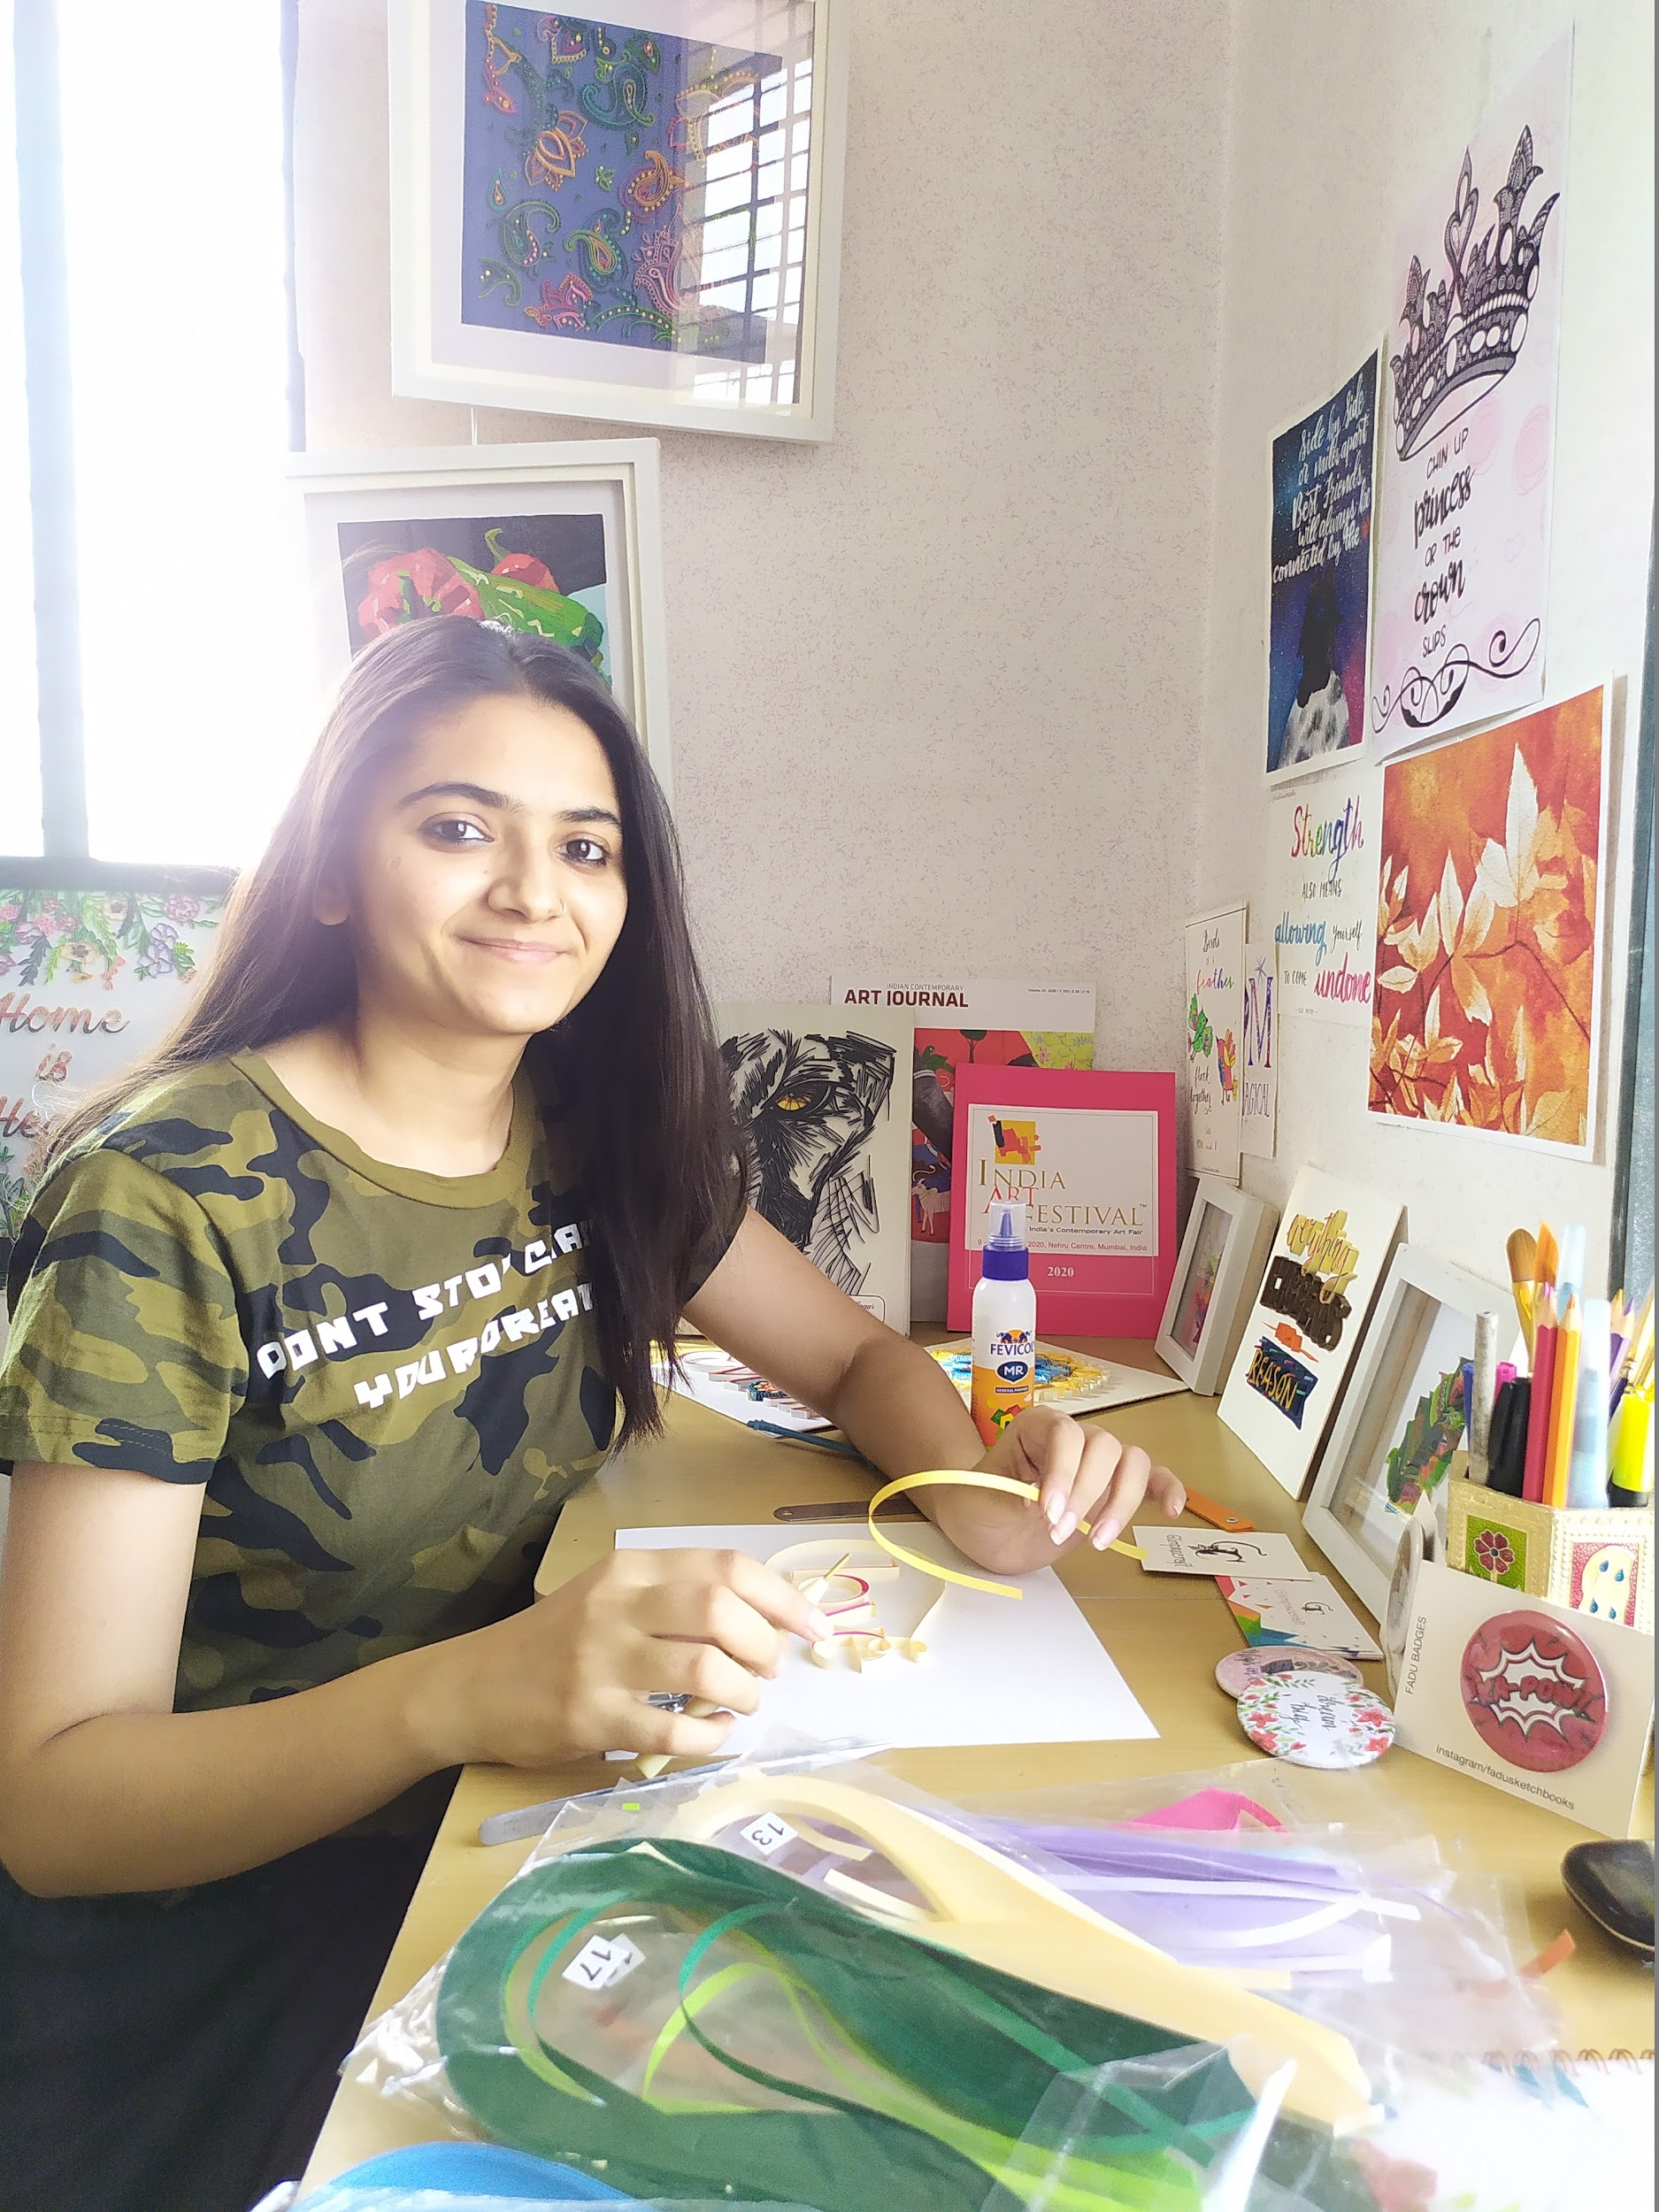
Location Gujarat, India
Facebook https://www.facebook.com/glimpsecraft/
@glimpsecraft
Instagram https://www.instagram.com/glimpsecraft/
Etsy https://www.etsy.com/shop/GlimpsecraftIN
Pinterest
pinterest.com/glimpsecraft/_created/

Ingredients
- Paper Artist
- Quilled Painting

Preparation
- Who/what influences your work? Firstly, the work of Sabeena Karnik and Yulia Brodskaya had influenced me, how cleverly they use the paper to express the subject. Especially the techniques which they use in their projects. When designing quilling papers was my hobby, gradually my interest in giving them more beautiful and attractive shapes had developed.
Currently, artists who are working with different art forms like mix-media, knife paintings, paper folding, are also influencing me.
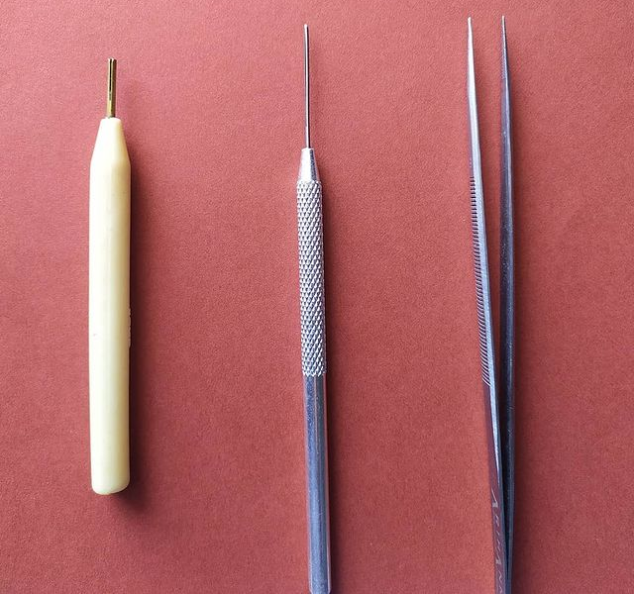
Here are her tools of the trade
- Do you create art full time or do you have another job or passion? Yes, I am creating my art full time, you can also say I am a full time artist. I am enjoying my art journey by using paper strips because of this I never thought about another job.
- How do you balance your art and work? In making of Paper quilling takes a lot of time and Working as an individual and keeping balance is tough. Think about new ideas, manage social media, Marketing strategies and work on art to manage all these things for which I create schedules.
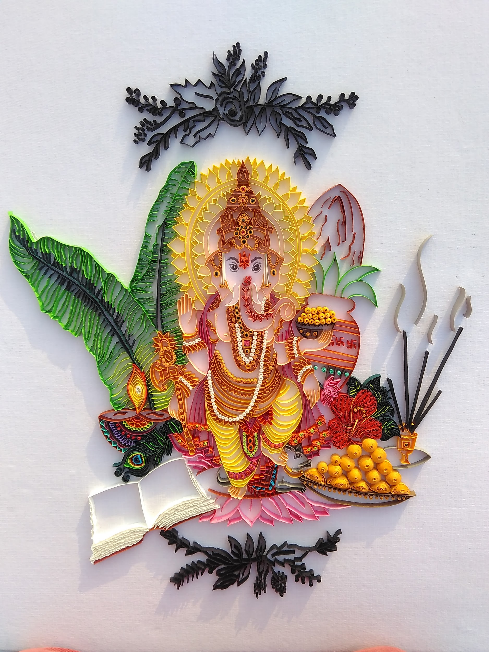Lord Ganesha (it’s picture of ganesh ji and ganesh ji is an Indian god)
- Has this changed since the onset of COVID
Year 2020 brought lots of new opportunities in my art journey. My first exhibition was in January and it was a great experience in Indian Art Exhibition, which was organized in Mumbai. Even I received many orders because of that exhibition and then started my new experiences with an online shop on Etsy. One of my customers recommended me to put my work on etsy and I started my first debut in an online shop. Covid19 brought lots of changes in my life in a positive way.
- I hope you do not mind me asking, but you seem fairly young?
Yes, I am a young girl. Recently, I graduated in Bachelors of Administration.
- How did you go from Bachelors of Administration to creating paper art?!
-From school time my interest I always use to do different craftworks and participate in art activities.
I do paper quilling as a hobby for a long time and never thought to do it professionally and when I was in college and I have sent my work for framing at that time someone saw my work at the frame shop and appreciate me and interested to buy my work and after that and this was the turning point of my life, I realise that I already developed my skills and experience with paper as because I making it for so long time I should give a chance to the thing which I love to do.
- Then I decided to start working as a professional paper artist.
- It looks like you create portraits, geometric shapes, dog portraits and landscapes. Do you prefer any one subject?
No, my main motive of creating this art is, whatever I plan or create must be unique, with new techniques and clever use of paper stripes.
So, I never prefer to work on any single subject.
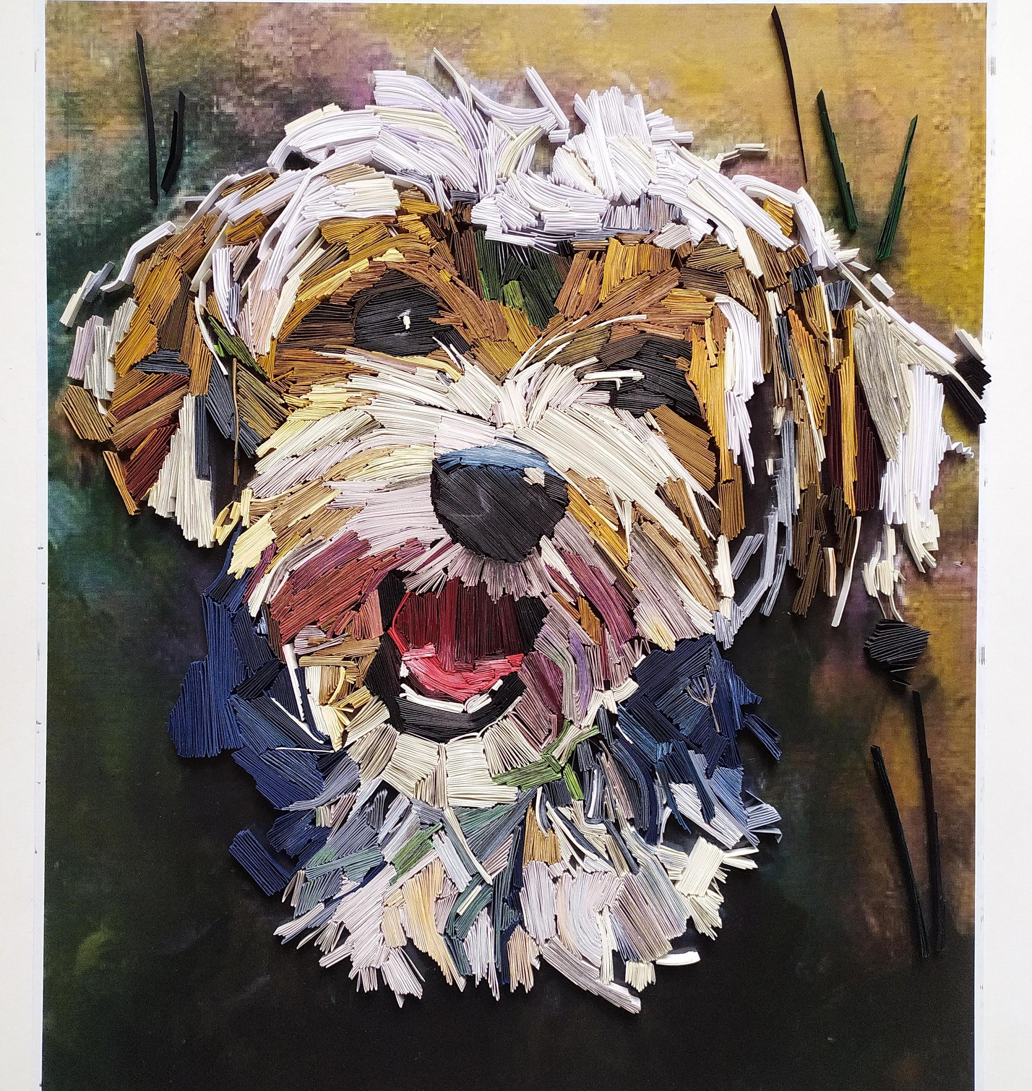Quilling Havanese Portrait
- Do you have a studio space? Can you show us what it looks like?
Yes, I have a small corner for myself in my big house, where I do my work, including thinking of new ideas.
My suggestion to you is, our work space should be organized, because it helps us sometimes for getting some new ideas, also organized stuff helps to get our work done easily.
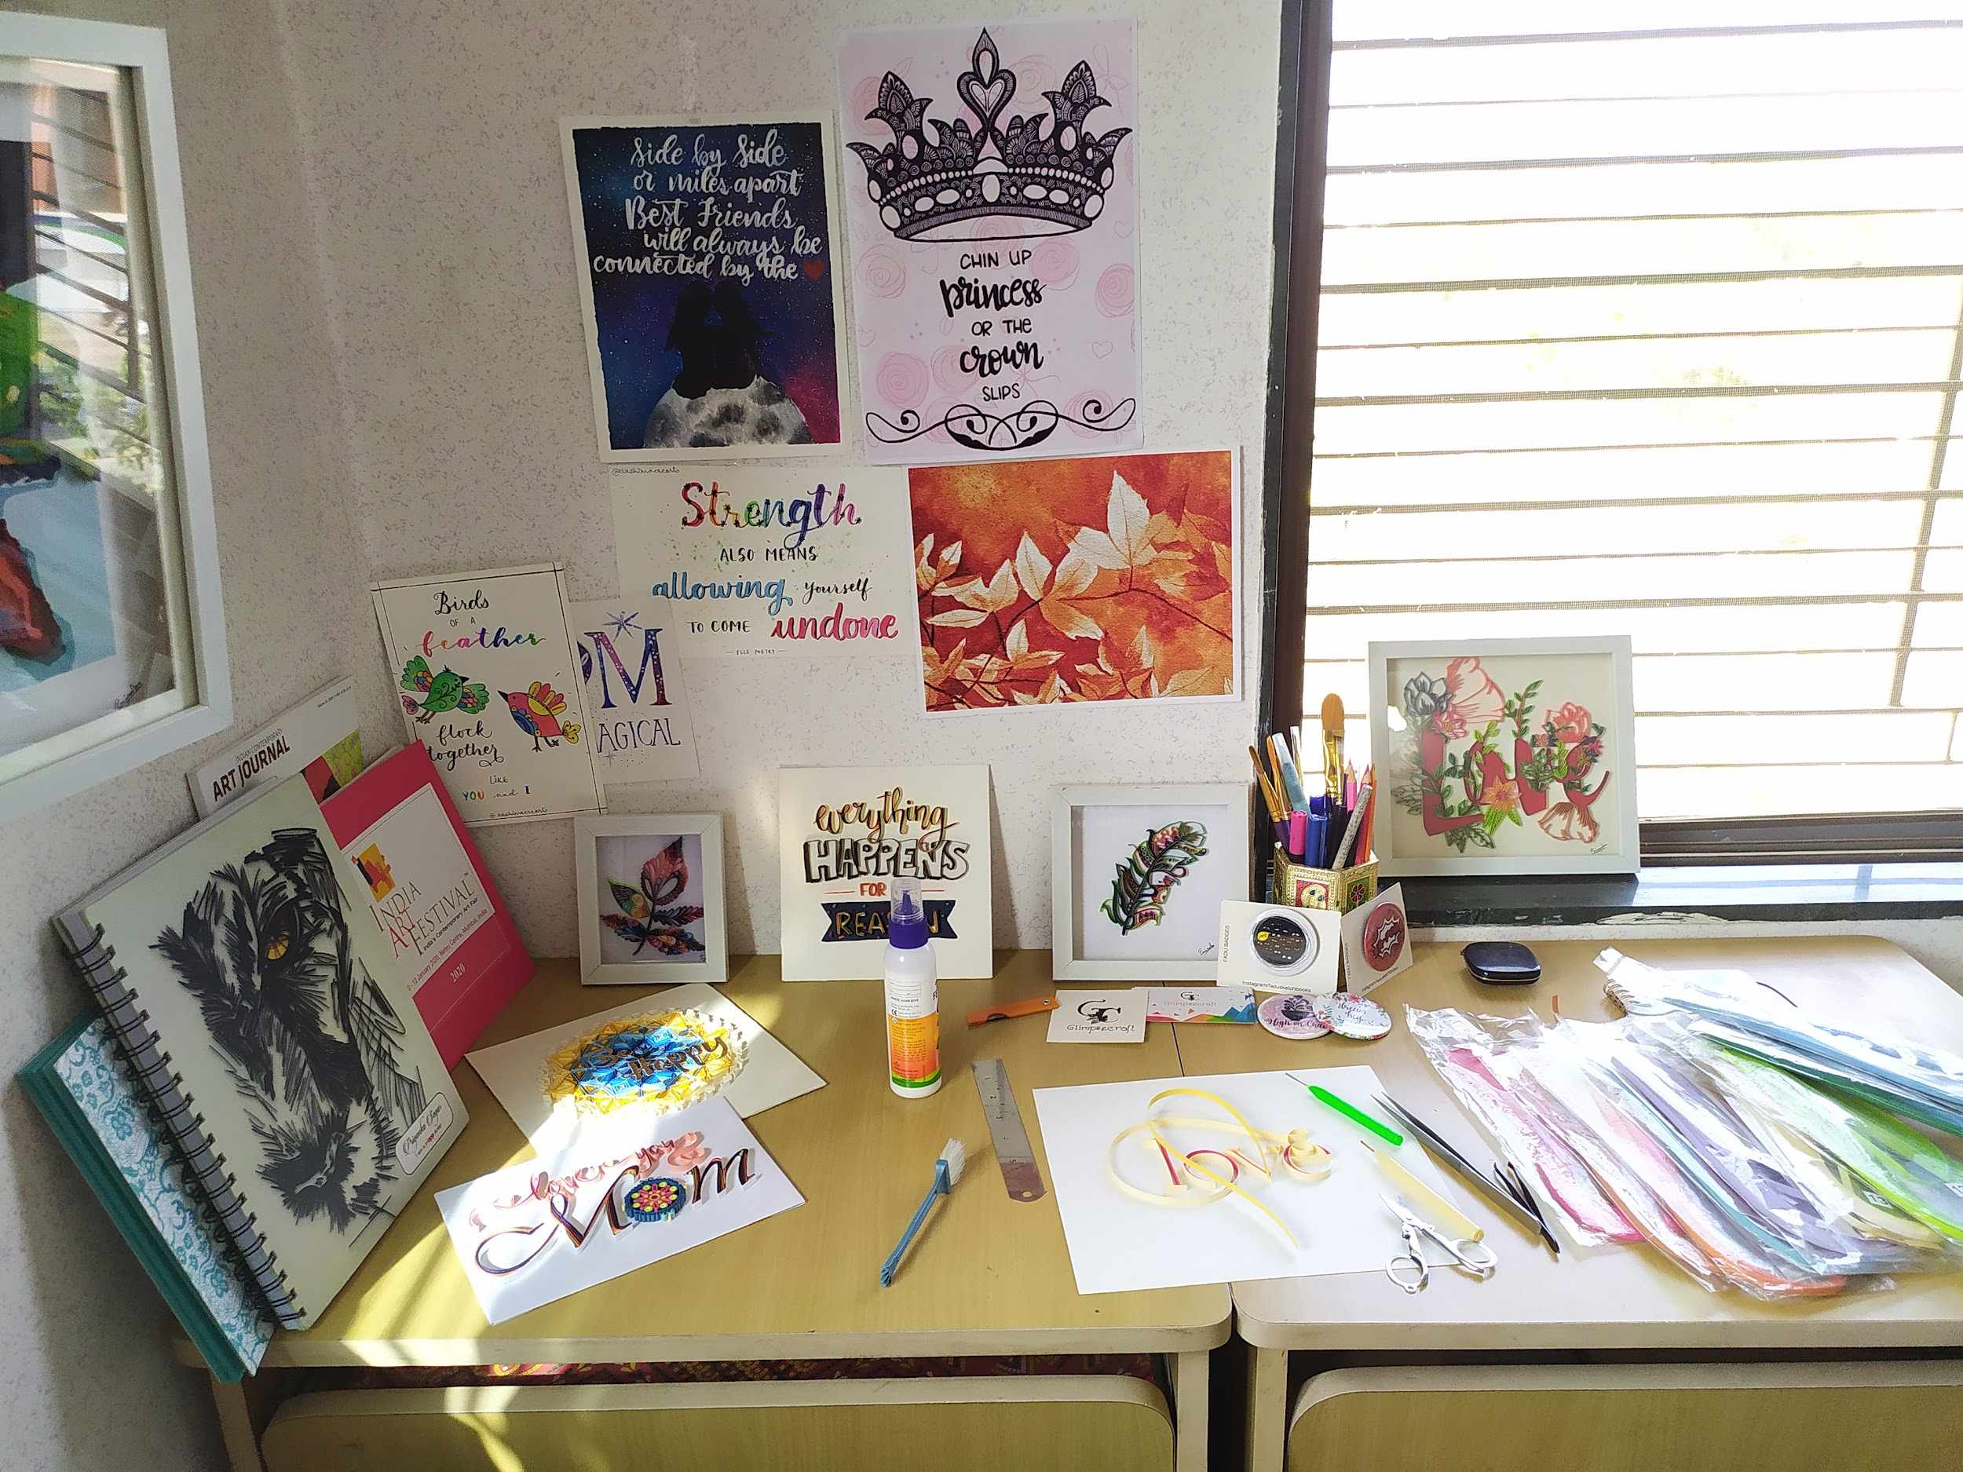
I prefer to do my work in silent places, with some soft and soothing music.
- How long does each piece take?
Time depends on design, size and detailed work. One of my recent work almost took 3 months and its still incomplete. So if design is simple and the size of that particular piece is small then it takes 5 to 6 days.
- If you don't mind telling us about how you approach your work, for example do you create sketches, story boards or Photoshop references first?
First, I think about a theme. Then, I try to create such an environment around me which can give me more hopes and can clear my ideas about the subject.
- Also, You currently have 2,125 followers on Instagram, do you have any advice for artists trying to get more eyes on their work?
These are some few things which follow to get more eyes on my work
-regular update of your new work.
- upload high-quality pictures
- reply to all comments
- appreciate other art forms
- Share your thoughts, your thinking about art and techniques to your followers
- do live sessions on social media
- show your work in detail through videos
- Lastly: Do you have any upcoming shows, events or projects you would like to plug?
Because of this covid situation, I have no plans for any exhibitions right now.
But I have some new ideas about my new project that is inspired from a monument, which is in Iran.
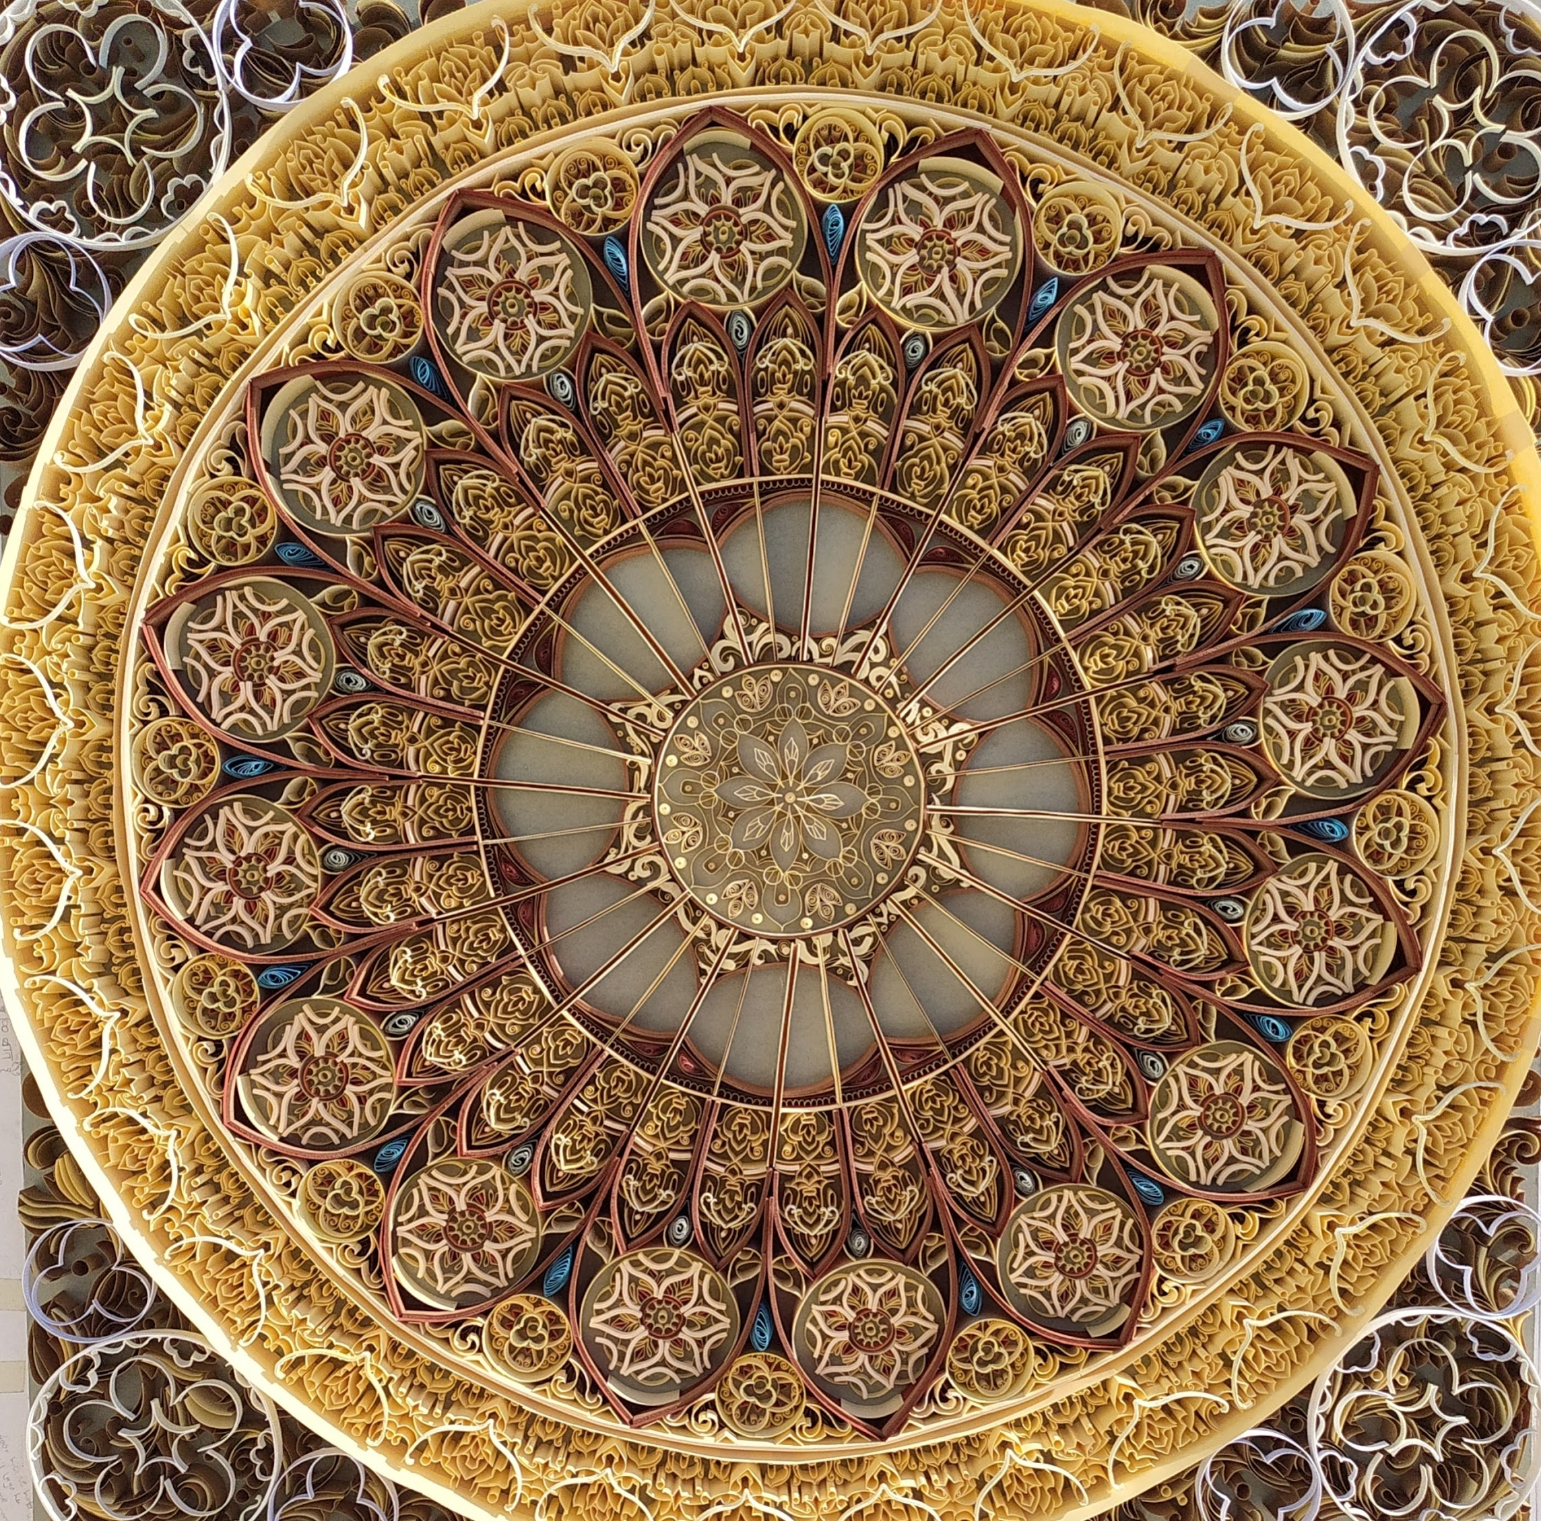Mandala art by using Paper quilling 60 x 60 cms (In this piece i have use 20 to 2 sized strips of paper and this one is one of my toughest work because it took 3 months to complete it)

Chef-d’œuvre

