Interview with painter
Samantha Bias
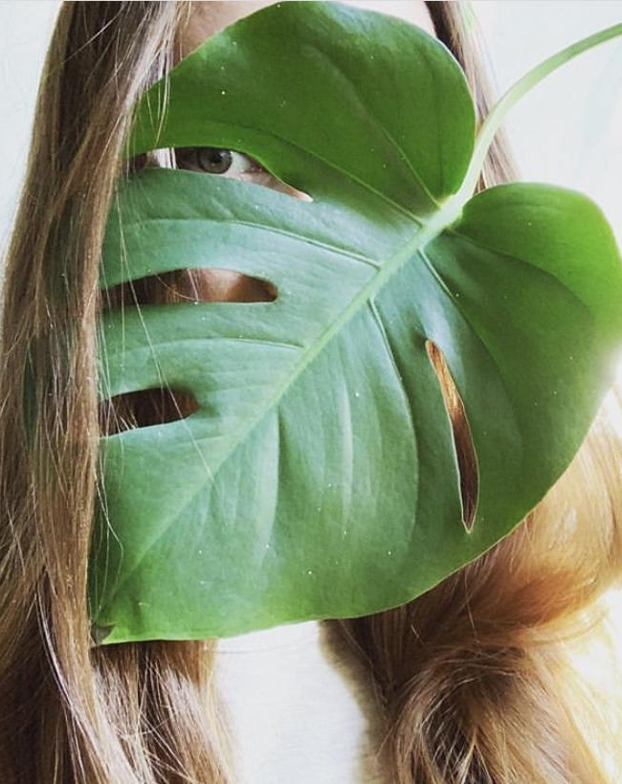
Location Cleveland, OH, USA
Website biasedart.wix.com/website
Instagram @bias.samantha
Facebook @BiasedArt
Email: biasedart@gmail.com

Ingredients
- Teacher
- Photographer
- Experimentalist

Preparation
- Artistic Weapon of Choice: Oh, I like this question! I would say it is a cross between watercolor painting and alternative photo processes. About twelve years ago, I began my journey through art. After going through a deep depression after the death of my grandmother and shortly after I was sexually assaulted. I started art therapy classes as a way to cope and took up watercolor painting. From there I painted mostly self-portraits and worked my skills over time.
Last year in 2019 I was accepted into an artist residency at The Cleveland Print Room after conveying an interest in trying out a new art medium in photography. I particularly liked learning about old world and primitive photography methods. I learned about “camera less” photography by using the sun as your lens and began doing what I am known for, which is Chlorophyll Process.
Chlorophyll Process is an alternative photography method using the natural photosynthetic properties of plants with a large format negative selectively preserving the chlorophyll (green) part of the plant while the rest is subjected to the sun resulting in a lasting image.
I'm sorry to hear about your past, I have a similar story. I'm interested in what one of your self portraits might look like from this period if you care to share one?
Attached are two self portraits from that time period - mind you this was over a decade ago so they aren’t that great. It’s on colored pencil actually those were the only digital files I have from then.
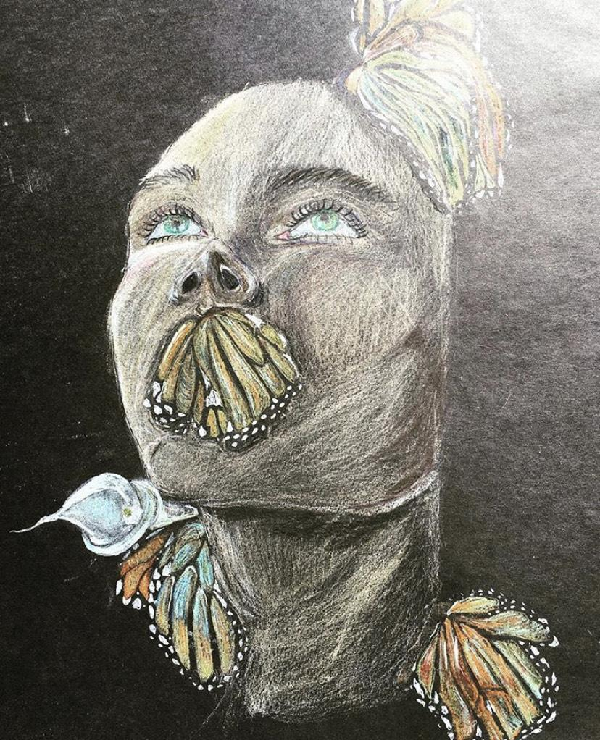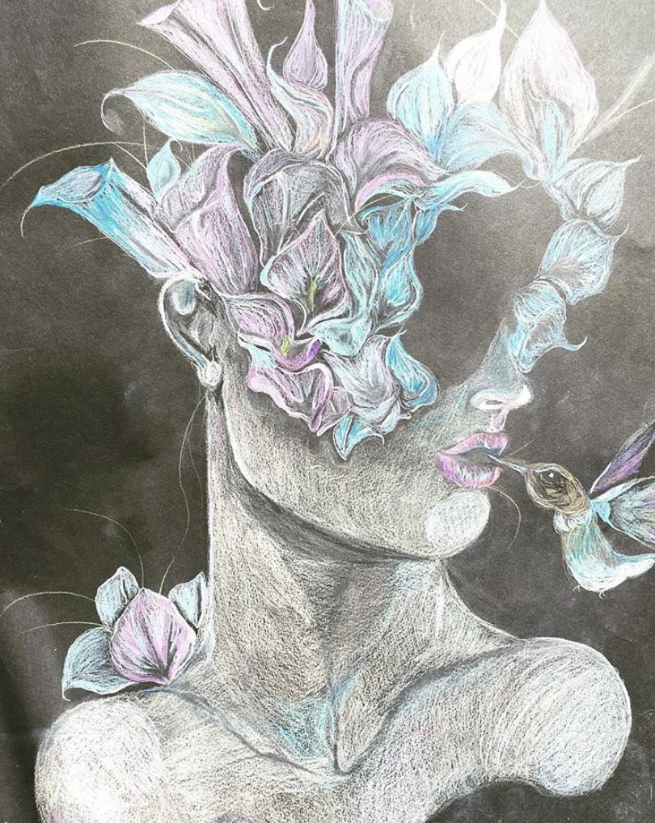
Beautiful! Reminds me of a piece you have in the Creative Women Today Show! It is amazing to see how you have progressed since then.
- If you don't mind telling us about how you approach your work, for example do you create sketches or Photoshop references first, do you go right to attacking the media, etc. ?
When I am going to create something, usually it comes to me as a vision and a lot of the time happens before I go to sleep. I remember learning about Salvador Dali and how he would sleep with a spoon in his hand and a plate by his feet. When he would fall asleep the spoon would drop and hit the plate, waking him and that is the precise moment he would have his visions for his paintings. Although I would not dare to compare myself to a great like that, I tend to find my inspiration in a similar fashion.
Once I get a vision, I typically seek out my inspiration. When I do not have the images I need, I typically seek out found photos and references with permission. From there I take digital photos and turn them into high contrast negatives for my Chlorophyll Process Prints.
- How did you get your start in the art world?
I got my start in the art world about 11 years ago. I would ride my bike around with my portfolio strapped to the back and stop at local art galleries hoping to show my work. Back then, smart phones and social media weren’t so prominent so much of the time I tried to make an in-person connection and hope my work was strong enough for the task.
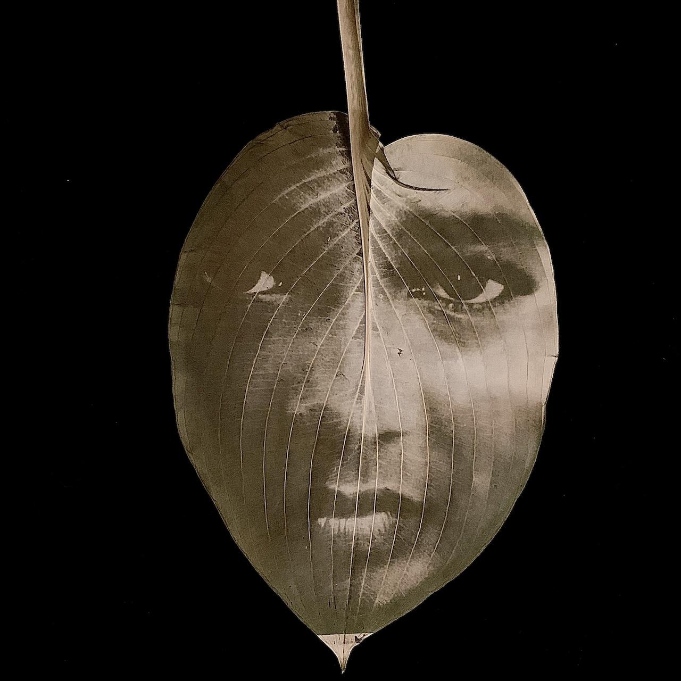
My first show was at the Doubting Thomas in 2009 called the “Undone” show where they showed regional artists whose work wasn’t finished or still in progress. I had ten paintings in that show.
From there it just took a lot of work, grit, skill and learning how to network to get my foot in the door. Only the past two years did I start getting into group gallery showings and winning honors. It takes time, patience and believing your art in order to make it in the art world.
- Of your own work, what would you say is your favorite and why?
That’s a tough one. Every new piece that I make is my new favorite! But there is one painting that I did two years ago called “Flowers Are the Music of the Ground”, a watercolor painting that is currently being featured in the Creative Women Today V Show. There is just something about that piece that is so precious that I cannot part with.

- What is your most misunderstood work? As far as misunderstood work goes, I painted a piece last year of the twins Itari and Inemi from the UK. The reference photo was of them laying in the grass nude together. I posted the painting online and mentioned they were sisters. I had a few people call my work “obscene” and “incestuous”. It was not my intention at all. It was to show the closeness and bond of the sisters and personally did not find it obscene at all. Something I learned from doing my art - you can’t please everyone. They will have their own interpretation of your art that derives from their angels and demons and you can’t do anything about that. Misunderstood painting attached.
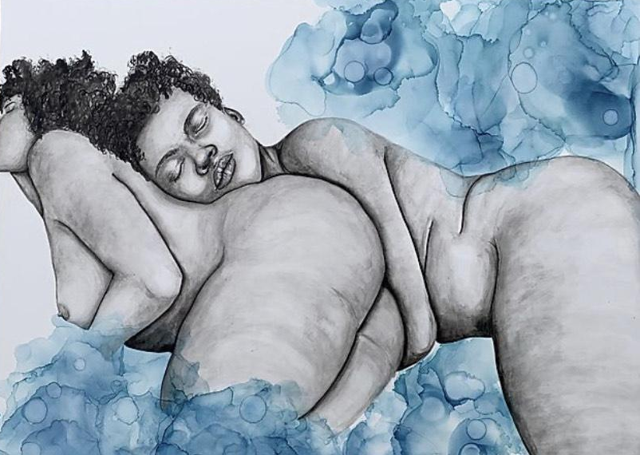
That is a shame! Such a beautiful innocent piece of artwork. Our world does not understand that nude form unless it is in the form of pornography.
- Who are your influences,
My very first influential artist was Andy Warhol. I know, I know not the best influence but I liked the way he took ordinary objects and made them extraordinary. I like to think that I have inherited that kind of approach. I work with a lot of ephemeral or easily discarded or overlooked objects and breathe life into them. I feel like Warhol did the same.
Next, I would say Georgia O’Keefe whom I am currently paying homage to in my most recent project Photo Synthesis: Transformative Environmentalists. I looked up to her as a young artist for her painting skill as well as her vigor as a female artist in a predominantly male art world. I thought to myself, “if she can, I can”.
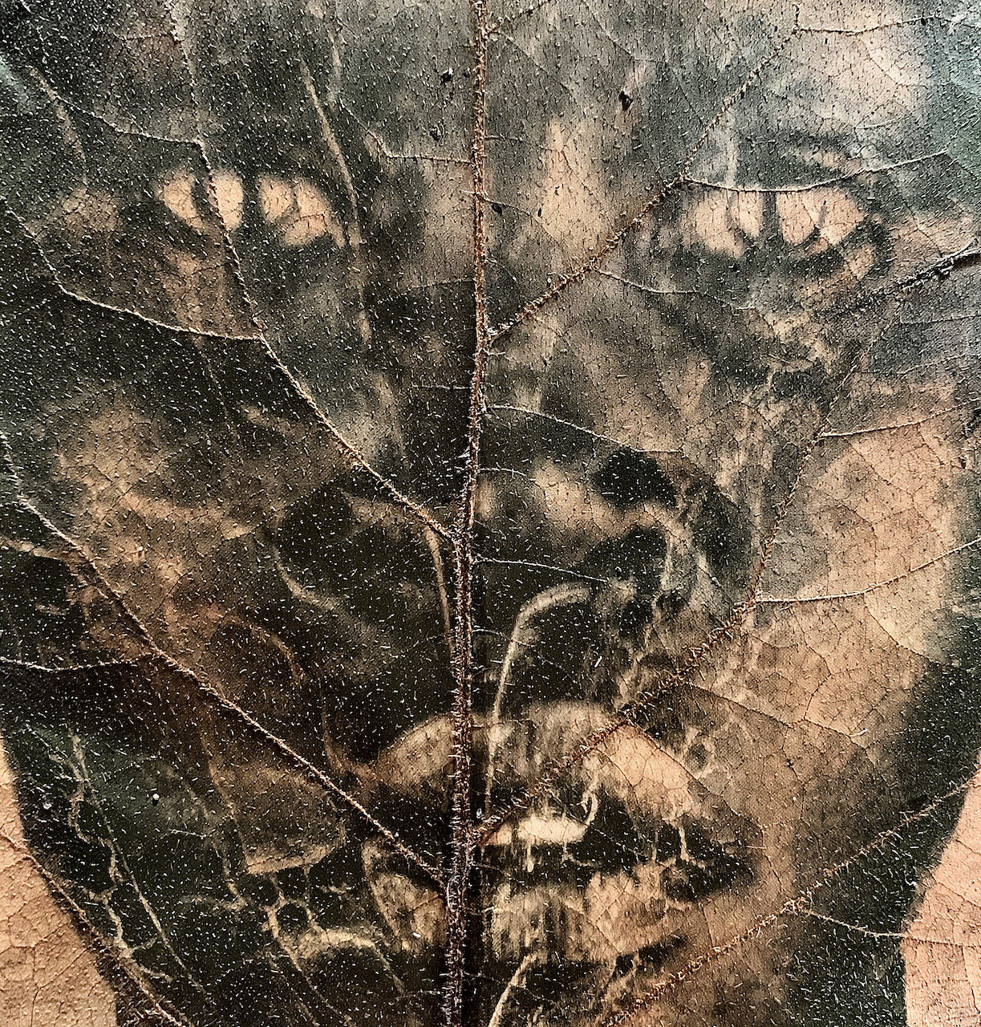
- Some artists only stick with one media or theme at at time while others experiment, would you say you experiment?
Many artists are jack of all trades and I am no exception! I have tried embroidery, acrylic painting some oil painting, charcoal, illustration – you name it I have probably done it. In order to really find what medium(s) work for you it’s always good to try many kinds of media if you have access and can afford it.
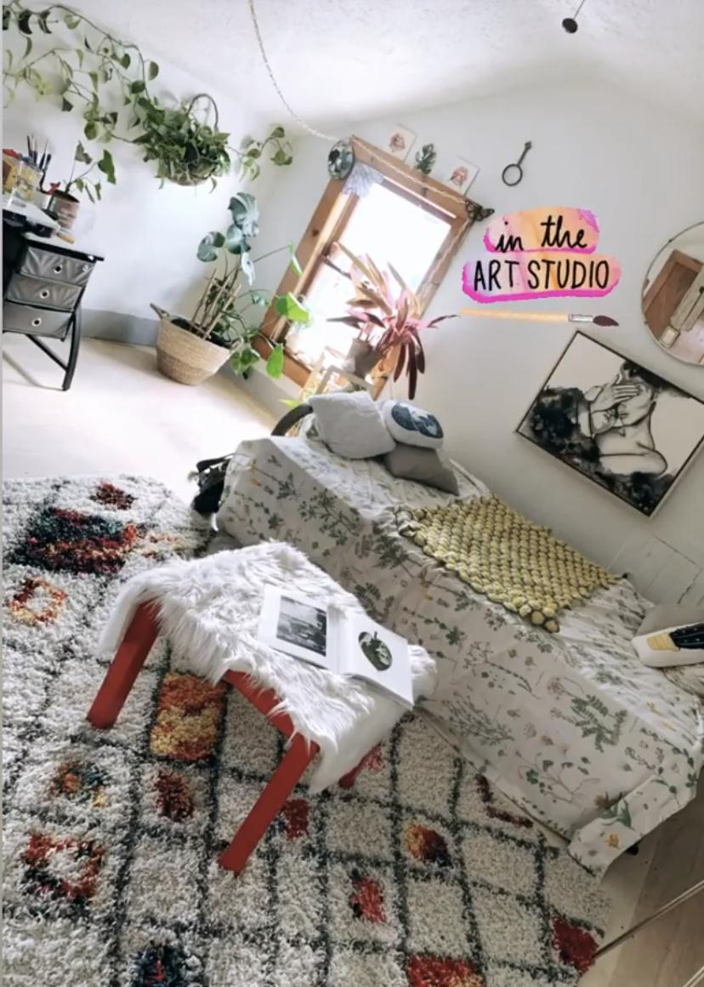
- Do you have a studio space? Can you show us what it looks like? Any tips on
sorting/organizing or are you of the mindset that creation comes from chaos like myself?
Currently I have a home studio which I recently revamped with the help of my husband. We painted all the walls white and put in fresh wood flooring. I put some plants in the window and I keep my space very minimal. Everything is very organized and everything has a place. I keep my space sacred so that when I am in my studio, I always feel there is an invitation to creativity without too much influence on past work so that everything is fresh. I only keep one painting on the wall at all times, and switch it out periodically so my space doesn’t stay stagnant.
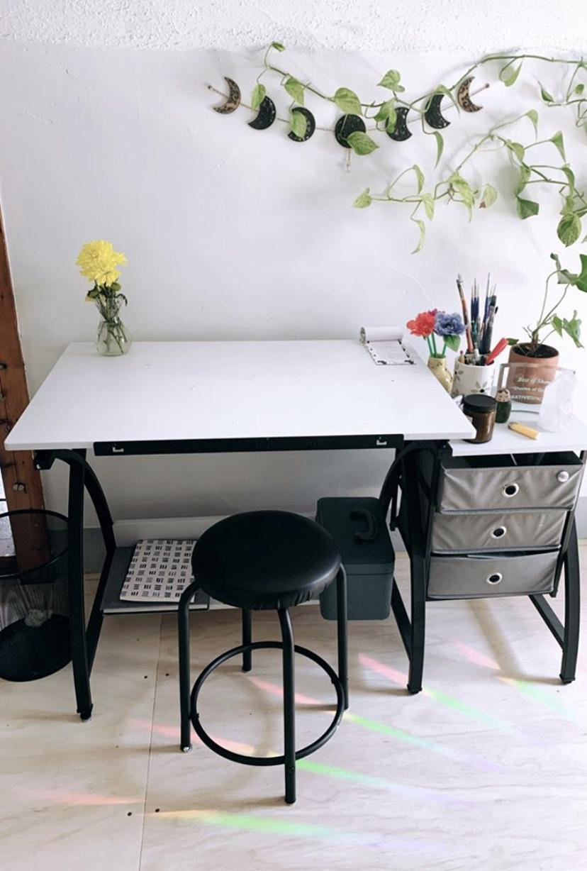
I just love the rainbow rays on the floor and the plants.
- Do you have a day job or are you able to live off your work?
Right now, I am a working artist. I work a full-time job for the City of Cleveland as an art instructor. Much of my time is spent teaching ceramic classes and school groups as their subsidized art teacher since, sadly many art budgets are being slashed left and right. Though, I am happy to provide free art programming to those who need it most.
As for sales of my work, I do make a lot of art sales but it is not enough to live off of full time.
- If you weren't an artist, what is another career path you may have taken?
Honestly, artist is such an integral part of my identity I don’t know what I would do without it. That being said, I am currently going back to school to finish my Masters in School Psychology. I plan on using art as a catalyst for students to learn to cope just like I did. I find psychology and the human mind very fascinating and am excited to be starting on this new path soon.
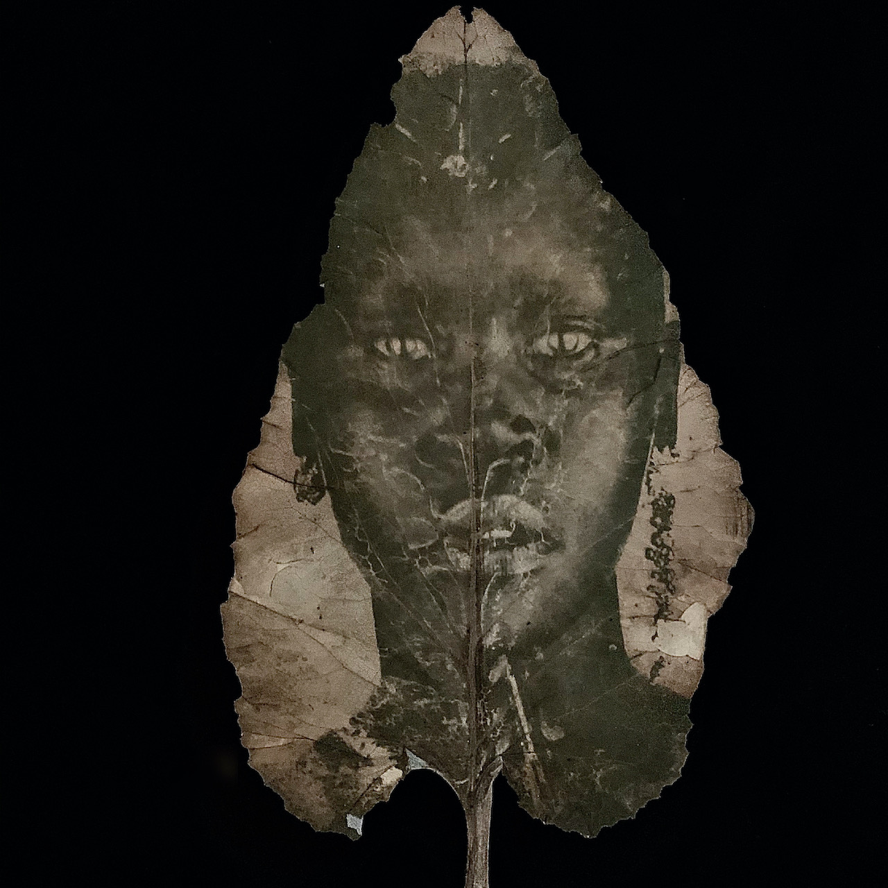
- Would a successful artist such as yourself have advice for underlings trying to break out into the world?
Well first thank you for calling me a successful artist. I do feel that I have accomplished a lot in the past couple of years but there is so much more I want to go after.
My advice is to keep going, stay motivated and believe in your work. Don’t just create things that you think others want to see. Art comes from the heart and you may be surprised that people tend to like the raw and real that comes from you.

Upcoming Shows:
This year has been a whirlwind and after so many cancellations I am happy to say that my main exhibitions that I have been working on are still in the works.
-Photo Synthesis: Transformative Environmentalists, Cleveland Botanical Gardens, August 4th-September 9th
-All That Remains
Lassier Museum, Shaker Heights Historical Society, September 4th - November 7th

