Interview with illustrator
Joseph Vargo
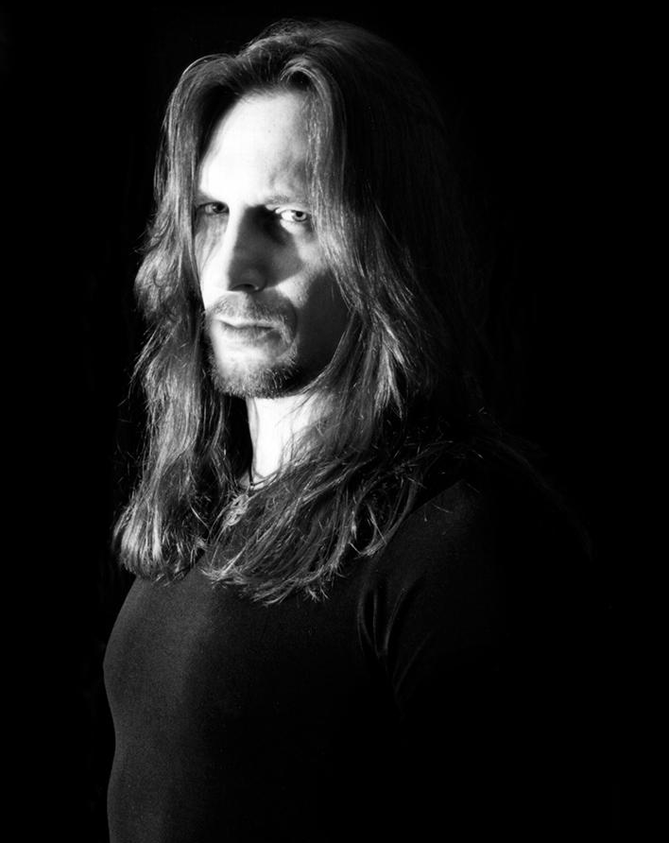
Location Ohio, USA
Websites:
Monolith Graphics
Nox Arcana
Joseph Vargo
Doctor Arcana

Ingredients
- Monolith Graphics
- Painter
- Musician- Nox Arcana

Preparation
- Artistic Weapon of Choice: A. I use a few different mediums to create my work, including pencil, watercolors and oils, but the vast majority of my artwork is created with acrylic paints. I became very busy in the 90s and had to create paintings quickly that could be photographed and scanned for publication, so I became adept at working with acrylics. I love the gloss and depth of oil paintings, but I didn’t have the luxury of time to work in this medium for all the paintings that I needed to create. I do very little sketch work before I begin a painting. I usually gesso a stretched canvas or piece of illustration board with gray gesso. After a few layers of gesso, I paint the entire board black or dark blue, then begin painting some loose grey shapes to form my characters and background structures. Once the main composition begins to take form, I begin adding more colors and using smaller brushes to tighten up the details. As the painting develops, the colors and values become brighter, until I apply the final highlights with white. I realize that my style is very unorthodox, but it enables me to start with a loose idea and make changes as new ideas develop during the creation process. I rarely use photographic references for my characters or fantasy backgrounds, but I do refer to photos when I need to paint animals that have to look a specific way. I’m constantly influenced by other artists, but I like to use my imagination as much as possible.
- Can you tell us more about how you got your start in the art world Mr. Vargo? I always had an interest in art and was constantly drawing when I was kid. After high school, I attended the Cleveland Institute of Art, but became disillusioned with the curriculum and left after one semester. I got a regular job and nearly gave up on pursuing a career as an artist. Eventually I began taking jobs here and there as a freelance commercial artist doing a lot of art for friends in bands. I wasn't charging much, so it barely paid the bills, but it kept my interest in art alive. In my spare time I began painting and building my fantasy art portfolio. I sent samples of my work to dozens of record labels and book publishers and got a few small jobs, but a lot of rejection letters. I decided that if I was going to make it as an artist, I would have to self-publish my work to make a name for myself. After establishing Monolith Graphics in 1991, I began selling my prints and t-shirts at local boutiques and Renaissance Fairs. As my work became more popular, it garnered the interest of some national distributors who wanted to carry our merchandise. By 1997 we were producing posters and calendars in very large quantities to sell in several popular chains of stores like Hot Topic and Spencers. This was a great break and we capitalized on it by creating the Monolith website and adding the web address to all our calendars, postcards and magazines. We were literally getting paid to advertise our company. In 2000, we launched Dark Realms Magazine, which explored Gothic culture. The magazine ran for eight years and was another great way to advertise our products. I did the cover art for all 32 issues, as well as contributing interior art and writing articles. My time was split between my creative pursuits and my business, but my philosophy has always been to do whatever it takes to succeed.
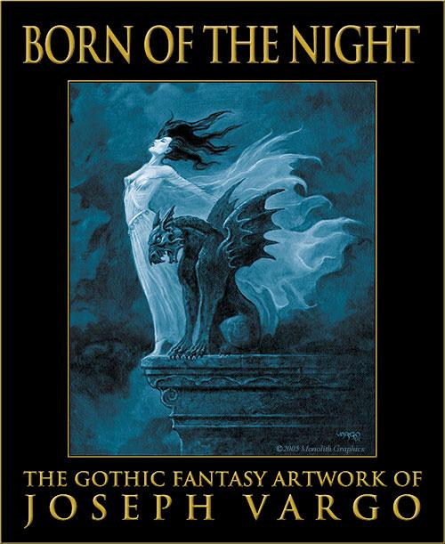
- Do you experiment with other art forms and media? I have done some sculpting over the years, but mainly for fun. I write and produce a lot of music as well for my musical project, Nox Arcana. I’ve produced 26 albums to date, 18 with Nox Arcana and the rest with other bands I’ve worked with in one way or another. I’ve also written several books centering around Gothic themes. We recently released our first video game, The Cabinets of Doctor Arcana. It’s a dark adventure game with tons of puzzles. I got to combine my artistic, musical and literary skills in one project to create the look, sounds and story of the game. It took several years to put it all together, but it was very satisfying to create something like this that allows me to bring one of my gothic visions to life so fans can immerse themselves in it and explore a shadowy realm of my imagination.
- How did The Gothic Tarot come to be? I've always been fascinated with the Tarot. I think my interest was sparked at an early age when my aunt gave me a deck of Gypsy Witch fortune telling cards. A few years later, I picked up the Waite and Marseille decks. I loved the symbolism in the illustrations and how they could be interpreted a variety of ways depending on how they pertained to a person's life and present circumstances. 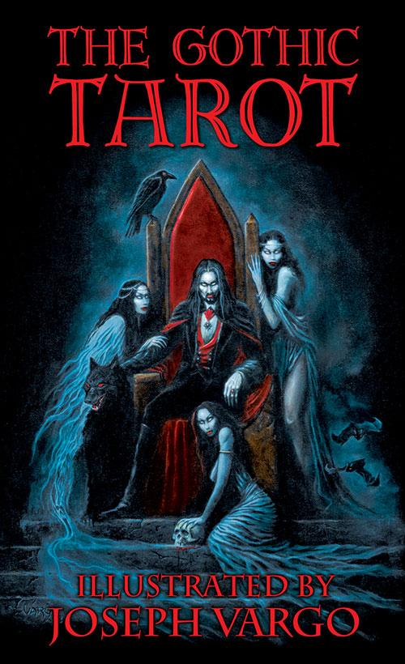 I had considered doing a Tarot deck as early as 1981, but I just didn't have the patience to commit to such an extensive project back then. As the years passed, and my portfolio of work grew, I began thinking that a lot of the images that I had created could be used for a Tarot deck, and since my forte was gothic fantasy art, it stood to reason that my Tarot deck should embrace the darkside. Once we started compiling the images from my existing body of work, which at the time consisted of over 200 images, it was strange how many of them fit perfectly into place with little or no alteration. I think of it as serendipity. It was just meant to be, or perhaps I was always subconsciously painting images for The Gothic Tarot without being aware of what I was creating. A majority of the pre-existing images that were used in the Gothic Tarot were altered to fit the deck. These alterations were usually subtle and consisted of simply adding the various suit icons, but in some instances, the alterations were more dramatic. In the end, I only had to create about fifteen entirely new images for the deck. Creating a tarot deck is an ambitious project for any artist because of the amount of time it requires to research, write and illustrate. The Gothic Tarot is a standard tarot deck with paintings depicting all 78 cards of the Major and Minor Arcana. The images are based around classic gothic themes such as vampires, ghosts, gargoyles and dark angels. A large percentage of the art was adapted from my original existing works, while other art was created specifically for the deck. Many of the existing pieces were altered to include pentacles, cups, swords and wands. Although the project took less than a year to assemble, it represents over ten years of my artistic career. The deck is like a miniature gallery of my most popular works in the gothic realm. We published and distributed the deck through Monolith Graphics, but we ran into a few problems finding the right printer. One of the companies refused to work on the project because they thought that tarot cards were evil. We also had a problem with one of our major retailers who refused to carry the cards in their stores because some of the cards depicted images of pentagrams. It was like we were back in the Dark Ages. Eventually we ironed out all the problems with production and distribution and the deck became very popular and garnered some critical acclaim. The response was so positive and we received so many requests for an expanded guidebook, we decided to create The Gothic Tarot Compendium a few years later. The Gothic Tarot Compendium contains illustrations of all 78 cards of the Major and Minor Arcana, and translations of their symbolic meanings, allowing readers to utilize The Gothic Tarot to its fullest divinatory potential. The book also offers my personal insights concerning the mythological and occult symbolism hidden in the artwork, and includes detailed instructions for several traditional and original card layouts that reinforce the gothic theme of the artwork.
- Of your own work, what would you say is your favorite and why? That’s tough. It’s like asking someone to pick a favorite child. I’ve created hundreds of paintings, musical compositions and stories over the years and I spent a great deal of time working on each one of them. When you step back and look at a large body of work, there are always some that stand out as being better or worse than the rest, but everyone has their own personal preference and mine change from day to day. Of all of my projects, I would have to say that the computer game is my favorite because it allowed me to create art, music and a story for one project. I also did all the sound effects and narrations for Doctor Arcana, in addition to designing all the puzzles in the game, which is another of my creative passions.
- Who are your influences, Frank Frazetta, the father of modern fantasy art, has always been my biggest influence as a painter. His work cast a spell on me when I was a teenager. His paintings vibrantly capture raw emotion, combining the savage and the sensual. Primal thoughts and actions tap into our inherent base emotions, such as fear, violence and lust, devoid of the subtleties of romance and civilized action. If an artist can reach their audience on this level, it stirs these base emotions and resonates deeply within them. Artists should be inspired to emulate their heroes, but never copy them. I strive to instill Frazetta’s primal energy in my Gothic works but also keep my compositions and subject matter original, summoned from my own imagination. My musical influences are soundtrack composers like John Carpenter, Ennio Morricone and Wojciech Kilar. To a lesser degree, I’m influenced by all music I hear, whether it’s a song on the radio, or the soundtrack in a movie or TV show. You can always learn something new everyday.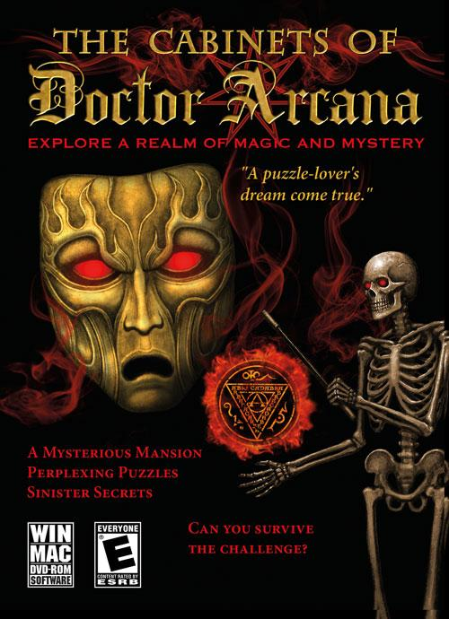
- Do you have a day job? I know you own Monolith Graphics publishing company… I also know you write and create music with Nox Arcana, can you tell us more about that? Running Monolith Graphics has been my full time job since 1991. I’m fortunate to be able to make a living doing the things I love. Creating art, music and writing is the fun part, but there are a lot of business aspects that require a lot of time and effort. As for the music, I had been in a few rock bands when I was younger, but I always loved instrumental music, especially horror film soundtracks. After achieving some notoriety with my art and other musical projects, I decided to create a series of moody, immersive concept albums of haunting melodies and sound effects that revolved around specific gothic themes. I teamed with William Piotrowski, who was only 15 at the time. Aside from his musical skills, he possessed an amazing aptitude for studio engineering. We built our own home studio and began writing and recording every day. Within a few months, we had created the first Nox Arcana album, Darklore Manor. The haunting music was accented by eerie sound effects and ghostly narratives reciting creepy poems, sinister nursery rhymes and even spells from the black books. Over the next few years, we released a series of albums based on various dark themes that intrigued us. The concepts of the albums ranged from haunted Victorian mansions and creepy carnivals to Grimm fairy tales, ghostly pirates and sword and sorcery. We paid tribute to some icons of gothic literature, such as Edgar Allan Poe and H.P. Lovecraft, and even released several albums for the winter holidays. Nox Arcana's music has been used in television, independent films and computer games, and has been performed by two different orchestras. The music is comprised of moody and melodic instrumental compositions inspired by classical composers such as Beethoven and Mozart, as well as modern soundtrack composers. William left the band in 2009 and moved to Los Angeles to pursue a career as a film composer, but I continued Nox Arcana as a solo project and have produced eleven albums on my own since then. William and I are still very close friends and he continues to act as the studio engineer for the mastering process of all Nox Arcana albums.
- Do you have a studio space? Can you show us what it looks like? Any tips on organizing or are you more of creation comes from the chaos like myself? I have a home studio room where I paint and record music. Most of my paintings are smaller than 18”x24”, so I don’t need a huge studio area to paint large works. The room is adorned with skulls, swords and occult artifacts that establish a moody work environment for my subject matter. I set things up so that everything I need is on a small table within my reach as I sit and paint on an inclined drafting table. Tubes of acrylic paint are in a small box and the colors I’m using are sitting on my porcelain palette so I can grab them quickly. I have a small jar of water that always ends up with three or four brushes sitting in it. My work area becomes more chaotic as the painting develops and my palette is always a mess by the end. 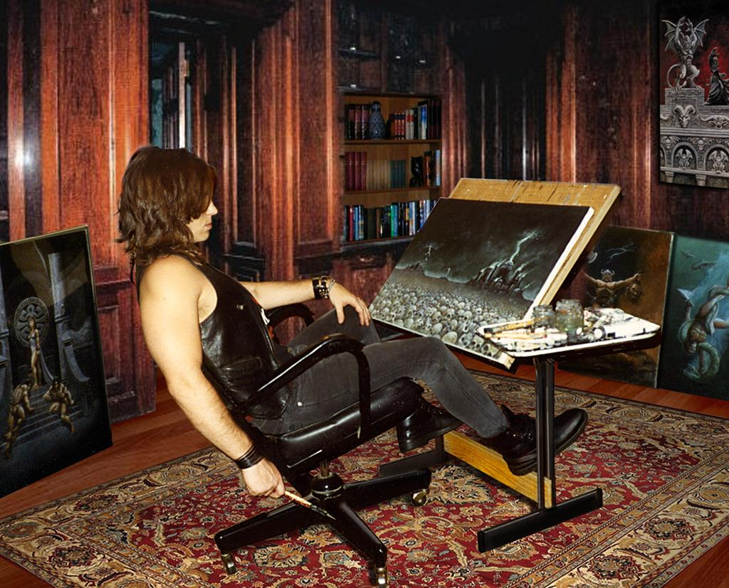 When I work on music, I often have ideas for new songs in the middle of working on other songs. I record everything into individual computer files and organize them in folders according to themes. I have hundreds of unused melodies that I’ve compiled over the years. A lot of them are really strong pieces, but they just didn’t fit in with any of the themes I was working on. Eventually I’ll stop doing strict concept albums and start developing and releasing a lot of these orphaned songs.
- Your partner Christine Filipak and yourself; how does that work? I have personally had conversations with other artists who think that two artists will just be poor and homeless together. Some are concerned that if one partner is more successful than the other, it might create jealousy. I however, think it would be fun to have another to bounce ideas off of and create works and understand each others need for creative time. I wouldn’t have it any other way. It’s worked out great for us. We have very similar tastes and our skills complement each other. There’s never any jealousy or ego involved. When we worked on projects like Madame Endora’s Fortune Cards, Dark Realms Magazine or The Cabinets Of Doctor Arcana, we both contributed a lot of creative ideas and work. We both want the finished product to be the best it can be, so it doesn’t matter who contributes what. We both get credit for our work, but because Christine does so much more behind the scenes, I have more time to be creative, so I get more glory and end up with more products with my name on them. If it weren’t for Christine, I’d probably just be a guy who paints and makes music in his basement and my work would never be seen or heard by the outside world. It’s great to have someone that shares the same vision, but brings other ideas to the table and also contributes countless hours being creative in addition to all the time spent on the less glamorous rigors of running a business.
- Would a successful artist such as yourself have advice for underlings such as myself and my readers trying to break out into the world? I painted more than 100 paintings before I made any money at my art. The secret really is persistence. Being creative consumes a lot of time. If you don't spend that time doing something that you find gratifying, you will quickly lose interest in your work. Doing what you really love has its own rewards. My persistence with my work is inspired by my own sense of accomplishment. I am only being true to who I really am while fueling the dark fire that burns in my heart. The other advice I would give is to do whatever you can to get your work out there, whether it’s at gallery shows, local art festivals or on the internet. Display your new works on social media platforms and in other venues like Deviant Art. Youtube is a great venue to advertise your talents for free. Make videos that show your art or show you creating or discussing art techniques. It’s hard for artists, especially the more introverted ones, to grasp the concept of self-promotion, but it really is what separates the popular artists from the unknowns, no matter how good you are.

- Lastly: Do you have any upcoming shows, events or projects you would like to plug? No. I don’t do live shows or conventions anymore. I’m a pretty private person and I love spending my time creating new works.
Thank you very much for allowing me to be a part of your holiday party and allowing me to interview you!
Thank you, Cecelia.