Interview with paper artist

Wendy Bale
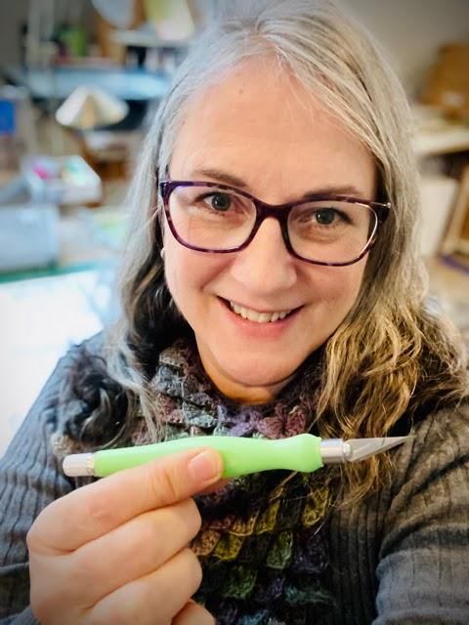
Wendy with her favorite knife for paper cutting
Location Jamestown, NY, USA
Website Www.wendybaleart1st.com
Youtube Wendy Bale
Wendy Bale Art1st - Home
@Wendy_Bale_Art

Ingredients
- Paper Cutting
- Graphic Design
- Drawing

Preparation
- Artistic Weapon of Choice:
Hands down my favorite tool is my Excel Blade shown here. When I was in my 20’s I had a graphic design job doing traditional paste up with an Xacto Knife 40 hours a week. This ergonomic handle is a huge improvement and the blades are better. No-roll flat sides, plus, helloooooo…day-glow GREEN!
- If you don't mind telling us about how you approach your work, for example do you create sketches, story boards or Photoshop references first?
Everything I do starts with a sketch. I like to work out values and composition in little thumbnails. They usually aren’t very pretty, but they help me noodle out the basic plan. If I’m doing something complex, like a composite of various elements, I sometimes throw it into Photoshop to work out the design.
- How did you get your start in the art world?
I worked in advertising early on, then went out on my own for a while doing illustration and freelance graphic design. At 28 I got an opportunity to start up a fashion catalog creative department for a silk clothing company. All they had was a tiny Mac computer with a 9” screen. Nobody knew how to use it (even me!) I never dreamed it would lead to a 30-year career.
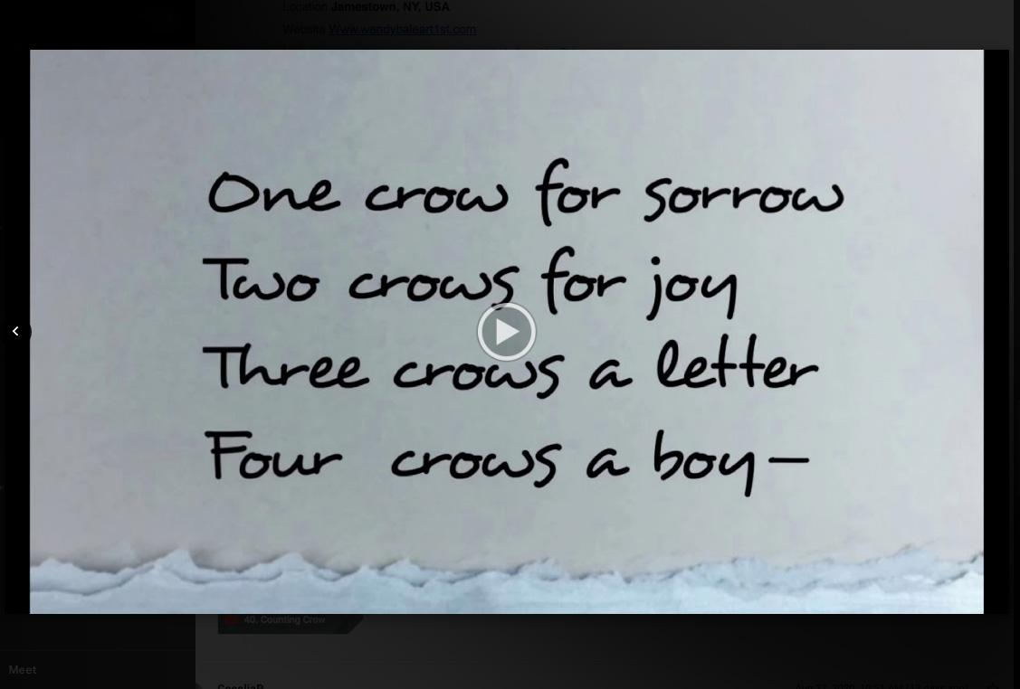Youtube: Counting Crows Part One
- I would say you experiment with other art forms from cut paper, light boxes, sculptures with moving parts (I'm thinking of that kool bat with flapping wings) circuit boards...am I missing anything? lol and how did you come about to start working with all these different media?
Sadly, the corporate job pretty much forced me to give up my own artwork. I had a studio, but it was just a storage space for art supplies. When I moved out here to New York, I no longer had to travel all the time. I started taking workshops and getting back into my own art, so I was happy to try anything. The automaton came from a call for work called “The Mechanical Circus” at 3rd on 3rd Gallery. I saw a YouTube video and thought it could be done in a weekend. I worked on that piece for six weeks before I got the mechanics to work correctly! I love to create things that fool the eye. Like that circuit board, which is really all cut paper and a wee bit of ink. Did I fool you?

- Who/what influences your work?
Early influences were graphic designers, printmakers and illustrators like M.C. Escher (I was born on his 100th birthday, by the way), Albrecht Durer, and Aubrey Beardsley. From looking at their work, I developed a love of black and white which I still have today. In spite of growing up in a family full of painters, I’ve always been more comfortable drawing or doing printmaking than painting. In the past few years while exploring the cut paper medium I have looked to the internet and social media and discovered amazing work all over the world. Contemporary artists, many of them fellow members of the Guild of American Papercutters, have had a huge influence on the techniques I’ve tried. I’ve just barely scratched the surface.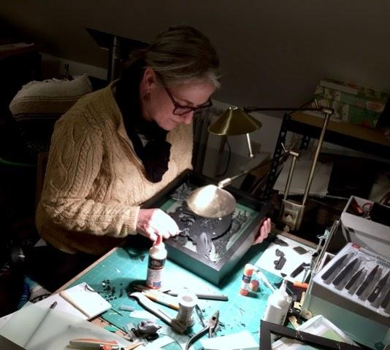
Working on New Process, a cut paper piece in the night studio
- I believe you moved here to work at a graphic design firm? Are you still there, if so how do you balance your art and work?
I retired from the corporate life on April Fool’s day 2019. Before that, I did a lot of work in my studio at night, hence the reoccuring “Night Studio” theme I play with. I used the art to decompress after the stress of the job.
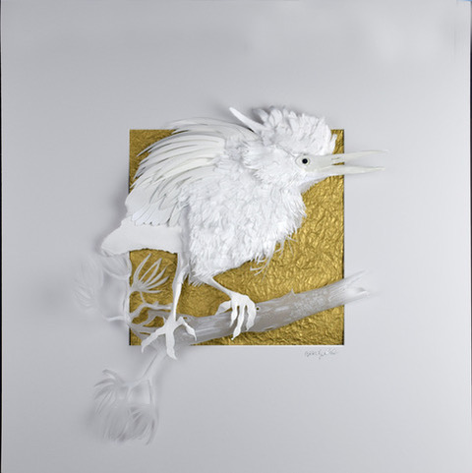
Green on Gold, 24 x 24 Private Collection
- How has business been during the past few months with the pandemic? Have you had to change anything about how or when you create?
My furniture-designer husband, Sandhill Bill and I were a couple weeks out from hanging a show we had worked on for two years when everything was postponed due to Covid-19. My solo show in May was moved to August and, with a few changes to the way receptions are usually done, we managed to pull that off—but we had to be creative. I have been super busy this entire time and actually have more trouble with life balance during the pandemic. I guess I need to learn how to relax.

- Of your own work, what would you say is your favorite and why?
Probably my current favorite is “Green on Gold” which is a white cut paper green heron on a gold metallic paper. It was one of those pieces that just came together easily. I like working in all white paper and I love our little green herons that visit our backyard pond. I have some big charcoal on canvas drawings that are close to my heart as well. You’ll have to wait until our show next spring to see those!
- The one thing I am dying to ask is, how do you create all these videos!? It must be time consuming, do you work on them alone or do you have assistance?
I started working with an art business coach, Sergio Gomez with Art Nxt Level out of Chicago. He encouraged me to do the videos. I make them on my phone and edit them in iMovie on my laptop. I use MoShow, an app on my iPhone to do the fancy transitions. I use a tripod and rarely need assistance, but ask Bill to help me if I need a photo assistant or a male voice over. Time consuming? Yes! I really like the editing part and spend at least one-two days a week working on these weekly videos. Here’s one from the night studio: https://youtu.be/FlCDPc3j-Q0
I also adore doing stop motion video and those require even more time, but moving little cut paper pieces around for hours on end is pretty exciting when you play it back and see the characters flying across the screen. Totally old school there, but super fun. Here’s a favorite: https://youtu.be/yfYRMToj8Po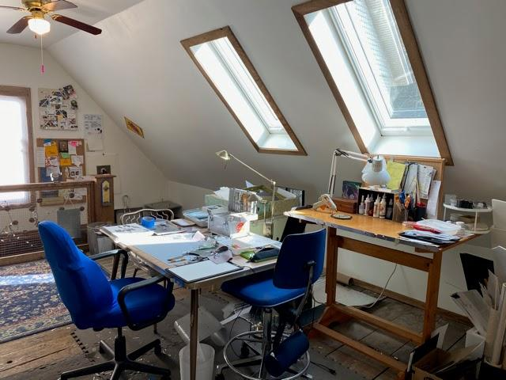
The paper cutting studio above the garage.
- I believe you and your husband Bill are from Wisconsin, how did you end up in Jamestown, New York of all places?
Bluestem needed a senior designer. so they transferred me to a different catalog company, Blair in Warren, PA. Bill and I were thrilled with the idea of living in such a beautiful area! We found this house on three acres, with plenty of wall space for our art collection, a barn for a shop and a hidden pond. It was close enough to my new job so we moved in and never looked back!
- If you weren't an artist, what is another career path you may have taken?
Maybe a photographer. My parents were photographers and owned and operated a photo studio in Northwest Iowa. I would have been smart to pay better attention as a kid growing up in the studio. I used to quip, “I don’t know an F-stop from a bus-stop!” As an adult, my design career revolved around photography (I hired and directed fashion photographers) and now, photographing the cut paper pieces is a big part of the process. Kicking myself— I should have learned more when it was right there in front of me.
- Do you have a studio space? Can you show us what it looks like? Any tips on sorting/organizing or are you of the mindset that creation comes from chaos like myself?
Here at Sandhill Designs Studios we are lucky to have a lot of studio spaces. We converted the attic of the garage into my cut paper studio. It’s great for smaller projects, but if I want to work large—or need great ventilation— I use a section of the barn Bill uses as a wood-shop. We also have a little photo studio set up in a spare bedroom. This was a boarding house in the 1800’s so there are a lot of bedrooms. I waffle between being hyper-organized (losing everything) and being surrounded by stacks of paper (knowing where every scrap is piled).
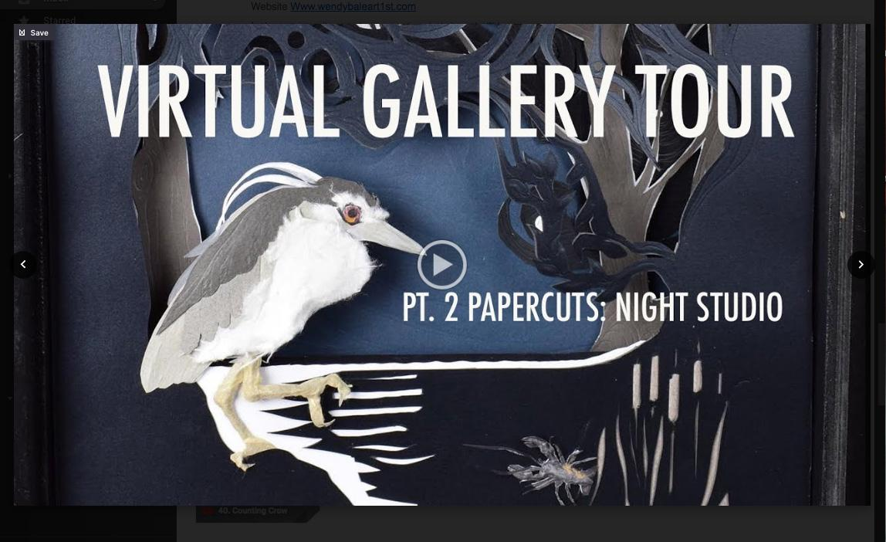Gallery Tour — Pt 2: Night Studio
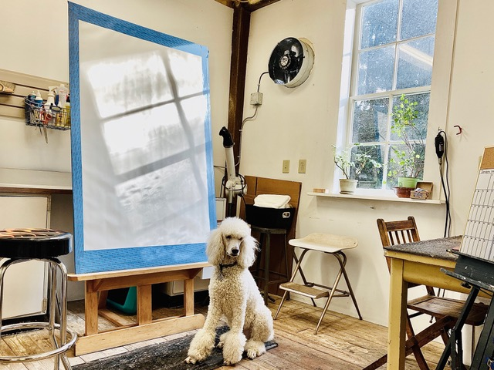
Charcoal Studio in the barn, which has a huge fan for ventilation (also doubles as Poodle Parlor)
- Would a successful artist such as yourself have advice for other artists?
A creative person…someone with talent, drive and a practiced eye can be an asset in many jobs. Be open-minded. If you need to make a buck, look for a way to market yourself outside the norm. You’re not selling out, you’re just doing what you have to do. I had to make a better living, so I designed catalogs. My best advice is to stay connected and be supportive of your fellow artists. Like you doing these interviews, Cecelia, this is an awesome project. My husband, Sandhill Bill likes to say, “All boats float!” He’s had many years in the art community and knows the results of generous promotion. When we celebrate each other, we bring up the art community as a whole. Put yourself out there creatively in these crazy times. We are all in this together.
- Lastly: Do you have any upcoming shows, events or projects you would like to plug?
This fall I am doing workshops on Zoom, which will be a fun way to introduce people to paper cutting during this time of social distancing. While the physical show is past, you can see the online viewing room of my recent solo show, Papercuts wendybaleart1st.com/papercuts-solo-show. Additionally, my work is included in the International Online Art Collective Special Art Sale, http://www.internationalonlineartcollective.com/special-art-sale/ and closer to home, at Tri-County Arts Council (Olean, New York) “A Little Something” https://www.myartscouncil.net/gallery.html#A%20Little%20Something. Next spring the postponed duo show, “Riparian Zone" will be exhibited at the Crary Art Gallery in Warren, PA. It’s going to be worth the wait, I promise! If you subscribe to my quarterly newsletter, “Snippets” I will make sure you are the first to know when we get a new date. Sign up at the bottom of any page of my website: wendybaleart1st.com
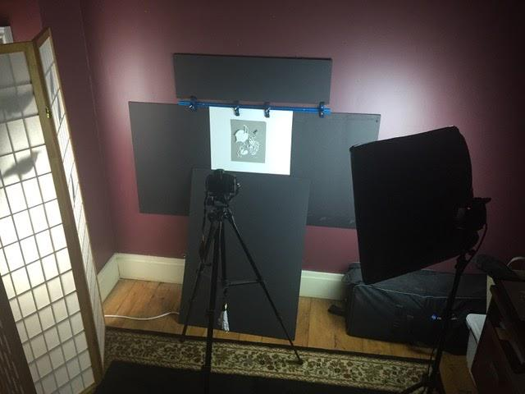
Tiny photo studio set up in a spare bedroom of the old boarding house.

Chef-d’œuvre
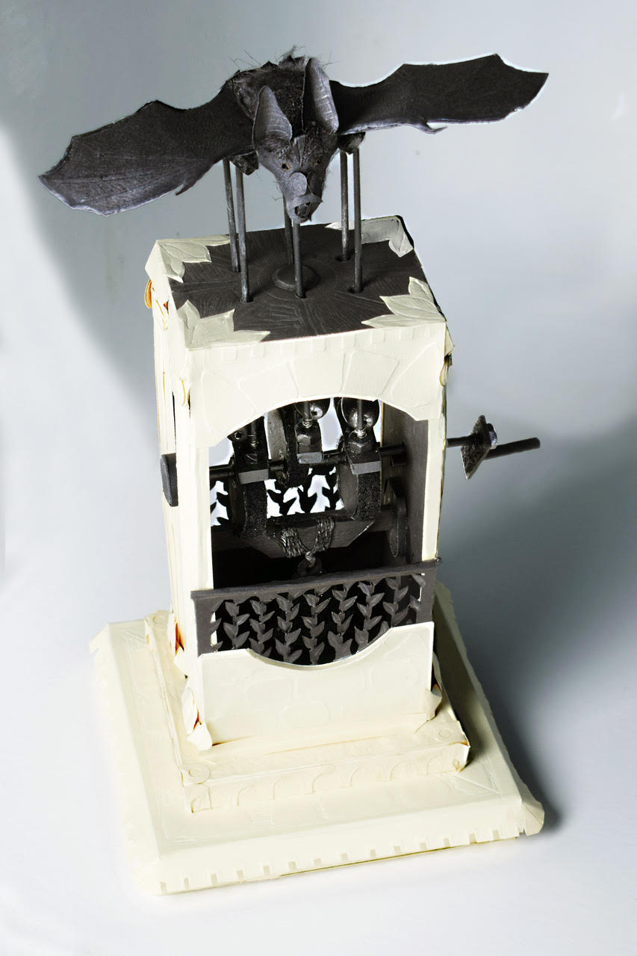
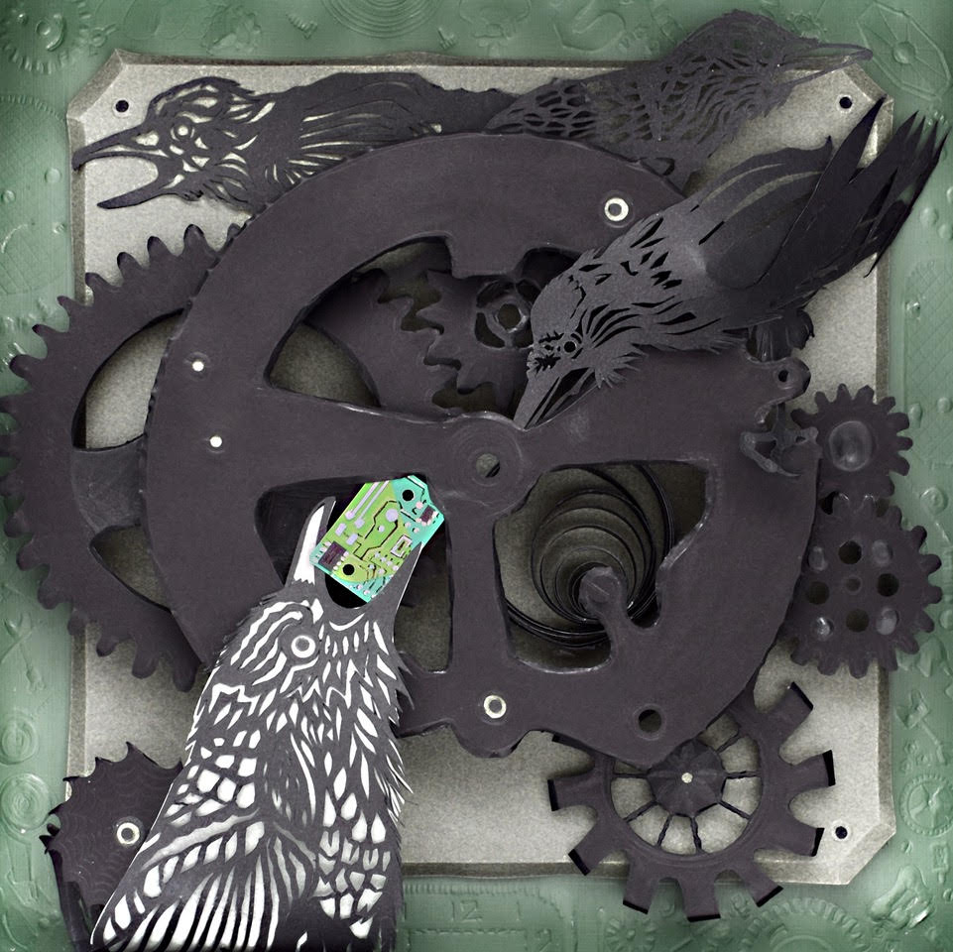
The Mechanical Circus” at 3rd on 3rd Gallery

