Strange Brew Interview with illustrator

Azriel Mordecai
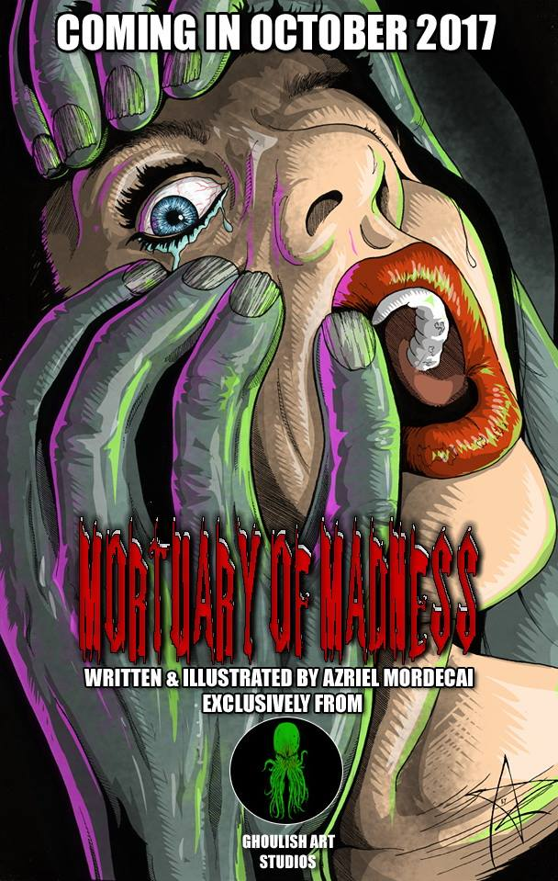
Location Syracuse, NY , USA
Patreon GhoulishArt
Facebook @GhoulishArt
Twitter @GhoulishArt
Instagram @ghoulishartstudios
Band Info Omega

Hats Worn
- Illustrator
- Musician
- Lovecraft Expert
- Furdad
- Computer Builder

Q & A
Artistic Weapon of Choice: Pencil, mechanical. Usually a Uni Kura Toga. After that, Sakura Micron pens. I've used those two things for most of my career.
The whole color thing is fairly new for me. Coming from comics, I focused on pencils and inks because someone else worried about colors. I never really tried developing it as a skill until fairly recently.
What made you start wanting to do colored pieces?
Knowing that I wasn't good with color... I knew that the concept was the same as what I had done with pencils -shading and gradients and stuff like that, but I had just never developed the skill. My first few attempts were disappointing, so I put it down for a while and started doing my colors digitally, because I could step back and delete color I wasn't happy with. But I prefer really drawing and producing physical art so I never would have just settled on digitally doing everything. So, I started doing little things here and there to build up technique and confidence.
Talking to other artists whose opinion I respected, like yourself and Edward Yancey, I was able to learn different things and that helped.
Yes, I think networking with other artists is an invaluable resource.

Of your own work, what would you say is your favorite and why?
You know, I think it changes. Space Chimp is probably my current favorite. I worked on that one on and off for over a year... Basically in two two week sessions a year or so apart, and I really pushed myself with it to do more than I had done before because it's such a cool image. But I think an artist will always tell you that their favorite was last one that presented them with a challenge and they were happy with the outcome.
I think that's because a lot of artists are generally never completely satisfied with what they do. They could always tweak or improve on it.
Or at least, they think they can. Parents never want to see their children grow up, right?

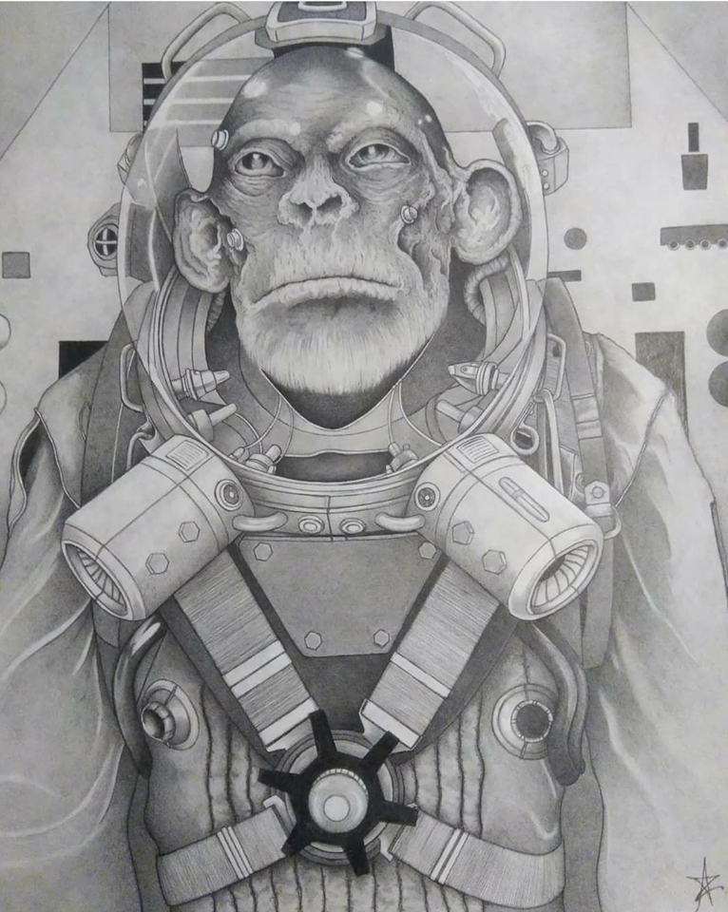
I know you have had some issues with people stealing your work, would you care to go into detail? Ooof... It's sort of the way things are nowadays, right? If the internet can be blamed for anything, it's for the death of appreciation for the arts. Music and art are things that people just seem to expect to be there when they want it and the creators are more of an afterthought. And artists and musicians will tell you that it is increasingly harder to make a living doing these things.
Something that bothers me is the mentality of "You should do it because you love it", which is completely ignorant of the concept of "trying to make a living doing something you love".
As for me, I've had my artwork downloaded and re-uploaded several times without attribution, credit or links. I've had my artwork being sold for download on a foreign site. And I've had flame wars with sites that have tried to justify stealing my work and distributing it against my wishes. It's something artists have to deal with from that percentage of the population I was talking about a minute ago. 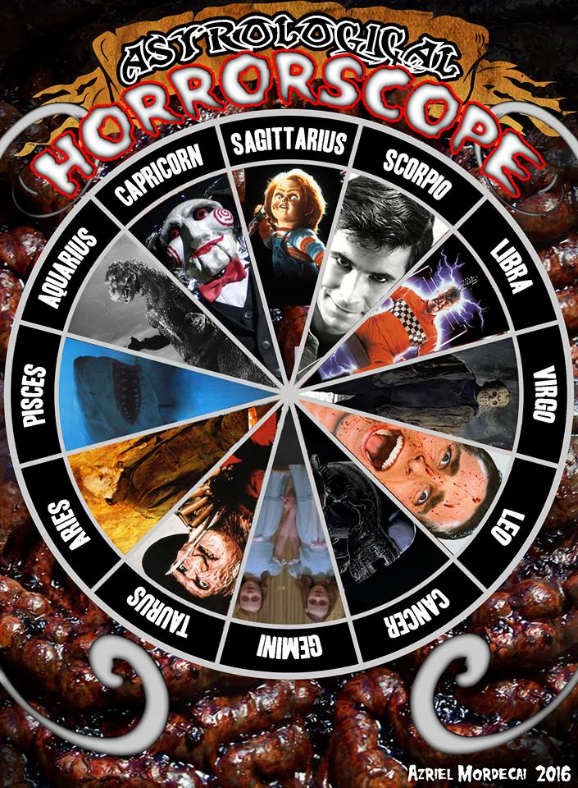People who just expect art or music to be there and who have no concept of the very real reality that you get what you pay for, and if people do not pay for art and music, it will just not be available. Musicians will not foot the enormous bills to do what they do if they simply can't afford it. Artists can't put in the time, the material costs, the time to develop and progress. People buying their work does more than put money in their pocket, it puts confidence in their heart.
A confident artist can do amazing things.
It's like Kevin Smith said, and I paraphrase ‘if you encourage an artist, you can get amazing things for life. Discourage them and you get nothing.’

Who are your influences? Well, Bob Ross and a guy named Mark Kistler. They were the closest I've ever had to real art instruction aside from reading or whatnot. Mark Kestler was Commander Mark and his PBS TV series taught me all the basics of drawing and cartooning when I was a kid. I learned words like foreshortening, I learned about perspective and dimensions. Bob Ross made me feel like I could paint even though it was years before I picked up a brush. I learned a lot from listening. After them, I'd say George Perez, Caravaggio, Durer, Neal Adams, Bart Sears we're all artists I picked up a love for early on. Jim Lee is probably the only artist in comics who could be considered on the level of Jack Kirby and I always look to his linework for just "That's what art can do..." sort of inspiration. Joe Jusko and Alex Ross as well. They make me think I can paint the way I draw. I can't, but they make me want to try.
So you were self taught?
Yeah, entirely. I took art classes in high school, but it bored me. They spent too much time on the artists and their lives and the schools of art and all that history, and not enough on art. When we got around to art it was , "here's some chalk, draw that bowl of fruit". I was drawing comics by this time and the teachers just said it was wrong. It's funny now that comics are so mainstream and back then I was very much looked down on among the artists for drawing them.
But being self taught doesn't mean I don't take it seriously. I've learned many things from many people, I have read every book I can get ahold of and I'm always working to improve my abilities. I think some people think being self taught means you didn't take it as seriously. In my case, it meant that I just want the person the curriculum was designed for. In a lot of ways I was ahead of the curve and in a lot of others the teachers were behind the curve.
I learned from Commander Mark, Bob Ross and a column Bart Sears wrote in Wizard Magazine called Brutes & Babes. His columns taught me a lot about comic art and I incorporated a lot of that into my frame of reference. That was the most formal training I've ever had if you want to call it that.
The curriculum isn't designed to be interesting. The naughty bits are overlooked, the darker stuff is only mentioned. They want to ignore the sexual or the graphic because they don't want to disturb the children or whatever. I always found it funny though that the history books were filled with paintings of horrific battle scenes... Waterloo, Ardennes... People bleeding to death or run through with swords. A lot of the same stuff they avoided in art curriculums. I still don't get it.
When I discovered Caravaggio, Durer, Dore and Bosch, it blew my mind. I couldn't believe they didn't show us that stuff. That would have been interesting. I'm sorry, but for all the love it gets, the Mona Lisa is pretty damned boring when you are a teenager.
Hahaha. Yeah I would have to agree. I personally found it hard to relate to most academic artists. They are mostly white males. I think that is rather discouraging.
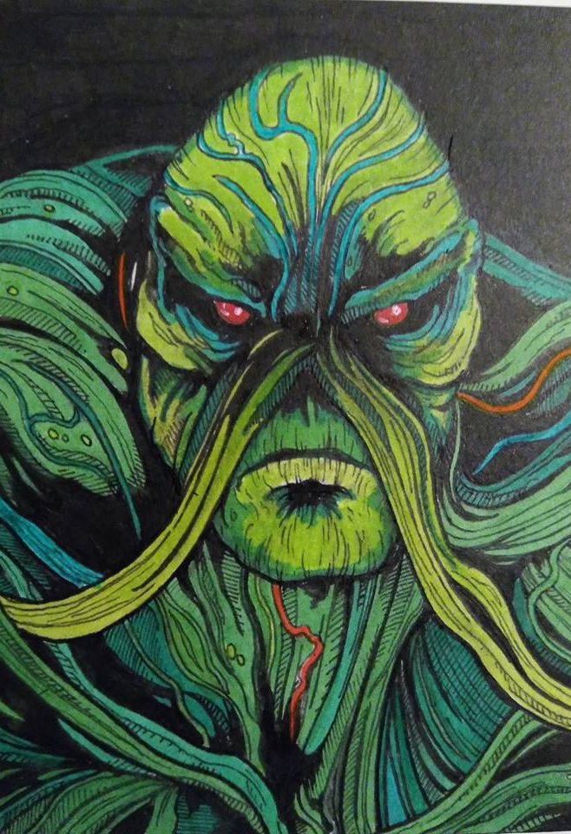
I always wished I could get an art teacher like Robin Williams in that movie... "Screw the boring stuff... Here's a painting of a woman having sex with a goat!" I mean, that's the mythology and there's dozens of paintings like that, but not in the art curriculum.
Movies are the same way though. Violence is okay, but hide the boobies. It's a shame really. Especially in terms of art study. Sort of off subject, I think if kids saw more classical art and nudes, there would be a more realistic body expectation among the youth. Old school painters didn't paint beauty the way modern opinion depicts super models as representing beauty. Real beauty verses contrived beauty.
I think you are on with the idea that more nude art in schools possibly helping with body image issues
refresh my memory, what is your ethnic background again?
Half Mohawk and half Euro mutt, basically.
My mother's side of the family has Dutch, German, French and English origins.
I know you once said that you involved with a native tribe but not allowed to take part in certain ceremonies if I recall correct.
Were you in any way influenced by Native art, music or culture?
Right, but those were rare really. I mean, I never really tried to insert myself into it either because I had respect for the fact that it was traditional for it to be this way. I didn't take it personally.Yeah, to a degree I was. I love that culture. I don't really consider myself a part of it any more than I consider myself a part of white culture or New York culture or any of that. I focus on my own culture... The one of my universe. I love native drumming and that has always been a factor in my music, but the art has never really been of interest to me.
Do you have a studio space? Can you show us what it looks like? Any tips on sorting/organizing or are you more of creation comes from the chaos like myself?
I have an area that an organized and cluttered mess. It serves for my computer space, art space and music space so there's a mixing console and a computer desk, and a drawing table... It’s sort of like Jack Kirby's dungeon. Not a hospitable place but a pace. Where work gets done. As for organizing, I don't spend a lot to organize. I've found certain cheats, I guess you could say. I use CD towers and empty CD cases to hold markers, though I have recently been moving over to Thornton's Art organizers that are less than ten bucks each and store a large number of markers. Artist's Loft makes some that they sell for around the same price at Michael's stores that fit fewer markers in the same space, but fit larger markers like the Sandford Prismacolor, Copic or the TouchFive markers I use now.
"but a place where work gets done"
Honestly though it's been so hot I haven't been up there in a bit. I've been working from a folding table and a huge clipboard because I have AC in the rest of the house. It's a mess. LOL
At least you're honest!
One of the benefits of working with pencil and paper. I don't have to move a ton of stuff
Ahem, what are you trying to say ?
Some artists only stick with one media but you hop all the way across the realms of expression, can you tell use more about what you play musically and how you balance that (and your day job) with your art?
Well, aside from drawing, I paint occasionally and do models and that sort of thing. Music is my first love and I've been playing since I was 13, starting with drums before moving to bass, guitar, keyboards and eventually stuff like the cello and zither.
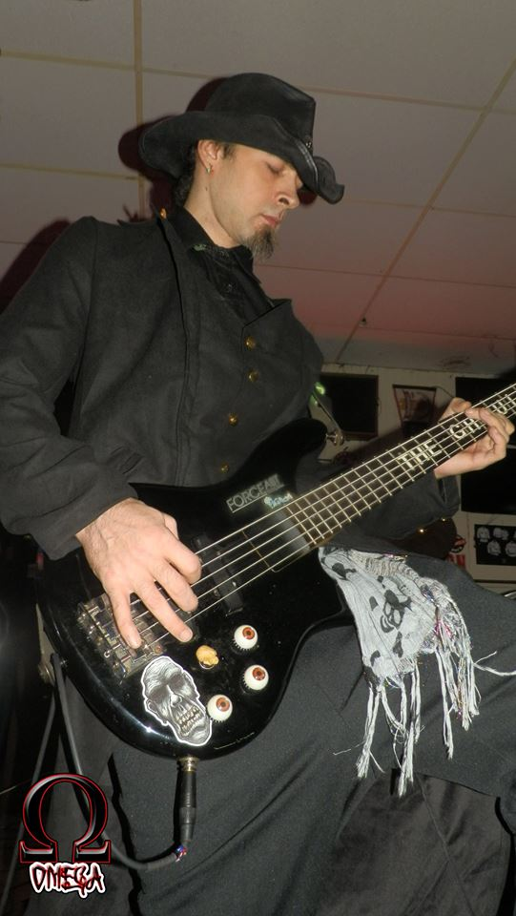
Again, I taught myself. I've always been around musicians so you could argue I was taught without being taught, like on the job training. It's tough keeping up on everything really. I play bass in my band and we rehearse several times a week when we aren't playing and that's a lot of time. Then I still have to work on my own, keep up on the other instruments and draw. This is the main reason I control how much art I commit myself to when it comes to commissions or commercial projects. That's why I have a hard rule that I only take commissions if I'm interested in the subject matter.
So what fuels you to keep going, I know you told me about some REALLY potent coffee before?
Black Blood of the Earth. Great stuff that can put you into orbit. If you can't get it though, Death Wish is also tasty. (Here’s to hoping they see this and put him on their Death Cast)
You can accomplish so much more when you don’t sleep much. LOL
That is a great rule to have. Recently you had your work featured in a film, where can we see that and would you mind telling us how it came about?
Yeah, Eldritch Code. That was really cool. It's a short based on a story from an issue of the comic Cthulhu Tales from BOOM! Studios. I was contacted by the director, Ivan Radovic after he had seen some of my work online. He thought it was perfect for what they were doing and asked for certain pieces and I sent them pretty much not having any real idea of what it would amount to. I knew it was something related to the Lovecraft Cthulhu Mythos but not much else. When I saw it, I was impressed by how much of my at was used and how amazing it was as a film production. I'm not saying that because of my involvement in any way either. I watch a lot of horror, both indie and mainstream and have watched many shorts and many had attempts to make a Lovecraft style film and it's so hard to do. But somehow Ivan nailed it. It's available on YouTube for free on the directors website, just search for "Eldritch Code".
Any other projects you’d like to talk about? Pink Marilyn, or Clockworks perhaps.
Clockworks is something I'm really looking forward to getting finished but myself and my partner on that project... You might know her. Very talented lady...
We've both been very busy lately, but are both excited about it. It's a sort of steampunk fairy tale influenced by stuff like Miyazaki and Tim Burton. It's definitely different in that it's sort of a family story, but also very dark in places, while very bright and hopeful in others. It's not as same as a lot of stuff nowadays but not too bizarre to be interesting. To adults or children.
You talkin' bout moi?
I am, yes!
LOL
I am very excited to get the ball rolling on that project when the time comes. It will be the biggest project I have been involved with to date and has the added bonus of working along-side my muse.
Awww. It's definitely a big project. Lots of characters. It's like a whole world building thing really. And that's even at the heart of the story. I can't really think of anything like it despite the fact that it's very down to earth at it's core. It's interesting to work on a story where not a single aspect of it, really, exists in any way. Every character is a unique creation. I think that's an interesting and unique thing.

Upcoming Shows:
November 2018 Syracuse PowerCon

If you see this guy would you wish him a happy birthday!

