Interview with writer
Jesse Pohlman
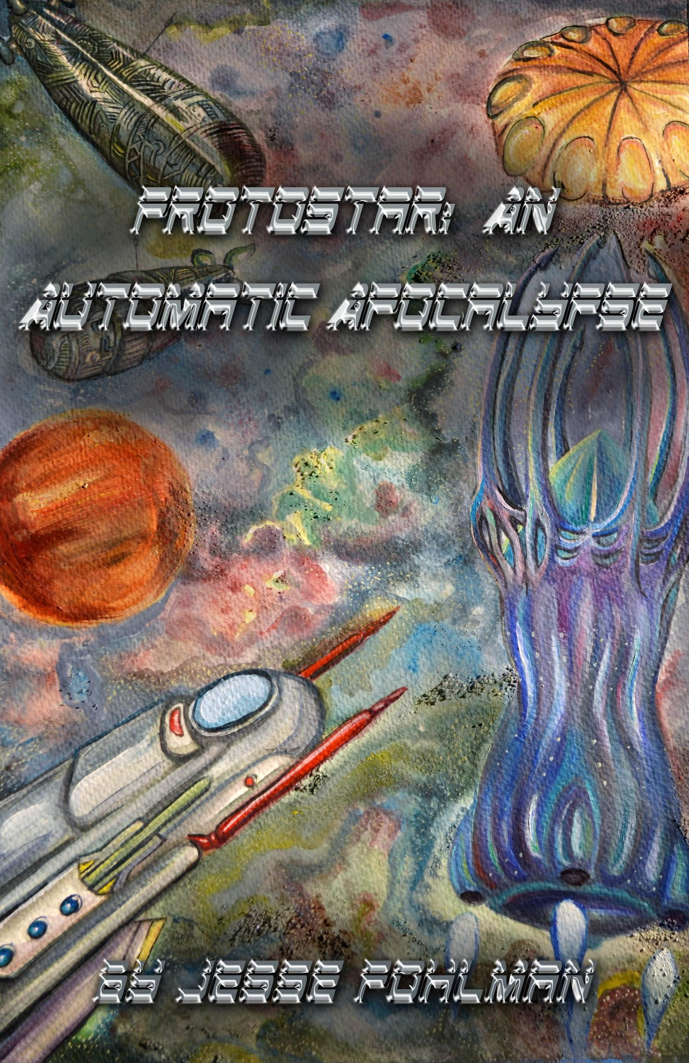
Location Long Island, NY, USA
Website: www.JPohlmanWriting.com
Twitter @JPohlmanWriting
Facebook: @jesse.pohlman
jpohlmanwriting@gmail.com

Ingredients
- Writer
- Lifeguard
- Educator

Preparation
- Artistic Weapon of Choice: I’ve honestly dabbled in most things, from good ol word processors to writing terrible scripts in Python, and I vary things up with Twitter chains and even protest signs on occasion. I guess the best way to answer this is: What gear do I use? Well, I use computers for semi-obvious reasons. I prefer a mechanical keyboard when possible, although lately I’ve started to question that. I strongly recommend dual-screens if you’re going to be doing any kind of research (or, at least, become a master of snap-to-the-side-of-the-screen feature), because being able to swap back and forth as if you had two different things on your physical desk is essential, and I went literally decades without fully grasping the advantage. Money is an obstacle to a lot of creative careers, so make it a point to treat all of your gear well and try to avoid cheaping out – at least in terms of durability. A low-powered laptop you can beat up a bit and keep for ten years is still a laptop to have, so long as it maintains basic functionality with whatever situation you might end up with; for example, having an HDMI output in case you need to plug it into a smart-board to teach a seminar or class. I also maintain at least one journal, and I use multi-colored pens (Red, blue, black, purple and green) to make different notes.
- Can you tell us more about how you got started with writing? I started as a tiny nooblet in a text-based roleplaying game called Dragon's Gate, back on AOL 3.0. I progressed into the distilled crack that was AOL Chat room roleplaying (If you know the name Rhy'Din, you know what I mean). I know that teenage-me spent a lot of time indoors due to a lot of time in not-the-best-health, so I connected with other people, many of whom I'm still friends with to this day, through creating characters with them and eventually going on to create whole worlds together. Most of this was conveyed through text, though we involved image files and the like; some of the best creators I know came from a background like this and went into acting, writing, or actually making games or owning games stores. The thing with me is, I tie it all back into an urge to create, using words like Lego blocks and building gigantic storylines. In fact, I got a lot of my influences from playing Lego with friends, too.
- Of your own work, what would you say is your favorite and why? Ahh, the, “Pick your favorite child!” question! Of course, books aren't children, and favorites change over time and shift around due to their subjective nature. I think, out of all of the novels I've written, Protostar: An Automatic Apocalypse is probably my favorite. I wrote it while my father was going through serious liver issues that required a transplant to cure. I'd spend hours while he got tests and treatments just tapping away on my laptop. I incorporated my love (and fear) of the concept of Artificial Intelligence. I got to write some crazy star-ship combat scenes while also exploring Humanity's frailty, both emotionally and physically, compared to what the future is shaping up to be.
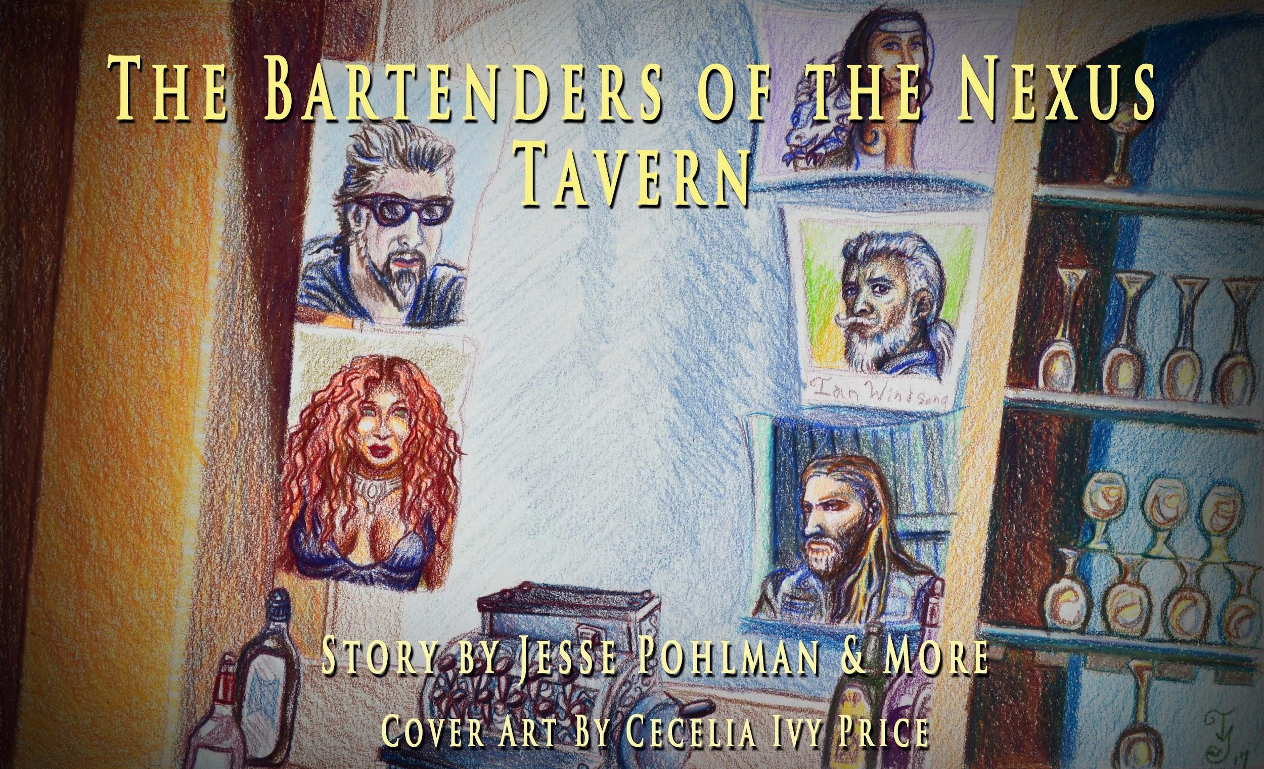
- Do you have a day job? This is a complicated question! The answer to that is no, but not for lack of trying. Right now I'm lifeguarding and doing a lot of tutoring, because I was a teacher in New York City for a couple of years and was a Teaching Assistant elsewhere, before that. When I've looked into writing jobs, it's been very hard to find them in my area; I think it speaks to a comprehensive change in the way content creation and consumption has shifted since hand-held computers became not just, you know, an invention but became ubiquitous to the point that everyone has one with at least one camera. Orwell would probably smack each and every one of us, except that he'd relent at the last minute and concede that technology is really more about what you do with it than what it's capable of.
- How do you juggle your day job with with your writing schedule? I've been lucky, in that a lot of what I do is very creative. Lifeguarding is, when things are going right, a relatively low-difficulty job where 95% of what you do is watch the swimmers and occasionally have to correct dissident patrons. There are real emergencies, of course, and I've been in more than one situation where someone's life is on the line and I've have to make snap decisions to decide the best way to save their lives. With that said, I think those experiences have given me an understanding that there are consequences to our actions or lack thereof, and it translates into my writing well. Teaching was the same way; I'd spend hours crafting lesson plans to hit certain things I needed to convey, and to express my love of history and writing.
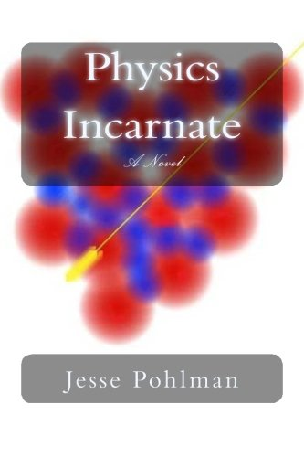
- Who are your influences,
The 'best' book I've ever read is Oryx And Crake, by Margaret Atwood. In all honesty, though, my influences were more teachers and professors and the things I learned from them than it was particular writers, mainly because I never got to know those writers as well as I got to know them, although many of them also write, at least academically. Those people helped shape my life in ways that most individual authors couldn't do because I've never even seen most of them. My love for Dystopian literature specifically started around 9th or 10th grade and went straight through my college years. That said, now-a-days creators have a lot more power to reach into your home and interact with you, so sometimes I'll be a fan of a writer's non-written content, but not have read their books (J.P. Bequbain's Youtube channel Terrible Writing Advice is a great example). When I was really young, I was a huge X-Men fan, so the Marvel Cinematic Universe is pretty much a gigantic thrill ride for me, although I'm crushed that they canceled Luke Cage and Iron Fist, even if Danny Rand was my least favorite of The Defenders (Farewell and Excelsior, Stan Lee, who passed as I worked on this). Then there's Anime, and my tastes range from Akira Toriyama's Dragon Ball franchise (Vegeta > Goku) to Kentaro Miura's Berserk (the Manga).
- Do you experiment with other art forms and media?
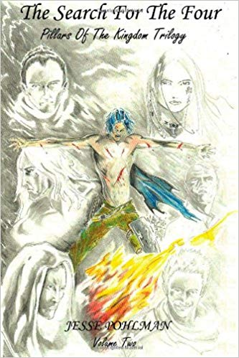
Huh. Well, I kind of touched on this a bit, but I've experimented with doing Youtube video reviews of Dystopian literature, film, and concepts. I was a big fan of James Rolfe and Doug Walker (Y'know, before everything went sideways with Channel 'Awesome'), and I posted some materials but nothing really seemed to work out. I don't think any of my material would have been particularly bad in retrospect, but I don't think it would be good, like the kind of good that makes money. I think I got stuck when writing and reviewing crossed more into the realm of film editing, camera quality and lighting, and that's not really my area of expertise. I think that even back then, there were years of professional experience going into what was made that I simply didn't have. I've also dabbled in some other passions, such as gaming and anime discussion, but I do that less formally.

Upcoming Shows:
I want to thank you again for the awesome interview opportunity, and for literally a decade of friendship and collaboration!
December has been a crazy month for me. On the 5th, I published the second edition of Pillars Of The Kingdom, Volume 2 for Kindle. On the 20th of December, I’m releasing the conclusion to the series, “A Decadent Demi-Goddess,” for which none other than Cecelia Ivy-Marie Price did the cover artwork for. It’s amazing to see these characters I’ve worked with in my imagination suddenly show up in ink and paint.
You can pick up any of my Fantasy, Sci-Fi, Super-Hero or otherwise novels on Amazon’s Kindle, and some of them are even available in paperback, with hopefully more to come!
Amazon Page

