Strange Brew Interview with painter
Jeremy Lampkin
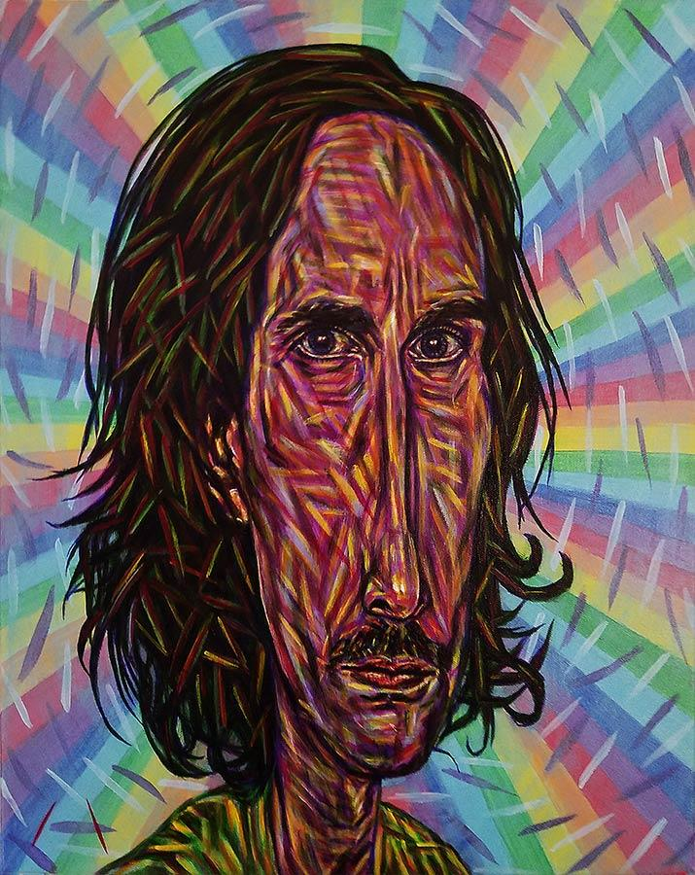
Location DeKalb, IL, USA
Website http://jlampkin.com/
Instagram jeremylampkin
Facebook jeremylampkin & lampkin7
Ello lampkin7

Hats Worn
- Curator
- Painter
- Model
- Day Job: Webmaster and Barback

Q & A
- Artistic Weapon of Choice:
Acrylics

- Can you tell us more about your artistic process Mr. Lampkin?
My artistic process begins with a basic underpainting, followed by a systematic method of dashing color after color using the 7 colors of the rainbow and white. This creates a certain turbulence in the atmosphere, an electric aura. Also, I distort the anatomy of my figures similarly to primitive art.
Do you think the distortion in the figures relates to yourself as a taller more stretched out figure?
Perhaps. It's a connection I feel with primitive art such as African or Moai sculptures. I see my figures as if they were giants about 9-10 feet tall but with very slender frames.

- Of your own work, what would you say is your favorite and why?
'Elegance' This one was a based upon the study which I based my art style on. I spent about 18 months slowly working on that study, until I finally decided to pursue that style. It's also based upon a photograph that meant a lot to me, which is tough to explain briefly. I consider that painting my finest work.
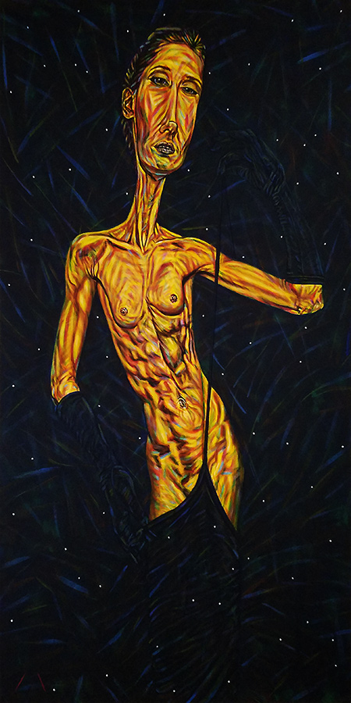
Elegance
- What is your most misunderstood work?
While much of my work is misunderstood, I think the most so may be the 'Reservations and Concentration' diptych.
I think it's misunderstood because it's generally taken on the level of politics, when it uses esoteric symbolism and irony to tell a story of a prisoner with a freed mind, while referencing 2 major genocides from recent history.
Asked to explain the use of symbolism such as the swastika, all I can say is that it means everything that anyone wants to see it for. It is a spiritual symbol for followers of all different faiths. In the world of the occult, the swastika is known to represent the number 6, a solar symbol also representing the number of man. In my painting, there's a play on the 5 pointed stars evolving into swastikas, or suns. On the most mundane level, the swastikas here would represent the plight of the Native Americans as Reservations, while representing Nazi Germany as pertaining to Concentration.
Any comments about them being rejected? Has this happened before?
3 times in a row now...I understand why they were rejected. It would be nice if they could just ask me for a replacement, but I seem to always end up leaving with art that was initially accepted, but later rejected.
That must be very frustrating. Especially after the time and expense to driving to the venue to drop them off, to then turn around and pick them up.
Yes, a little frustrating but not a big deal because the other pieces were still accepted. If they'd just rejected them outright it would have saved the trouble of preparing and bringing it, or better yet I could have swapped it for a different painting.
- Who are your influences?
I'll try to limit my response to the fine arts, as that would include a great many. As far as visual artists are concerned, the most influential to me would probably be Diane Arbus, Egon Schiele, Amedeo Modigliani, Duchamp, Dali, Picasso, and Van Gogh.
Fair, but If music or something else inspires you to paint, feel free to include that.
My influences would be extensive. Many of my pieces were actually inspired by women who sort of posed erotically in front of me for kicks. Charles Manson has been a great influence on many different levels. The stories from the Bible, legends from history, and various cultures, cults, religions, and lifeways have been highly inspirational. Music by artists like Prince who transcend genres inspires me too. In fact, all free spirits are an inspiration even when I just meet them.
- Some artists only stick with one media or theme at at time while others experiment, would you say you experiment?
I think I do both. I will keep each of my series going until eventual completion, but also experiment with other ideas all the time too. Regularly I use acrylic on canvas, but I also use livestock markers for abstracts.
- We were both in an exhibit at Awakenings. Can you tell us more about the exhibit and the works you submitted?
I donated a few of my abstracts, which are painted very quickly as compared to my more composed work. I also donated quite a few of my art prints, which sold very well. In fact, me and you were the top 2 sellers at that exhibit.
Wish I could have been there! I don't get hear that often :-)
Awakenings is a gallery with the mission of supporting survivors of sexual violence. They have events such as reiki clinics for the benefit of survivors, who also volunteer as the staff. It's an amazing place that feels like a true sanctuary, which also has a powerful permanent collection on exhibit.
It was a great night

- I have personally used you as a model for my art, do you want to talk about your modeling or photography?
I'm not too serious about modeling. It's just something that I happened to do and receive encouragement to do more of. I generally model if asked, but don't pursue it much myself if at all. I like to do it though. It's a different kind of art requiring a collaboration between artists, which I find intriguing.
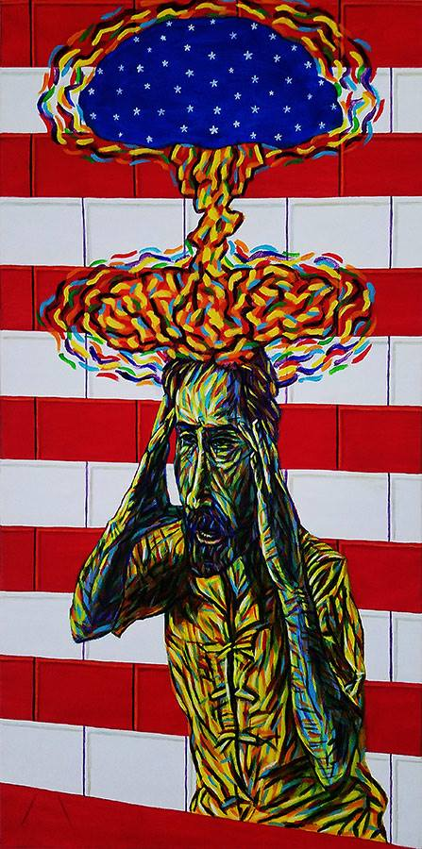Concentration

- How do you store your large pieces of work? I imagine you have a studio space or do you make a studio wherever you are at (can you share a photo)?
Currently several of my paintings are on exhibit. Otherwise I store them at my mom's house, at my gallery, and at my workplace. Ultimately we plan to (temporarily) convert the gallery into a vanity gallery for myself and a few other artists, so my art will be basically stored on those walls and rotated to be shown in other galleries.
- You curate a gallery space now, can you tell us what that is like and how it came about?
A new friend I met last year mentioned my idea for a gallery to a lady who was teaching at a seminar. On her own initiative, she contacted city hall in Rochelle, then me and put us in contact.
Rochelle’s city council was very interested in having a local art gallery. They, and unfortunately the general populace, just doesn't know what art is.
It's been fun but ultimately I can't have much passion for putting on shows in a small town with the kind of outlook this one has. My advisors warned me about this from the beginning, so it was no surprise. Instead we are looking at doing our group shows at venues in active areas. 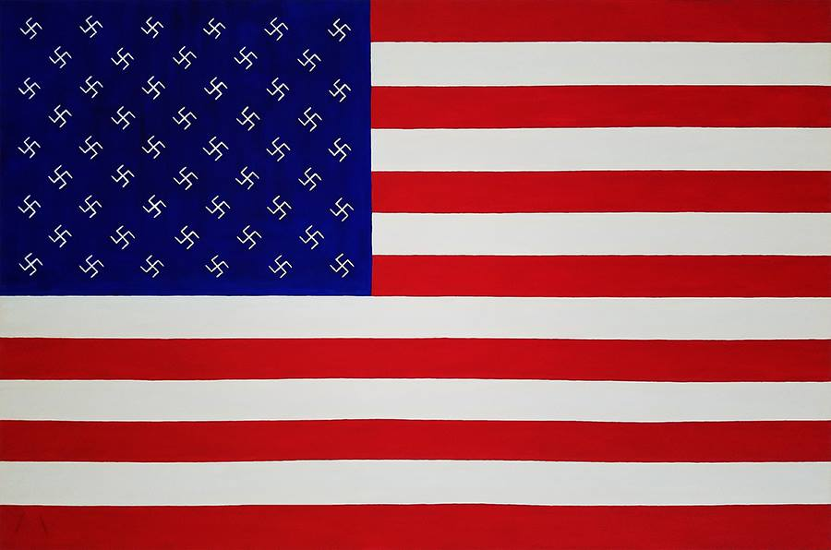
Reservations
That is unfortunate after all your hard work.
It works out for the best. I gained the experience needed to propose exhibits at other galleries, among other things. We started the art scene in Rochelle, whatever may become of it. And hopefully, we'll be back.

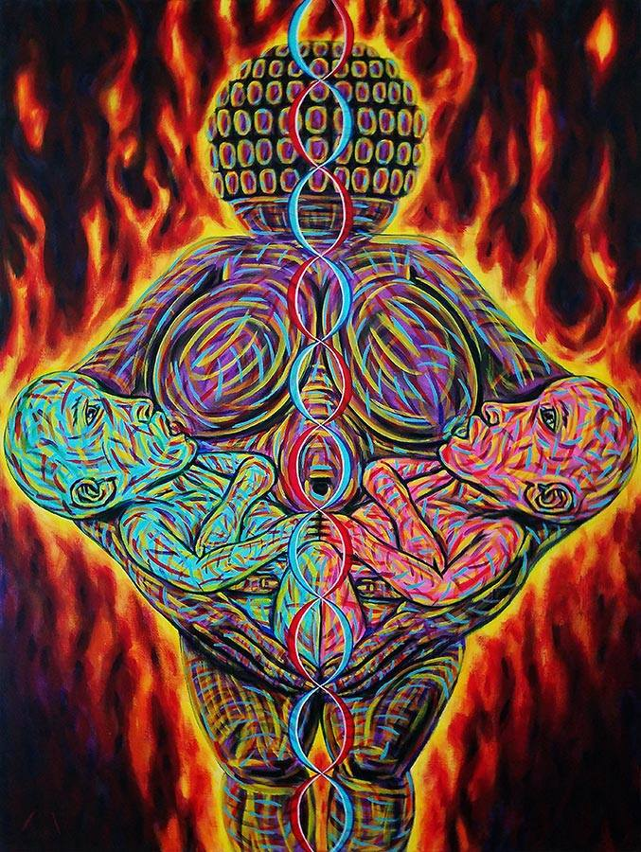
- Any advice for artists? My advice for artists would be to freely explore painful subjects they've had experience with. In my experience, this makes the most relatable artwork. Also it's important to find exhibit opportunities. This can be difficult, especially for those whose social skills need work, but it probably accounts for at least 50% of the work an artist needs to do to be seen.
- Are there any other things you are doing right now you want to promote? Calls for art for the gallery or personal accomplishments, etc Well Faux Pas Gallery has Dump City coming up Aug 17 through Sept 22. After that we'll have a call for art for our last exhibit in Rochelle for a while. That show is scheduled to open December 7 and will be curated by Angela Bachman.
- Thank you very much for allowing me to interview you, but also for letting me have a show at your fine gallery space!
I believe you have been the most developed artist we've shown yet. It's not just my opinion either, the same goes for each of my partners.
You are making me blush. After along shitty morning I needed that. Thanks!

Upcoming Shows:
JUL 28 - NOV 3, reception JUL 28
Tragedy @ Wildrose Brewing Company · Griffith, IN
AUG 3 - AUG 4, receptions both dates
The Voice of the New! @ Horseflower's Creative Hotspot · Rockford, IL
AUG 2 - 31, reception AUG 11

Absolutely Abstract @ The Next Picture Show · Dixon, IL
AUG 17 - SEPT 22, receptions both dates

Dump City @ Faux Pas Gallery · Rochelle, IL
SEPT 30 - OCT 30, reception OCT 5
Dangerous Lullabies @ Historic Dole Mansion · Crystal Lake, IL
