Interview with writer and artist:
Hue & Rodimus13
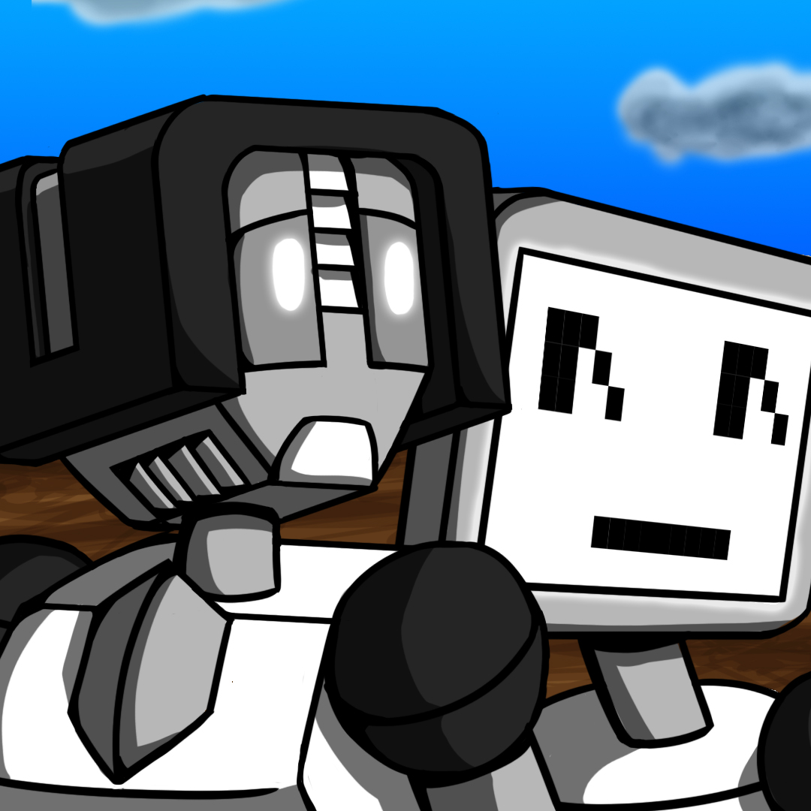
Webtoons: https://www.webtoons.com/en/challenge/hue-are-you/list?title_no=209076
Tapas: https://tapas.io/series/Hue-Are-You
Instagram: https://www.instagram.com/hueareyoucomic/
Twitter: https://twitter.com/hue_are
TeePublic: https://www.teepublic.com/user/rodimus13
https://ko-fi.com/hueareyoucomic

Ingredients
- J: Hi I’m Joan, also called Hue. The writer of Hue Are You.
- T: And I’m Thomas Also known online as Rodimus13. I’m the artist.

Preparation
- Artistic Weapon of Choice: T: I guess that would be my Cintiq tablet and stylus. I draw the entire comic on my computer using Photoshop.
J: I use google docs so I can type away on my laptop when I get the dialogue correct in my head. Due to my dyslexia I don’t care much for handwriting and prefer to type so I can adjust the screen as needed.
- If you don't mind telling us about how you approach your work, for example do you create sketches, Photoshop references first, or do you go right to creating a final draft? J: Well for me, I have it all planned out in my head so it’s mostly making sure I am filling out the details. I’ve always been like that where I basically write the first few drafts in my head before writing out and further editing it. Drove my teachers bonkers. For critical parts I make sure to outline the important events in a google document and then start writing everything out in the form of a script. Normally about 3 to 4 weeks worth at a time so Thomas can look it over.
T: For me my process starts with reviewing the script Hue writes for me. I go through it and figure out how many panes each line will have and adjust things so we get our average for 20-25.
J: Sometimes I get a bit too excited and he comes back going “You made it 40 panels for one update” and we have to figure out how to move scenes around so there’s a break that makes sense.
T: So after I get the panel count down I start doing what I call my roughs or pencils. Where I go and create a quick rough sketch of every panel in the comic. I will sometimes use references for stuff like poses, plant or animal life, or specific backgrounds I want to use. I have also recreated the factory where the main story takes place in Minecraft to use as a reference. Once I have all the roughs done, I’ll then start inking and coloring each panel one at a time. Normally averaging about 5 per day.
J: He doesn’t always do them in order since it depends how his work flow is going. The process normally takes 5 to 7 days.
- You are a husband and wife team, Is it ever hard to work together or do you naturally work well together?
J: So it doesn’t hurt that we have known each other since we were 12. His dad and mine were besties from high school. At this point we’ve literally known each other for 2/3s of our lives. I’m not saying it’s perfect. Like any couple we get stressed out, but we have basic rules we follow. Being honest with each other, keep our words kind, and it’s ok to say we need a minute to get our words and thoughts together.
T: It helps we’ve been coming up with stories like this for ages. Just before we started dating we bonded over creating a beast wars fan fic together.
J: And we both understand the ups and downs of each other’s art. We do our best to keep that in mind when making requests or trying to make changes. We also know that the other does know something about both. I can’t draw, but I still understand layouts and such. And Thomas does know how to improve dialogue. Neither of us acts like we are above the other and listens to ideas when offered.
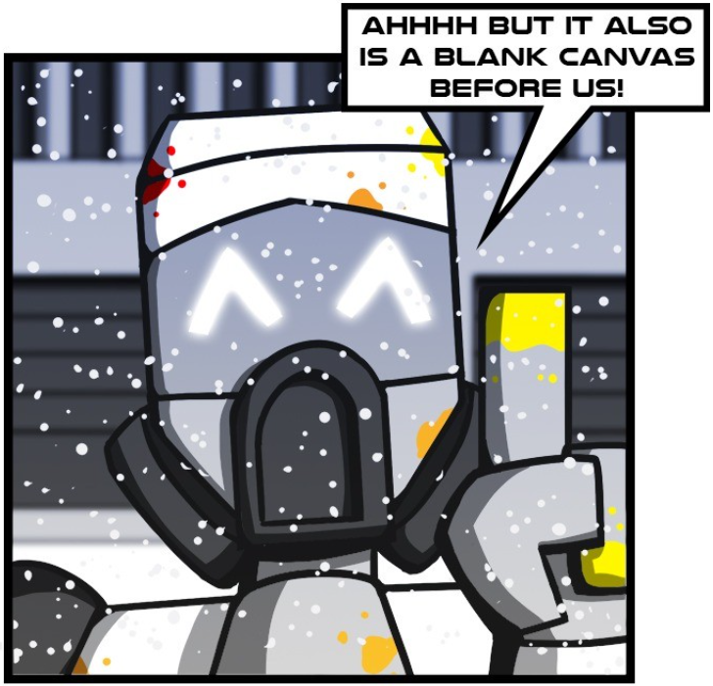
- Hue Are You now has 50.3k views, 328 Subscribers, 6.8k likes and consists of 221 episodes. Your first post was November 3rd 2018, how did you get started?
J: So fun fact we actually started in July on Webtoons, which is also where the comic lives. We entered because of a contest they were doing that year to become one of their original comics. But the story started well before that. About 8 years prior. I had a dream that I couldn’t shake about a robot alone in a factory with other bots coming out and scaring her as she tried to find someone to help. From there the story grew in my mind… but we kept not starting it.
T: The contest on webtoons gave us the needed kick in the seat to really get this thing rolling. It also helped that we wanted to set an example for our son.
J: He was just starting school at the time. And we realized what example were we setting? Waiting until the idea was “good enough” or we were “good enough”. How could we tell him to chase his dreams and ideas… if all we did was sit around. So once we started we agreed to keep going, no matter what.
- Some posts are back to back while others maybe a week apart. It must be hard to keep up posting that often, how do you stay motivated?
J: So the back to back posts are normally shorter ones for special events like Inksgiving- think like a donation drive for creators. Those we prepare well in advance and release at set goals. But overall we try to stick to once a week, which is a lot of work. More so for Thomas. While I did the front end work of making the script in my mind for so long, sometimes playing with ideas as I drive home, he has to be at his computer to make it all work. So, my motivation for writing the scripts out properly is I have the story and want to finish it. I try to make sure he takes breaks.
T: So for me, this has essentially become my job. But that also means I try to treat it like a job. I “clock in” at my desk, put in my 9 to 5, and “clock out”. I take breaks during the day, especially for lunch, and all that helps me from getting too overwhelmed or burnt out. I very rarely work late into the night any more because it was sucking up too much of my free time.
- Who/what are your influences, J: I wish I could say mine. I’ve read so many books in fantasy and sci fi in my life. I was one of those kids. And I read webcomics all the time that take chances with their works… some of which are done now. So I can probably tell you half the sci fi and fantasy sections at your local library.
T: For me I get a lot of inspiration from Transformers and Gundam. But really I love I lot of Super Robot things.

- Do you both have a day job or are you able to live off your work?
T: Yes and no.
J: So, I work full time as a teacher for Middle School. I teach Family and Consumer Sciences specifically. I’m lucky my district pays a living wage for teachers, so with no debts currently we ended up with an interesting situation during the pandemic.
T: We didn’t feel comfortable sending my son to school. While my work accommodated me for a while being at home, they switched to not letting me work at home at all, to unpaid leave, to telling me to choose between working for them or not. We chose not and made the comic and my freelance work a full time job.
Good for you!
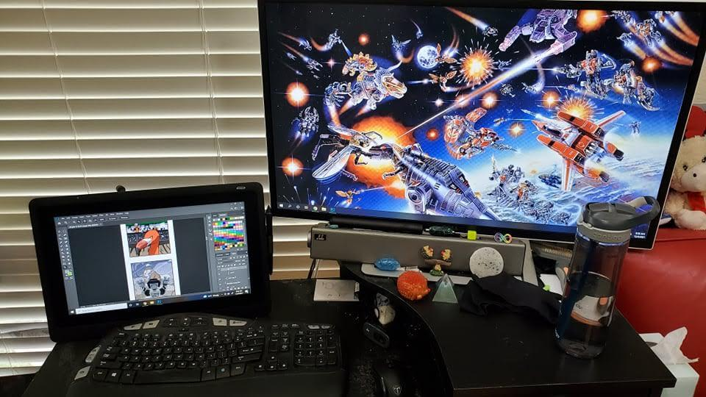J: Honestly I’ve been wanting to let him do it for a while, but we owed too much money for loans and things to do it. We don’t make much off the comic, maybe a couple hundred a year. But we are hoping to turn it into a book series later so maybe it’ll make some money then.
So I have to ask Joan, what is Family and Consumer Sciences?
J:Family and Consumer sciences is what became of Home Ec in the USA. It switched the focus from home care to how many of those same skills can be applied to real world careers. So across my three classes I teach various topics. A sample includes:
Mental health- including disorders like depression and bipolar, Food health and safety, OSHA regulations, Interior design, Personal care careers, Fashion and sewing, Child care, learning, and development, Abuse, Budgeting, Family and Family Crisis situations, meal planning, Running a restaurant, The tourism industry
Sounds like the Home Ec class I wish they had when I was in middle school. Also sounds like a lot to juggle.
- How has business been during the pandemic and what are you doing to adapt?
J: Well we don’t really make much of it and as we mentioned before, it turned from doing it at night when he got home to now it’s his day job. Something I’m really glad for.
T: Yeah, I was starting to get less and less time to do my other hobbies. So I think the change was good.
- Joan, if you weren't a writer and Thomas if you weren’t an artist, what is another career path you guys may have taken?
J: As I mentioned before I do teach. However, I love cooking. I possibly would have been a chef or something along those lines. I still think I’d at least be writing stories though. The fact we both love creating stories is literally how we bonded and became best friends as teens and then led to us dating long distance.
T: That’s hard.
J: It really is because I can’t picture anything else for you.
T: Chances are I would have gone into real estate appraisal because it’s what my dad does as a business and I could have trained under him.
- Do you have a studio space? Can you show us what it looks like?
J: We have a small house so our work is done in the living room. I have my chair.
T: And I have my desk which is only one chair away from where she sits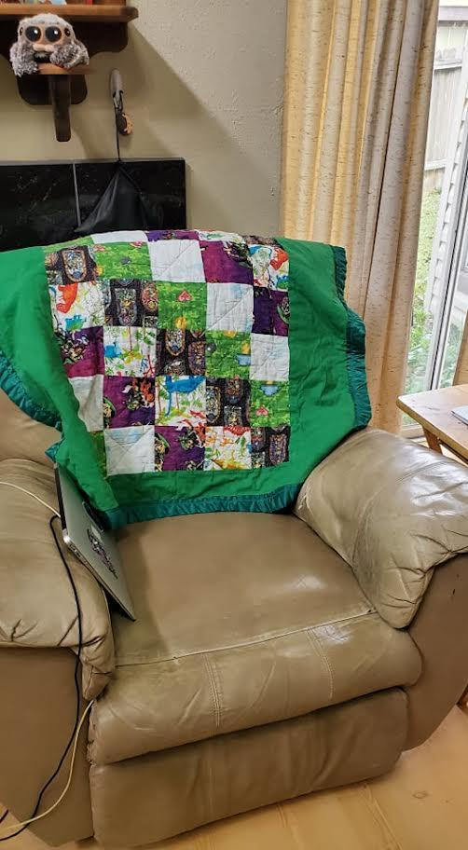
- Do you have any advice for other comic artists just starting out?
J: Just do it. Don’t be scared of screwing up. Listen to others if concerns are brought up about sensitive topics. Research what you want to write. Think about the story you want to tell… and tell it the best way you can.
T: Push yourself but not into a burn out. And don’t be scared to try new art styles and techniques.

- Do you work to a strict schedule each day or week? Or is it more of a fluid process??
J: For me it’s more fluid with a deadline of “Babe the scripts ran out”. It has to be since as a teacher I always have work to do from school.
T: For me because of how it works I had a schedule where I try to finish by Saturday. It was a lot worse when I worked full time, but now that it’s the primary thing. Each week, it’s easier to meet that deadline.

J: I do make sure the schedule breaks in the comic though. While we have updated every week, I plan out times for Q and A comics for Fun 4 You comics. Both of which are shorter and the art design is simpler. Thomas can normally knock out a Q and A with a couple 4 panel strips in a week, which gives us two weeks of content and him a week off.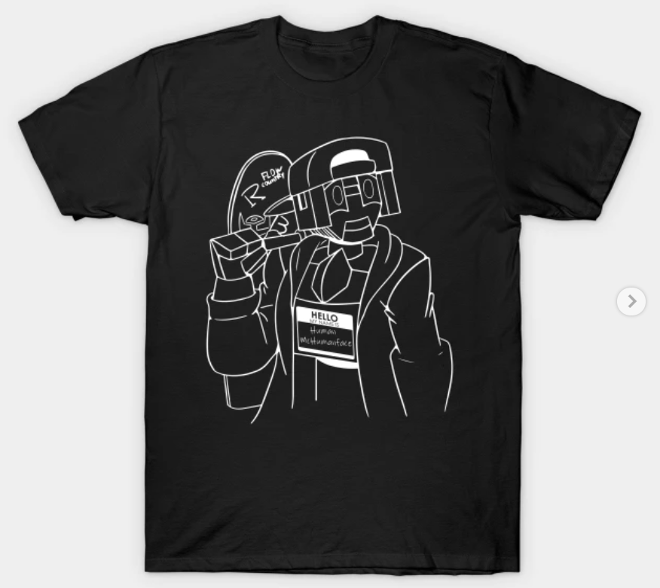
T: Or a week of buffer. We have about 3 weeks right now, in case one of us is sick or has an art block.
J: Or I tell him to take a few days off.
- Can you tell us what you’re currently working on/what you most recently produced?
T: So, our most recent project has been the Hue Are You comic. The story opens with all the humans are dead and we see the last one die for unknown reasons. The super computers in charge of the robotic armies declare they are still at a tie after this death and must continue to fight. But with the ability to endless make repair and construction type bots, there doesn’t seem to be an end. So, they order all factories to stop production.
J: There is then a time jump about 100 years into the future with the same factory falling to ruin. For unknown reasons the production line starts up and Build-a is made. Through her we start to see how the world currently is and the state of things. We also have it confirmed no humans or supervisors are left in the world. She begins her journey of building and meeting new bots and friends. Slowly starting to uncover the mystery of how she came to be and what she may have been made for.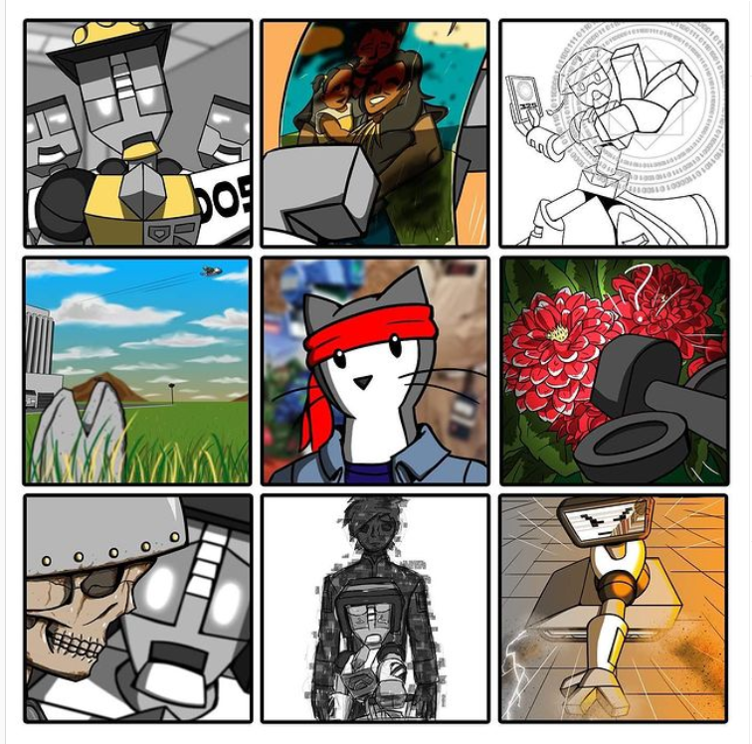
T: Color is a huge part of this story and what colors you can and can’t see as things go along show different milestones and emotions. We never promise that the story will have a happy ending, but it does have a set ending. What we do promise, is we are going to make you feel things for robots.
J: I probably have too much fun doing the soft moments as wind ups for the pulling at your heart strings ones. Just a warning.

- Lastly: Do you have any upcoming shows, events or projects you would like to plug?
We wish. With the pandemic still on we aren’t hitting up any cons just yet. We probably will by the time the spin off comic comes around. We have two planned for the future.

